**V1.10**

ICM Interface

User Guide



**Document control**

**Amendment history**

|  |  |  |  |  |
| --- | --- | --- | --- | --- |
| **Version** | **Release date** | **Effective date** | **Amended by** | **Comments** |
| 0.1 | 15.09.2013 |  | Javesh Boodnah | Initial full draft of document |
| 0.2 | 26.09.2013 |  | JC Le Saux / Andrew Fyfe | Review comments |
| 0.3 | 30.09.2013 |  | Javesh Boodnah | Revised draft |
| 0.4 | 10.12.2013 |  | Cassie Moore / Javesh Boodnah | Added chapter 2 + appendix |
| 0.5 | 10.01.2014 |  | JC Le Saux / Cassie Moore | Review comments |
| 1.0 | 22.10.2014 |  | Javesh Boodnah | Updated and baselined up to ICM Release 1.3.4 (2014) |
| 1.2 | 29.03.2016 |  | Tung Nguyen/Kieron Singh | Initial updated and baselined up to ICM Release 1.3.8 (2016) |
| 1.3 | 30.10.2017 |  | Marek Les / Kieron Singh | Updated for ICM Release 5.5.9.0 (ARA Scheduled Reports / Post-processing) – presented to ICMOC |
| 1.4 | 29.03.2019 |  | Andrew Little | Updated for release 5.6.7.0 which includes the IMS integration functionality |
| 1.5 | 21.06.2019 |  | Andrew Little | Updated for release 6.5.4.0 which incorporates the RAFM (Algo replacement) technology, and removing references to Algo and Algo related technology |
| 1.6 | 21.08.2020 |  | Irfan Ahmed / Kieron Singh | Updated for ICM release 6.8.5.1 |
| 1.7 | 27.11.2020 |  | Valia Kostaki / Kieron Singh | Updated for ICM release 6.9.0.2 |
| 1.8 | 27.04.2021 |  | Valia Kostaki | Updated for ICM release 7.0.2.0. ICMOC approved on 17/06/2021 |
| 1.9 | 04.10.2021 |  | Rebecca Kirk | Updated for ICM release 8.1.1.1 |
| 1.10 | 14.09.2022 |  | Gwenda McGill | Update for ICM release 8.2.2.0 |

**Document information**

|  |  |
| --- | --- |
| **Document..** | **Details** |
| Title | ICM Interface User Guide |
| Reference | ICM v8.2.2.0 |
| GHO document type | Manual |
| Location | TBC |
| Prepared by | Javesh Boodnah / Marek Les / Kieron Singh/ Andrew Little / Irfan Ahmed / Valia Kostaki / Rebecca Kirk/Gwenda McGill |
| Owner / location | Stephen Hainsworth / Capital Management and Modelling / Angel Court |

**Approvals list**

| **Name** | **Position** | **Date approved** |
| --- | --- | --- |
| David van der Merwe | Senior Director, Actuarial Ecosystems |  |

**Distribution list**

| **Name** | **Position** |
| --- | --- |
| All ICM end users | Various |

**Source documents used**

| **Document** | **Location/source** | **Author** |
| --- | --- | --- |
| Legacy ICM user guide – chapter-based instructions authored/modified by Deloitte/P1 | N/A | Various |
| All BP-XXX documents as supplied with the go-live version of Release 8.2.2.0 (2022) | SharePoint | cleversoft |

**Supporting process notes**

| **Document** | **Location/source** |
| --- | --- |
| Working with RAFM Projects prior to validation | DATA_GHO_RISK_ACTUARIAL\03 ICM\01 Documentation\01 Process notes\Working with RAFM Projects prior to validation - Process note v1.0.docx |
| Updating Base Engine for Merged Projects | DATA_GHO_RISK_ACTUARIAL\03 ICM\01 Documentation\01 Process notes\Updating Base Engine for Merged Projects - Process note v0.5.docx |
| Nesting within a single geography | DATA_GHO_RISK_ACTUARIAL\03 ICM\01 Documentation\01 Process notes\ Nesting within a single geography - Process note v1.0.docx |
| ICM Stochastic multi-shred on a single stochastic run | DATA_GHO_RISK_ACTUARIAL\03 ICM\01 Documentation\01 Process notes\ ICM Stochastic multi-shred on a single stochastic run v0.2_Clean |

Table of contents

1. Introduction 10

1.1 General background and system overview 10

1.1.1 Solvency II and Economic capital 10

1.1.2 Overview of the ICM 10

1.2 Scope of the user guide 12

1.3 Structure of the user guide 12

1.4 User rights by geography and role 13

1.4.1 User rights by geography 13

1.4.2 User rights by roles 14

1.5 Assumptions & pre-requisites 15

1.5.1 Checklist for training participants 16

1.5.2 Checklist for ICM interface users 17

1.6 User assistance 18

2. Summary of common business processes 21

2.1 End to end ICM business process model 21

2.2 The link between the ICM and external systems 23

2.3 Tagging 24

2.4 Scenario set production 26

2.5 Nesting process 26

2.6 Run infrastructure 30

2.7 The full run process (balance sheet requirement) 33

2.8 Entity set validation and nesting implications 34

2.9 Validation and lockdown process 36

3. General navigation 39

3.1 Introduction 39

3.2 Overview of key tabs 40

3.3 Menu navigation 41

3.3.1 RAFM projects 44

3.3.2 Entity structure 48

3.3.3 Lite models 51

3.3.4 Aggregation rules 54

3.3.5 Entity set 57

3.3.6 RSG Instructions 60

3.3.7 Scenario sets 63

3.3.8 Assumption sets 66

3.3.9 Bulk run profiles 74

3.3.10 System administration 75

4. RAFM projects 83

4.1 Introduction 84

4.2 Key inputs and outputs (RAFM projects) 88

4.3 Step by step approach to working with RAFM Projects 89

4.3.1 How to create a base engine project 90

4.3.2 How to create a standard ICM RAFM project 92

4.3.3 How to create a merged ICM RAFM project 94

4.3.4 Modify a RAFM project 96

4.3.5 Delete a RAFM project 98

4.3.6 Share a RAFM project 99

4.3.7 Copy a RAFM component 100

4.3.8 Download a RAFM project (project file) 101

4.3.9 Validate a RAFM project 102

5. RSG instruction set management 104

5.1 Introduction 105

5.2.1 Key inputs and outputs (translators) 107

5.2.2 Key inputs and outputs (scenario assumption set) 108

5.3 Step by step approach to working with translators, scenario assumption sets and RSG input files 109

5.3.1 How to create a translator 110

5.3.2 How to modify a translator 112

5.3.3 How to download a translator 114

5.3.5 How to copy a scenario assumption set 115

5.3.4 How to create a scenario assumption set 117

5.3.6 How to modify a scenario assumption set 119

5.3.7 How to export a scenario assumption set manifest file 121

5.3.8 How to generate an RSG instruction set 122

5.3.9 How to download an RSG input files 123

6. Scenario sets 126

6.1 Introduction 126

6.2 Key inputs and outputs 129

6.3 Step by step approach to working with Scenario Sets 130

6.3.1 How to create a scenario set 131

6.3.2 How to copy an scenario set 133

6.3.3 How to delete a scenario set 135

6.3.4 How to validate a scenario set 136

**6**.3.5 How to modify a scenario set 137

6.3.6 How to rename a scenario set 139

6.3.7 How to share a scenario set 140

6.3.8 How to export a RAFM Project (Base engine) 141

6.3.9 How to download the validation reports of a stochastic scenario set 142

6.3.10 How to download the Run Manifest file 144

6.3.11 How to trigger a validation run (RSG Standalone Run) 145

6.3.12 How to download the RSG Results Report 146

6.3.13 How to mark an RSG run as a failed 146

7. Lite models 149

7.1 Introduction 150

7.2 Key inputs and outputs 153

7.3 Step by step approach to working with lite models 154

7.3.1 How to create a lite model 155

7.3.2 How to modify a lite model 157

7.3.3 How to delete a lite model 159

**7**.3.4 How to validate a lite model 160

**7**.3.5 How to download the parameter file/report of a lite model 161

7.3.6 How to rename a lite model 162

7.3.7 How to copy a lite model 163

**7**.3.8 How to bulk upload lite models 164

7.3.9 How to bulk modify lite models 166

7.3.10 How to download results of the bulk upload process 168

8. Entity structures 170

8.1 Introduction 171

8.2 Key inputs and outputs 174

8.3 Step by step approach to working with entity structures 175

8.3.1 How to create an entity structure 176

8.3.2 How to modify an entity structure 177

**8**.3.3 How to modify an entity structure tree on screen 178

8.3.4 How to delete an entity structure 180

**8**.3.5 How to validate an entity structure 181

8.3.6 How to download the tree file of an entity structure 182

8.3.7 How to rename an entity structure 183

8.3.8 How to copy an entity structure 184

8.3.9 How to share an entity structure 185

8.3.10 How to submit an entity structure to an entity set 186

8.3.11 How to assign geographies to an entity structure 187

8.3.12 How to mark ‘nesting nodes’ within an entity structure 189

8.3.13 How to unmark ‘nesting nodes’ within an entity structure 190

8.3.14 How to download validation reports 191

9. Aggregation rules 193

9.1 Introduction 193

9.2 Key inputs and outputs 197

9.3 Step by step approach to working with aggregation rules 198

9.3.1 How to create aggregation rules 199

9.3.2 How to modify aggregation rules 201

**9**.3.3 How to delete aggregation rules 203

**9**.3.4 How to validate aggregation rules 204

9.3.5 How to download parameter file of aggregation rules 206

9.3.6 How to rename aggregation rules 207

9.3.7 How to copy aggregation rules 208

9.3.8 How to bulk upload aggregation rules 209

9.3.9 How to bulk modify aggregation rules 210

9.3.10 How to download results of the bulk upload process 212

10. Entity sets 214

10.1 Introduction 215

10.2 Key inputs and outputs 218

10.3 Step by step approach to working with entity sets 219

10.3.1 How to create an entity set 220

**10**.3.2 How to modify an entity set 222

**10**.3.3 How to delete an entity set 224

**10**.3.4 How to rename an entity set 225

10.3.5 How to copy an entity set 226

10.3.6 How to bulk assign components to an entity set 227

10.3.7 How to download results of a bulk assignment 229

10.3.8 How to bulk download parameter and experience files 230

10.3.9 How to validate an entity set 231

10.3.10 How to download the events of an entity set 232

11. Bulk Run Profiles 234

11.1 Introduction 235

11.2 Key inputs and outputs 237

11.3 Step by step approach to working with bulk run profiles 238

11.3.1 How to create a bulk run profile 239

11.3.2 How to modify a bulk run profile 240

11.3.3 How to delete bulk run profile 241

11.3.4 How to share a bulk run profile 242

11.3.5 How to enable a bulk run profile 243

11.3.6 How to disable a bulk run profile 244

11.3.7 How to create a run attached to a bulk run profile 245

11.3.8 How to modify a run attached to a bulk run profile 247

11.3.9 How to delete a run attached to a bulk run profile 249

12. Assumption set management 251

12.1 Introduction 252

12.2 Key inputs and outputs 256

12.3 Step by step approach to working with assumption sets 258

12.3.1 How to build an assumption set 259

12.3.3 How to modify an assumption set 263

12.3.4 How to rename an assumption set 265

12.3.5 How to copy an assumption set 266

12.3.6 How to create an assumption set as ‘Same as’ copy 267

12.3.7 How to assign LBU-level entity sets to BU-level nesting assumption sets (via nesting nodes) 269

12.3.8 How to assign BU-level entity sets or assumption sets to nesting GWAS (via assigned geographies) 273

12.3.9 How to un-assign entity sets or assumption sets from a nesting assumption set 278

12.3.10 How to download pre-run manifest file 280

12.3.11 How to run an assumption set 281

12.3.12 How to run an assumption set as a batch 285

12.3.13 How to run an assumption set under a Bulk Run Profile 290

12.3.14 How to download (post) run manifest 293

12.3.15 How to download the Risk Limits file 294

12.3.16 How to download run logs/reports from an assumption set 295

12.3.17 How to upload reports to a run 296

12.3.18 How to generate BU Reports 297

12.3.19 How to download generated BU Reports 298

12.3.20 How to lock down assumption set 299

12.3.21 How to mark runs on locked down assumption set 301

12.3.22 How to download the lock down/sign off report of an assumption set 302

12.3.23 How to assign a merged ICM RAFM project to an assumption set 303

12.3.24 How to unassign a merged ICM RAFM project from an assumption set 304

12.3.25 How to download an ICM RAFM project 305

12.3.26 How to export an ICM RAFM project 306

12.3.27 How to cancel a queued RAFM run 308

12.3.28 How to download Scenario Set RSG Results Report from an assumption set 309

13. Tags 312

13.1 Introduction 313

13.2 Key inputs and outputs 315

13.3 Step by step approach: use cases 316

13.3.1 Create a tag 317

13.3.2 Modify a tag 319

13.3.3 Delete a tag 321

13.3.4 View or download tag usage 322

13.3.5 Apply filter on ICM using a tag 324

13.3.6 Assign a tag 326

13.3.7 Archiving 330

Appendix 332

14.1 Run types explained 332

14.2 Dates in the ICM 333

14.3 Risk limits 335

14.4 Lite Model/Aggregation Rule and RSG Compliance Validation 336

Chapter 1

Introduction

# 1. Introduction

This user guide is designed to help business users at Prudential make use of the Internal Capital Model System (“ICM”) for the purpose of producing relevant and timely results. The target readership for this guide is the finance teams within Group Head Office (“GHO”) and within the Business Units (“BUs”) and their constituent Local Business Units (“LBUs”) across the Prudential Group.

This current version of the user guide is relevant up until Release 8.2.2.0 of the ICM interface which went live in September 2022 and has been fully updated to reflect all changes until that date.

Please note, the preferred ICM supported internet browser is Google Chrome. The users are advised to use this internet browser for their navigation into ICM.

## 1.1 General background and system overview

### 1.1.1 Solvency II and Economic capital

The design of the ICM was initially prompted by the Solvency II directive, which was a fundamental change in the solvency framework for European insurance groups. The ICM has from that time been run with two calibrations, being Solvency II and Economic Capital (ECap). In 2021 the Group Internal Capital Assessment (GIECA) replaced the ECAP metric. Going forward GIECA will become the single metric of the Group. This note has therefore been drafted assuming the GIECA metric.

The key output of the ICM on a day-to-day basis is therefore the Economic Capital Requirement (ECR) at both GHO and BU levels.

### 1.1.2 Overview of the ICM

The ICM includes models used to calculate assets, technical provisions, risk margin and capital requirements, and is used to calculate the following (not an exhaustive list):

* Group and solo ECRs;
* “What If” impact analysis on the ECR;
* Risk margin;
* Approximate assets, technical provisions and ECR on a “live” basis for continual solvency monitoring and for “What If” analysis;
* Projection of the balance sheet for up to 3 years in advance; and
* Profit and loss attribution – both Own Funds and /Available Economic Capital.

The diagram below provides an overview of the ICM:



Figure 1: ICM Overview

A description of the key components of the ICM is provided below:

* **Lite models**

The term “lite model” refers to the methodology that is used for the rapid calculation of the value of assets and liabilities for each product line under a large number of stochastic simulations (risk driver simulations over one year).

The methodology aims to optimise the trade-off between speed of calculation and accuracy and therefore different approaches are used for different business areas in order to maximise the overall effectiveness of the internal model.

Lite models are calibrated to heavy model results by BUs under a range of deterministic calibration scenarios in line with the Group Wide Operating Standards (“GWOS”) on lite models. The lite models are then tested using a range of deterministic validation scenarios, which are applied to both the lite models and heavy models and the results are compared. The lite models are refined until they reproduce the heavy model results under the validation scenarios in line with the guidance within the GWOS. The modular nature of the internal capital model structure ensures that lite modelling methodologies can continue to be refined over time.

* **Simulations**

The term “risk driver” refers to the development of 1 year real-world probability distributions for each of the risks modelled within the ICM (economic and non-economic), allowing for the dependencies between risk factors.

BUs define the risk drivers for non-market risks in each local entity together with associated dependency structures; Group Finance defines the risk drivers for market risks together with the dependency structures across different territories.

The risk driver information above is entered into the Risk Scenario Generator (“RSG”) calculation tool and it produces a RSG file containing a maximum number (such as 100,000) of risk scenarios for the base balance sheet run. These risk scenarios, when combined with the lite models above and asset portfolios (as appropriate) in the calculation engine (see below), provide the value of assets and liabilities for each of the 100,000 risk scenarios, which in turn gives the required capital for each risk scenario.

Various RSG files are also produced by GHO for the purposes of projecting the balance sheet, profit and loss attribution and “What If” scenarios. The production of some of these RSG files requires certain information which is provided to GHO by the BUs.

* **Entity structure and aggregation rules**

This refers to the way in which risks and legal entities are defined and consolidated within the ICM, including the definition of the legal entities and product groupings, and the resulting capital fungibility.

BUs will define the aggregation structure for all products within their territories; Group Finance will define the aggregation structure between BUs.

* **Calculation engine**

The calculation engine applies the lite models under a large number of simulations of the risk drivers, to calculate aggregate assets and liabilities in each simulation.

The assets and liabilities for each entity in each simulation are aggregated using the aggregation rules across the Entity Structure, allowing for fungibility of capital / entity structure and allowing for group level cashflows (such as group tax which depend on aggregated asset / liability values).

Calculation of the aggregated assets and liabilities in each simulation gives a full stochastic distribution of balance sheets, from which the ECR can be determined (using the 99.5% of the distribution).

The calculation engine is designed to perform these calculations very quickly to allow a large number of simulations to be carried out in every run (e.g. it is expected that a typical run of the model would involve up to 100,000 simulations to enable a 99.5th percentile to be calculated).

The calculation engine also calculates the appropriate allocation of economic capital back to underlying risk drivers and legal entities in order to allocate total group-wide diversification benefits. The ICM calculation engine is Risk Agility FM (RAFM), a software offering from Willis Towers Watson.

* **User interface and control environment**

The user interface facilitates “live” running of the ICM by BUs and GHO, as well as to provide the control environment for model inputs from BUs and GHO.

The control environment includes, for example, audit-trail of user changes, storage of historic assumption sets etc.

## 1.2 Scope of the user guide

This user guide assumes that all the relevant source data files required for the ICM have been created using processes adopted, understood and managed by GHO and the BUs in line with the guidance set out in the relevant GWOS. Therefore, the processes for creating these source data files have not been covered in this user guide.

## 1.3 Structure of the user guide

The chapters included in this user guide focus on the key concepts and components in the ICM interface and follow a consistent structure as outlined below:

* **Introduction**
* **Learning objectives;** outlines key points users will learn by completing the lesson.
* **General introduction to the concept***;* introduces the relevant component or concept as it exists within the ICM interface as well as business context.
* **Key inputs and output**s:summarises the key inputs required to complete a task in the ICM interface highlighting mandatory and optional inputs and the end product.
* **Step by step approach: key use cases**

Each chapter covers several use cases related to a specific topic. Each use case provides information and guidance on how to complete a specific task using the ICM interface. It includes:

* **Business context**: provides business context for each use case indicating when and why a user may need to carry out a task in the ICM interface.
* **Prior steps:**outlines essential activities a user must complete prior to carrying out the task.
* **User permissions:** lists necessary user permissions a user must have in the ICM interface to complete the task (only relevant in the cases where higher user permissions are required)
* **Steps**: the specific steps that users need to follow to complete a task.

## 1.4 User rights by geography and role

### 1.4.1 User rights by geography

**The general concept**

The ICM interface has a built-in concept of ‘geography’. The geography is used to segment the modelling components and results produced by ICM users across the different Prudential BUs. Each user with access to the ICM interface will be assigned to a specific geography in the system which is reflective of the geographical region of their business unit. If a single user has responsibilities in more than one geography, it is possible to allocate the user different permissions in different geographies.

 ‘**Geography’ in the ICM interface**

The business segmentation in terms of modelling components and production of results is reflected in the ICM interface by defining the limits on the files or components users are able to view and access.

Any items created within the ICM framework are endowed with the geography of that user and are visible by default to those in the same geography. It is possible to share components within the interface, thereby granting access to users from an additional geography. Results of ICM runs can be published to parent entities (see below).

As mentioned above, ICM components are, by default, only visible to users from the same geography.

**There are two mechanisms whereby users from other geographical user groups can see components:**

* Promotion to a published assumption set.  As part of the production reporting process, published assumption sets are created to allow collaboration across the Group.  As entity sets are nested into a published assumption set from lower geographies, their structure is immediately visible to their parent nodes.
* A user can choose to assign specific additional geographical rights to a particular component and “release” it to other geographies.  This may be a regional “centre of excellence” for aid in coding or may be a specific sibling or cousin entity (e.g. to allow both user groups to see a reinsurance lite model).

### 1.4.2 User rights by roles

The following section presents a set of defined GHO ‘roles’ and the relevant system permissions applicable to each of those roles. BUs should note that this is for illustrative purposes only and that they are not required to strictly adhere to the user rights structure shown here.

The rights afforded to users as a result of their role is a combination of component availability as well as specific use case ability (such as level 1 or 2, where level 2 provides higher authority)

**User types**

**Lite modellers & risk actuaries (GHO and BUs)**

* Build and set up components and produce assumption sets as well as coordinate runs
* Understand risk modelling decisions
* Will need to have a good knowledge of how the components in the system fit together and a detailed knowledge of system workings
* Will be an active and regular user of the ICM interface
* More senior actuaries with significant knowledge of the business are able to challenge the results produced and provide final review and lock down of assumption sets
* Build and maintain RAFM Standard Projects

**Lite modellers & risk actuaries (GHO only)**

* Build and maintain RAFM Merged Projects

**RSG users (usually GHO)**

* Responsible for the creation of scenarios in the RSG and uploading of the translator data to the ICM for the lite modellers to access for use in assumption sets.
* Not expected to have detailed knowledge of individual lite models or aggregation rules but should understand the general methodology.
* Can work outside the ICM interface to generate scenarios and are not usually given access to all tabs of the interface
* Build and maintain RAFM Base Engines

**Administrators and application support (GHO IT)**

* Has the ability to do anything in the system (all user permissions). Generally responsible for maintaining the system
* Acts as first line support for any issues encountered by users during their ICM runs

**GHO Capital Management and Modelling including ICM development (GHO)**

* + Responsible for authorising all administrative duties on the ICM, not excluding managing the addition and deletion of users to the system, setting up user permissions and general user maintenance
  + ICM development team also acts as a second/third line support for BUs and GHO to aid any issues encountered during runs and more complex investigations that are passed down from general application support

## 1.5 Assumptions & pre-requisites

This section presents a checklist of assumptions and pre-requisites for individuals attending training sessions to use the ICM interface as well for users of the ICM interface on an ongoing basis.

Training participants and the intended audience of this manual are assumed to be familiar with the key concepts covered in this guide as well as have working knowledge of certain tools listed below. Before attending the ICM interface training sessions, participants should ensure that they take necessary steps to meet the requirements listed below and/or refresh their knowledge regarding key concepts.

**Use the checklist below to ensure you have:**

* adequate knowledge of the key concepts which form the basis of the ICM interface;
* sufficient skills and exposure to tools which will help you carry out tasks in your local BU via the ICM interface
* access and adequate permission levels to be able to use the functionality of the ICM interface

### 1.5.1 Checklist for training participants

**Before attending a training session, participants should:**

Essential    Desirable 

|  |  |  |
| --- | --- | --- |
| **Requirement** | **Essential/ desirable** | **Requirement complete?** |
| Read the introduction section of this guide for optimal use |  |  |
| Understand the purpose and requirements of **economic capital measurement** |  |  |
| Understand the concepts and purpose of a **lite model** |  |  |
| Understand the concepts around **risk scenarios** and how these are used in the calculation of capital figures |  |  |
| Have experience of working with **Microsoft Excel** |  |  |
| Have a working knowledge of programming languages such as **C++** |  |  |
| Understand **local business unit processes** for capital modelling |  |  |

### 1.5.2 Checklist for ICM interface users

**Before using the ICM interface user guide to work with the ICM interface, users should**:

|  |  |  |
| --- | --- | --- |
| **Requirement** | **Essential/ desirable** | **Requirement complete?** |
| Attend a training session |  |  |
| Be familiar with the key topics covered in this guide |  |  |
| Understand that they are fully responsible for complying with Prudential’s requirements for information security, with said information available in the ‘Information Security supporting policies and standards’ that support the Group policy |  |  |
| **Access requirements** | |  |
| Ensure that they have the access to the required geographies within the ICM |  |  |
| Ensure that they have been assigned a user name and password to logon |  |  |
| Live internet connection |  |  |
| **Background information and knowledge** | |  |
| Be familiar with the relevant GWOS documents and other supporting documentation |  |  |
| Ensure they are familiar with the use of excel-based reporting templates such as the balance sheet tool |  |  |
| Have a knowledge of their local BU processes regarding:   * + Heavy modelling   + Risk drivers and modelling   + Scenario design (where relevant) |  |  |
| Familiarity with the purpose and requirements of the Solvency II regime and economic capital |  |  |
| **Skills** |  |  |
| Working knowledge of Excel |  |  |
| Have a working knowledge of programming languages such as C++ |  |  |

## 1.6 User assistance

All local business units and GHO have experienced users (local champions) who should be the first port of call for any issues involving the ICM interface. If users cannot get their issues resolved locally, they should then raise a ticket initially with the ICM Support Team.

The ICM Support Team will aim to resolve any user issues and will escalate if required to the GHO ICM Subject Matter Expert (SME).

This will aid in tracking all ICM issues to resolution in the most efficient manner.

Chapter 2

Summary of common business processes

**Chapter objectives**

*By the end of this chapter you will have:*

* ***learned on a high level how external systems and tools interact with the ICM***
* ***developed an understanding of the end to end business processes central to the ICM***

2.1 End to end business process model

2.2 The link between the ICM and external systems

2.3 Tagging

* ***worked through the lower level business processes required to run the ICM***

2.4 Scenario set production

2.5 Nesting process

2.6 Run infrastructure

2.7 Full run process

2.8 Entity set validation and nesting implications

2.9 Validation and lock down process

# 2. Summary of common business processes

## 2.1 End to end ICM business process model

The process model in Figure 2.1 depicts the end to end process enacted by the reporting teams in any given reporting cycle. This diagram has been produced to give a holistic view of the key activities in place and the systems they interact with.

The scope of activities include

* pre-ICM activities that produce inputs into the ICM
* all activities within the ICM workflow
* the interaction between the ICM and external systems
* the output produced by the ICM and subsequent destination

 igure 2.1: The end to end business process model

Some of the activities included within Figure 2.1 are more complex and have been broken down into further subsections (see the latter sections within this chapter):

* an overview of the link between the ICM and external systems
* tagging
* scenario set production
* nesting run infrastructure
* run infrastructure
* full run process
* entity set validation and nesting implications
* validation & lockdown process

## 2.2 The link between the ICM and external systems

Figure 2.2 depicts a high level overview of how the systems interact with one another throughout the end-to-end business process model as per Figure 2.1. It includes all locally developed tools and vendor sub-systems that directly interact with the ICM. In order to provide the business user with details of events that occur in the back-end of the main systems, these have been distinguished from events actually visible to the business user. The basic flow of the inputs, system actions and outputs are identified.



Figure 2.2: The relationship between the ICM and external systems

## 2.3 Tagging

Tagging is a data management mechanism used throughout the ICM. A tag is an attribute that is assigned to a component within the ICM. The tag acts as a label and does not affect the functionality of the ICM component in any away other than for filtering and data management purposes.

To facilitate this purpose, a controlled process has been implemented such that the creation of new tags has been restricted to the ICM Pru Group User.

There are three methods through which a component gets a tag in the ICM:

1. A user can assign a tag to each of these components (this is mandatory - component cannot be created without the tag)
   * Assumption set
   * Entity set
   * Scenario set
   * Scenario Assumption Set
   * Translators
   * ICM Static Data
2. The following components inherit the tag of the component it is assigned to
   * Lite model (from entity set and/or assumption set)
   * Entity structure (from entity set and/or assumption set)
   * Aggregation rule (from entity set and/or assumption set)
   * Entity set (from assumption set only)
   * RAFM projects
3. If a component does not have a tag, one of these 3 system tags are applied;
   * Historical (for all day one components without a user tag)
   * New (for all components at creation that get tags via inheritance only)
   * Rejected (for all components, that get tags via inheritance only, that are unassigned from all entity sets)

Tags assigned by a user are further categorised into prescriptive and descriptive tags. These are explained in Chapter 13.

The business process and tagging lifecycle are depicted in Figure 2.3.



Figure 2.3: The tagging business process model

## 2.4 Scenario set production

Scenario sets are produced by and distributed from the GHO RSG production team. It is essential that a business user select a scenario set which has the same purpose as that of the assumption set, such that the correct reports are produced from the right scenario sets.

Figure 2.4 describes the manual and automated steps required to produce a normal (non-critical) scenario set. Normal scenario sets are required for all run types. The trigger for which initiates an update to the base engine RAFM project is detailed in the appropriate chapter.



Figure 2.4: The normal scenario set

When running an assumption set in ‘Stoch and CS’ mode (which will be described in Chapter 12), the ‘batch run’ includes the ‘normal’ scenario set production (as set out above in Figure 2.4), and also includes the ‘critical scenario’ scenario set production. Where the ‘critical scenario’ results are produced, results will be maintained in the ‘Critical’ sub-tab in the Scenario Summary Set Table (which will be described in Chapter 6). Both sets of results follow the same process illustrated above, but the ‘generate run output’ internal system processes are different.

## 2.5 Nesting process

Nesting is a process of adding an entity set or assumption set to a grandparent assumption set. A grandparent assumption set is an assumption set that is owned by a legal entity (and its associated ICM geography) that is above the legal entity (and its associated ICM geography) of the entity set being nested. E.g. GHO is grandparent to PCA. Where LBUs and BUs share the same ICM geography (as is the case for PCA), LBUs may nest entity sets onto their parent BU assumption set, within that geography. Nesting may also take place across geographies from parent entity set or assumption set to the grandparent assumption set.

The overarching nesting provides Group with a controlled mechanism for aggregating results from relevant business units, via its Group Wide Assumption Set (GWAS). It allows GHO to select the structure for the results they require to report on by providing functionality for the BUs to “nest” their entity sets or assumption sets into the GWAS. This method enables Group wide runs. The business process is detailed in Figure 2.5.1.

Nesting process

1. For BUs below GHO, mark nodes on the entity structure, where you wish LBUs’ entity sets to be nested onto, as ‘nesting nodes’;
2. Create a BU-level Assumption Set and nest LBU Entity Sets onto this assumption set using the ‘Assign Entity Set’ option on all relevant ‘nesting nodes’ within the assumption set;
3. For GHO, assign geographies to the nodes on the entity structure that you wish entity sets and assumption sets to be nested onto;
4. Create a GWAS using the entity structure and publish it;
5. After the preceding step the published GWAS will be available to all geographies that are either below GHO;
6. The geographies that were assigned to the nodes in step 3 will be able to see a node, or nodes, that a user working within that geography would be able to nest an entity set or assumption set onto;
7. For BUs where a main BU-level Assumption Set was created with LBU entity sets via ‘nesting nodes’, the entire BU-level Assumption Set can be nested onto the GWAS at the relevant node(s) for the assigned geography using the ‘Assign Assumption Set’ option; and
8. For BUs where there are no BU-level Assumption Sets which contain nesting points themselves, a BU-level entity set must be nested onto the GWAS using the ‘Assign Entity Set’ option at the relevant attachment node for the associated assigned geography.

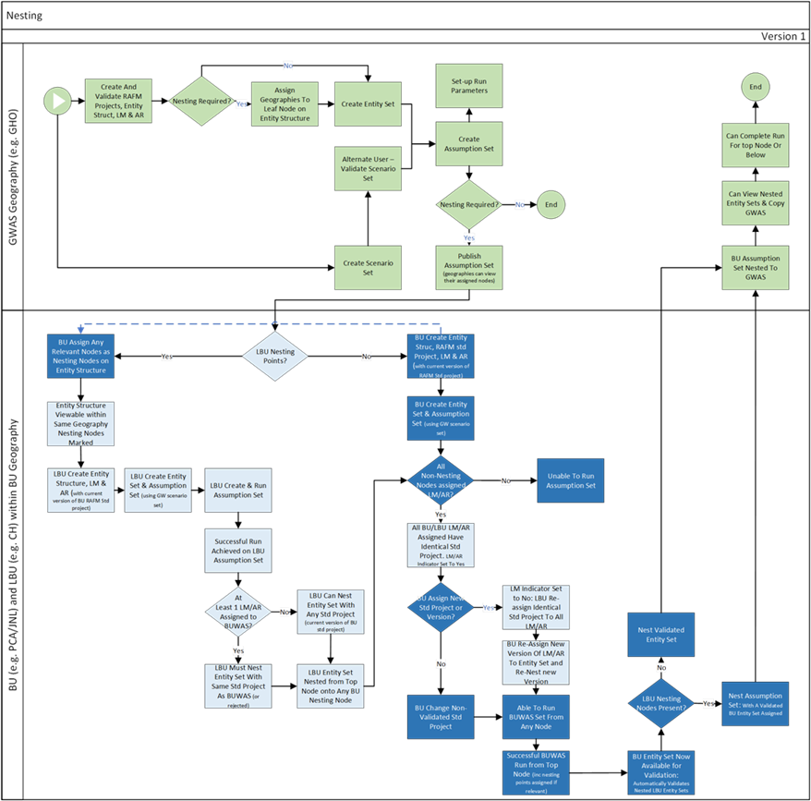

Figure 2.5.1: The nesting process



Figure 2.5.2: Levels of nesting

## 2.6 Run infrastructure

Run calculations are performed by Risk Agility FM, a software offering from Willis Towers Watson. It has been tailored for Prudential to enable simulation and aggregation of lite model results using RAFM projects. There are 2 environments in which a calculation run can be completed and each has its own structure and purpose. These are represented in figure 2.6 (Infrastructure components: RAFM Desktop and WTW vGrid). Please note, the ICM interface cannot interact directly with the RAFM desktop environment, but RAFM project and input files can be manually extracted from the ICM interface for use in the RAFM desktop environment..

An ICM run can only be performed from the ICM interface and can only be run on the WTW vGrid. A run from the RAFM desktop cannot integrate back into the ICM framework.

The RAFM Desktop environment allows a developer to build, test and generate project files/lite models. As RAFM project development is not conducted in the ICM interface, RAFM project development is outside the scope of this user guide.

When a run is submitted from the ICM interface, the ICM interface will initiate the RAFM Task Runner. This enables the run with no direct user-interaction with Risk Agility FM. The ICM supports multiple configurations of the Task Runner to maintain backward compatibility with older RAFM project versions. The Task Runner validates and submits data to vGrid and returns results to the ICM interface after the vGrid run is complete. All RAFM functionality is managed via the ICM interface. The functionality management includes:

1. The ICM workflow prepares a set of files in a predetermined directory structure which are required for the calculation and places these files in a working directory which is accessible to the RAFM TaskRunner;
2. The ICM workflow will call the RAFM Task Runner;
3. The RAFM Task Runner submits the files to the vGrid environment, using the parameters provided in the TaskRunner parameter file;
4. vGrid performs all the calculations as determined by the run parameters;
5. RAFM Task Runner returns the vGrid outputs to the ICM interface as specified in the Run Parameter;
6. The RAFM Task Runner returns a value for the following:
   1. An exit code which can be used to determine whether the run has been fully completed (or if it failed).
   2. The results for the assumption set run (Please see Section 2.7 for the run and bases type);
7. The ICM workflow imports the vGrid outputs and run status into the underlying database and updates the assumption set status;
8. Assumption set run results are available to the user.



Figure 2.6: Run infrastructure

## 2.7 The full run process (balance sheet requirement)

The business completes 3 different runs; main stochastic, critical scenario and big bang. Each of these runs are performed where relevant for Base, Projection and What-if. Each set of runs will follow the same bases and results of each are populated in the corresponding balance sheet. The 4 different runs are required for each bases in order to produce full balance sheet results. The business process is depicted in Figure 2.7.

Figure 2.7: The full run process

## 2.8 Entity set validation and nesting implications

The main aim for each reporting cycle is to produce results by the reporting deadline. The diagram in Figure 2.8 depicts the different phases that bring Prudential to this point. It captures the flexibility available for business units within the lite model development phase.

Once Group have produced, published and notified their Group Wide Assumption Set (GWAS) details, business units are able to nest and complete runs from their node downward on the GWAS. This provides BU with the ability to gain early sight of their results as they would materialise from running on the GWAS (circumstantial to grid management).

Running from the GWAS is optional and business units may choose to run from their own assumption set instead or as well as. All business units must have validated their entity sets and must have nested them by the business unit delivery date, to enable Group to meet their Group delivery date deadline.



Figure 2.8 Entity set validation and nesting implications

Figure 2.8 reference number notes:

A – Entity set must be tested using a locally created assumption set, from the node the geography of interest has access to.

B – Testing the group wide assumption set can only be achieved once all BUs have nested into the GWAS. It is mandatory for Group to complete this at this stage, however it may help in identifying early issues within the testing phase helping to meet the critical dates on time if done earlier in the process.

C to D are optional and although the functionality exists, in reality this will occur less frequently

E to H are mandatory and date critical to enable a final set of validated group wide results to be produced by the target date.

## 2.9 Validation and lockdown process

The validation process refers to entity sets and their assigned components. The purpose of validating an entity set is to confirm that the data held within has been validated and approved, also to provide Group with access to the underlying component versions as used within the context of the assumption set.

The lockdown process refers to the assumption set. The purpose of locking down an assumption set is for regulatory reasons if reporting externally (it enables specific runs to be tied to a version of an assumption set that can no longer be modified).

If the results are for internal use only, the assumption set can be locked down to help the team manage data but this is not a mandatory requirement. The diagram in Figure 2.9 aims to provide an overview of the order of events that are required in order to validate an entity set and/or lockdown an assumption set.

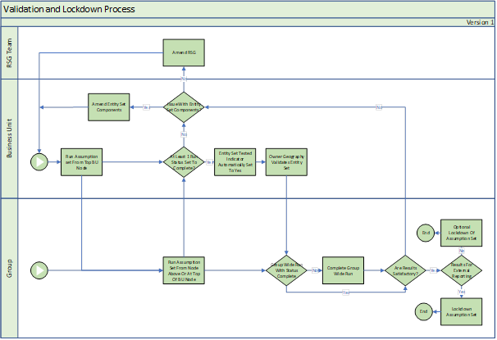

Figure 2.9: Validation and lock down process

Chapter 3

General navigation

**Chapter objectives**

*By the end of this chapter you will have:*

* ***learned how to identify the various sections of the ICM interface***
* ***developed an understanding of where to find key menu commands for each specific component as below:***

3.3.1 RAFM Projects

3.3.2 Entity Structure

3.3.3 Lite Models

3.3.4 Aggregation Rules

3.3.5 Entity Sets

3.3.6 RSG Generation

3.3.7 Scenario Sets

3.3.8 Assumption Sets

3.3.9 Bulk Run Profiles – BRP manager only

3.3.10 System Administration

* ***know where to apply the commands in the component walkthrough chapters, using this section as reference where necessary***

# 

# 3. General navigation

## 3.1 Introduction

The ICM interface is a web-based interface with up to 10 tabs available to a user.

The number of tabs visible to any user is defined by the access permissions based on the user’s role. For the purpose of this user guide, the ‘User Management’ tab will be excluded from discussion as will some sections of the ‘System Administration’ tab as they are only available to Support staff and not intended for use by business users.

Alongside tabs, users will also be restricted to views of data according to their geographical permission unless specific components have been shared with them.

The following subsections provide an overview of what the various menu items in the interface are, on a ‘per tab’ basis. Some menus are consistent across tabs and where there are obvious differences, this will be highlighted.

For more detail on the functionality of the menu items, users should refer to the specific section of that component.

## 3.2 Overview of key tabs

|  |  |  |
| --- | --- | --- |
| **Tab name** | **Description** | **Users** |
| * **RAFM projects** | * Allows the user to create and maintain Base Engines, Standard ICM RAFM Projects and Merged ICM RAFM Projects * Must be created prior to creation of any dependent component | Selected users from GHO Risk Modelling Team, BUs |
| * **Entity structure** | - Used for uploading the structure of the BU or Group  - Can be created at any time prior to the creation of the entity set | BUs |
| * **Lite models** | - Allows the user to create their lite models on the interface by uploading required components  - Also includes a bulk upload option- Can be created at any time prior to the creation of the entity set and the associated ICM RAFM standard project | BUs |
| * **Aggregation rules** | - Allows the user to create their aggregation rules by uploading required components  - Also includes a bulk option  - Can be created at any time prior to the creation of the entity set and the associated ICM RAFM standard project | BUs |
| * **Entity sets** | - Combines the entity structure, lite models and aggregation rules into one component ready for use in an assumption set  - Includes a bulk validation option  - Must be created after its constituent components but prior to the creation of the assumption set | BUs |
| * **RSG Instructions** | - Allows the user to upload translator data and join translator data in a scenario assumption set. This function replaces the need to manually upload files. | GHO RSG team, BUs |
| * **Scenario sets** | - Uses the Scenario Assumption Set attached to the interface to generate real time output for use by assumption sets  - Must be created after the associated ICM RAFM base engine has been created | GHO RSG team, BUs |
| * **Assumption sets** | - Combines the entity set with the scenario set to generate a run based on specific run parameters  - Allows the user to keep track of loaded and/or processed run components and their versions through manifest files | BUs |
| * **Bulk run profiles** | - Allows the user to create various sets of pre-defined run-time settings which is applicable to any valid assumption sets | BUs |
| * **System administration** | - Allows the user to monitor runs and environment usage as well as administer tags where permissions have been issued | App Support, BUs |

## 

## 3.3 Menu navigation

A summary of the various menu functions can be found in the table below, followed by detailed screen captures within each relevant tab.

**Key:** RAFM – RAFM Project; EST– entity structure; LM – lite model; AR – aggregation rule; ESS – entity set; RSG – RSG Instructions; SS – scenario set; AS – assumption set; BRP – bulk run profile

|  |  |  |  |  |  |  |  |  |  |  |
| --- | --- | --- | --- | --- | --- | --- | --- | --- | --- | --- |
| Menu | Sub menu | RAFM | EST | LM | AR | ESS | RSG | SS | AS | BRP |
| Maintenance | Create |  |  |  |  |  |  |  |  |  |
| Modify |  |  |  |  |  |  |  |  |  |
| Rename |  |  |  |  |  |  |  |  |  |
| Copy |  |  |  |  |  |  |  |  |  |
| Delete |  |  |  |  |  |  |  |  |  |
| Share |  |  |  |  |  |  |  |  |  |
| Same as |  |  |  |  |  |  |  |  |  |
| Enable |  |  |  |  |  |  |  |  |  |
| Disable |  |  |  |  |  |  |  |  |  |
| Download | Download tree file |  |  |  |  |  |  |  |  |  |
| Download validation report |  |  |  |  |  |  |  |  |  |
| Download events |  |  |  |  |  |  |  |  |  |
| Download general parameter file |  |  |  |  |  |  |  |  |  |
| Download experience parameter file |  |  |  |  |  |  |  |  |  |
| Download parameter file |  |  |  |  |  |  |  |  |  |
| RSG validation reports ('runs' table,  'download') |  |  |  |  |  |  |  |  |  |
| RSG validation sample ('runs' table,  'download') |  |  |  |  |  |  |  |  |  |
| RSG Results Report (‘runs’ table, ‘download’) |  |  |  |  |  |  |  |  |  |
| Download lock down/sign-off report |  |  |  |  |  |  |  |  |  |
| Download pre-run manifest |  |  |  |  |  |  |  |  |  |
| Download RSG Results Report |  |  |  |  |  |  |  |  |  |
| Download project file |  |  |  |  |  |  |  |  |  |
| Download RSG |  |  |  |  |  |  |  |  |  |
| Download RAFM Projects |  |  |  |  |  |  |  |  |  |
| Reports ('runs' table, 'download') |  |  |  |  |  |  |  |  |  |
| Stochastic Extraction Reports ('runs' table,  'download') |  |  |  |  |  |  |  |  |  |
| Run logs ('runs' table, 'download') |  |  |  |  |  |  |  |  |  |
| Run Manifest ('runs' table, 'download') |  |  |  |  |  |  |  |  |  |
| Risk Limits ('runs' table, 'download') |  |  |  |  |  |  |  |  |  |
| BU Reports ('runs' table, 'download') |  |  |  |  |  |  |  |  |  |
| Export |  |  |  |  |  |  |  |  |  |
| Export RAFM Project |  |  |  |  |  |  |  |  |  |
| Reports ('details' table, 'run' tab) |  |  |  |  |  |  |  |  |  |
| Run manifest ('details' table, 'run' tab) |  |  |  |  |  |  |  |  |  |
| Validation | Validate |  |  |  |  |  |  |  |  |  |
| Reject |  |  |  |  |  |  |  |  |  |
| Submit |  |  |  |  |  |  |  |  |  |
| Lock down |  |  |  |  |  |  |  |  |  |
| Mark runs |  |  |  |  |  |  |  |  |  |
| Calculation | Generate RSG |  |  |  |  |  |  |  |  |  |
| Trigger validation run |  |  |  |  |  |  |  |  |  |
| Bulk upload | Create |  |  |  |  |  |  |  |  |  |
| Modify |  |  |  |  |  |  |  |  |  |
| Download results |  |  |  |  |  |  |  |  |  |
| Bulk assign |  |  |  |  |  |  |  |  |  |
| Filters | Enable filters |  |  |  |  |  |  |  |  |  |
| Select Filters |  |  |  |  |  |  |  |  |  |
| Upload reports | Click button ('details' table, 'run' tab) |  |  |  |  |  |  |  |  |  |
| RAFM Project | Assign merged project |  |  |  |  |  |  |  |  |  |
| Unassign merged project |  |  |  |  |  |  |  |  |  |
| Run menu | Assign Entity Set |  |  |  |  |  |  |  |  |  |
| Assign Assumption Set |  |  |  |  |  |  |  |  |  |
| Unassign Entity Set |  |  |  |  |  |  |  |  |  |
| Run |  |  |  |  |  |  |  |  |  |
| Run Profile |  |  |  |  |  |  |  |  |  |
| Export RAFM Project |  |  |  |  |  |  |  |  |  |

Additionally, all summary tables displaying the components can be customised. This is valid across all tabs from entity structure to assumption set.

The customisation is as below:

|  |  |  |  |
| --- | --- | --- | --- |
| **Summary table display options** | Each column in the summary table has 2 further options, displayed by clicking the arrow next to the column name:  1. Sorting by ‘ascending’ or ‘descending’ – a good column to filter by ‘descending’ is the ‘Last modified system date’ as it allows users to instantly see the most recent items within that table first  2. Customising which properties are displayed via a tick-box selection  Note that dragging the columns horizontally also allows the user to re-arrange how they are ordered in the summary window for their own convenience.  An example is shown below for the ‘entity structure’ tab:    Re-arranging columns (click and drag): |  |  |

### 3.3.1 RAFM projects

1. On initial tab selection, the default screen displays the list of RAFM projects available in the system, with four drop-down menu options highlighted below:

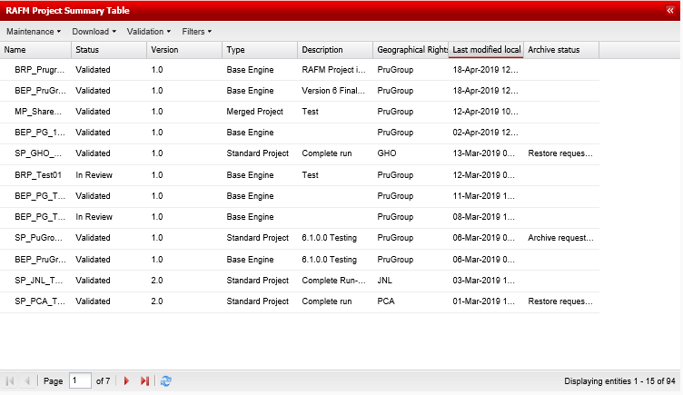

The table displays the properties of each RAFM project such as ‘Name’, ‘Status’ etc.

Please note: each RAFM project has its own row in the summary table, as such entries are not nested below the latest version of the project associated with a specific Name as is the case with other components.

2. Clicking a specific RAFM project reveals further details in the right hand pane (Properties for). This includes the geography, base engine, RAFM project file, RAFM project software version, status and tag.

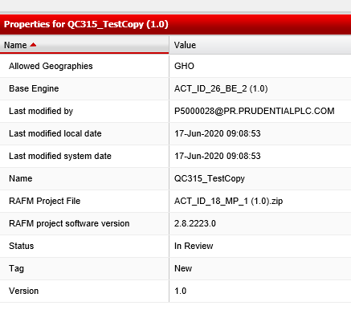

3. The four menu options are detailed below with the actions they contain:

|  |  |  |  |
| --- | --- | --- | --- |
| **Maintenance** | >> Create  >> Modify  >> Delete (only available if not assigned to a lite model or aggregation rule)  >> Share (only available to users from an allowed geography)  >> Copy |  |  |
| **Download** | >> Download project file |  |  |
| **Validation** | >> Validate |  |  |
| **Filters** | >> Enable filters (tick box)  >> Select filters (pop–up with various options – use ‘*’ for catch-all functionality) |  |  |

4. The ‘Details for Table’ has 6 tabs (as illustrated below) and shows the events/usage associated with versions of the RAFM project and its relationship with other ICM components (such as lite models).

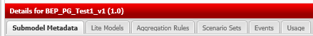

4a. The code base metadata table provides the detail of any metadata associated with the RAFM base engine/standard/merged project. Metadata is associated with a engine/project via the engine/project components when the components are being created. E.g. a lite model’s code base.

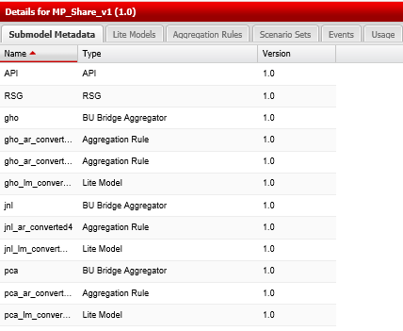

4b. The lite models table provides the detail of any lite model code base associated (linked to the lite model during creation of the lite model) with the RAFM standard/merged project. A link is also available to take the user direct to the lite model for review purposes.

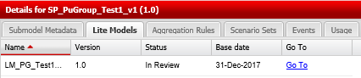

4c. The aggregation rule table provides the detail of any aggregation rule associated (linked to the aggregation rule during creation of the aggregtaion rule) with the RAFM standard/merged project. A link is also available to take the user direct to the aggregation rule for review purposes.

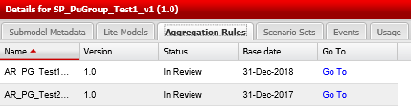

4d. The scenario sets table provides the detail of any scenario set associated (linked to the scenario set during creation of the scenario set) with the RAFM base engine. A link is not available to take the user direct to the base engine.

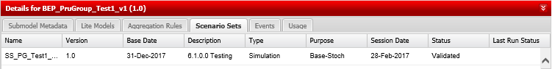

4e. The events table provides the same information for every component in the system and will be available for every such tab (lite models, aggregation rules, entity sets, asset portfolios, scenario sets and assumption sets).

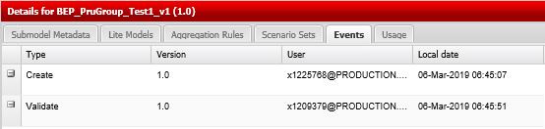

4f. The usage table provides details of each instance where the selected RAFM project was used as a component of a ICM run. The detail is maintained under the Name of the assumption set which ran.

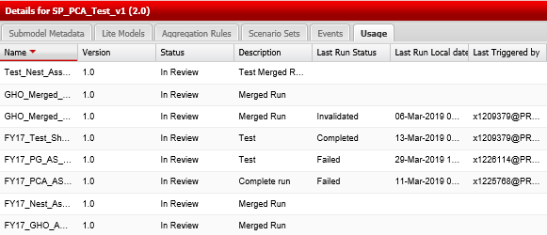

### 3.3.2 Entity structure

1. On initial tab selection, the default screen displays the list of entity structures available in the system, with four drop-down menu options highlighted below:



The table displays the properties of each entity structure such as ‘Name’, ‘Base Date’ etc. Note that clicking the arrow next to an entry in the table will reveal further versions of the entity structure.

2. Clicking a specific entity structure reveals further details in the right hand pane. This includes the actual tree (entity structure), which can be expanded or collapsed and a list of the properties in table format.



3. The four menu options are detailed below with the actions they contain:

|  |  |  |  |
| --- | --- | --- | --- |
| **Maintenance** | >> Create  >> Modify  >> Rename  >> Copy  >> Delete (only available if not assigned to a nested entity set, and does not have marked nodes which are nested onto )  >> Share (only available to users from an allowed geography, and where there are no marked ‘nesting nodes’) |  | 9 |
| **Download** | >> Download tree file  >> Download validation report (only available for validated components)  >> Download events |  |  |
| **Validation** | >> Validate  >> Reject  >> Submit (to an entity set) |  |  |
| **Filters** | >> Enable filters (tick box)  >> Select filters (pop–up with various options – use ‘*’ for catch-all functionality) |  |  |

1. The ‘Details Table’ has 2 tabs and shows the events associated with versions of the entity structure and its usage in assumption set versions.



The events table provides the same information for every component in the system and will be available for every such tab (lite models, aggregation rules, entity sets, asset portfolios, scenario sets and assumption sets).



### 3.3.3 Lite models

1. On initial tab selection, the default screen displays the list of lite models available in the system, with five drop-down menu options highlighted below:

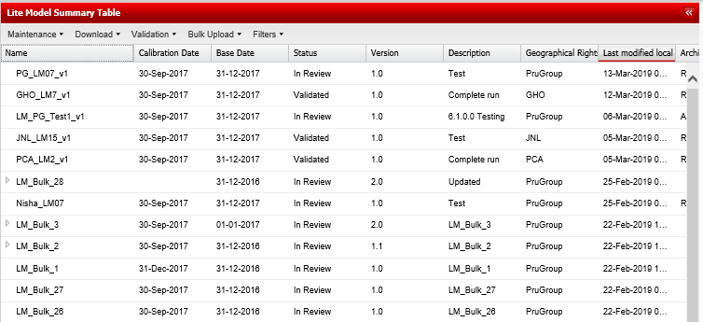

The table displays the properties of each lite model such as ‘Name’, ‘Calibration Date’ etc. Note that lite models can be ordered according to their properties by clicking on the header row of the appropriate column.

Clicking a specific lite model reveals further details in the right hand panes. This includes the C++ code, which cannot be modified in-screen (the modify button available in earlier ICM releases has been removed) and a list of the properties in table format.

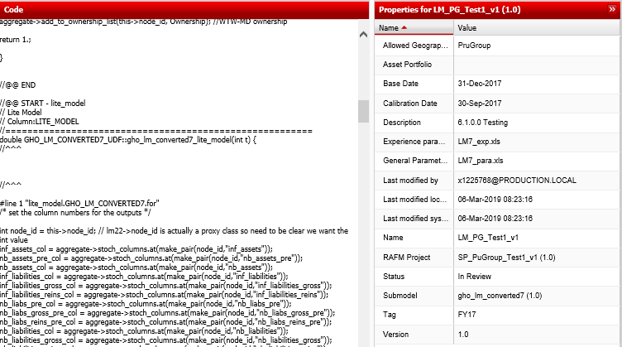

The five menu options are detailed below with the actions they contain:

|  |  |  |  |
| --- | --- | --- | --- |
| **Maintenance** | >> Create  >> Modify  >> Rename  >> Copy  >> Delete (only available if not assigned to an entity set)  >> Share (only available to users from an allowed geography) |  |  |
| **Download** | >> Download general parameters file  >> Download experience parameters file  >> Download validation report (only for validated components)  >> Download events |  |  |
| **Validation** | >> Validate (requires valid run completion and asset portfolio to be validated, if relevant)  >> Reject |  |  |
| **Bulk Upload** | >> Create (requires RAFM project/version, 1 x csv and 1 x zip file)  >> Modify (requires RAFM project/version, 1 x csv and 1 x zip file)  >> Download results (provides results of above operations for both creation and modification of lite models) |  |  |
| **Filters** | >> Enable filters (tick box)  >> Select filters (pop–up with various options – use ‘*’ for catch-all functionality) |  |  |

4. For further information on the ‘Details Table’, please refer to section 3.3.1 on the entity structure tab.

### 3.3.4 Aggregation rules

1. On initial tab selection, the default screen displays the list of aggregation rules available in the system, with five drop-down menu options highlighted below:

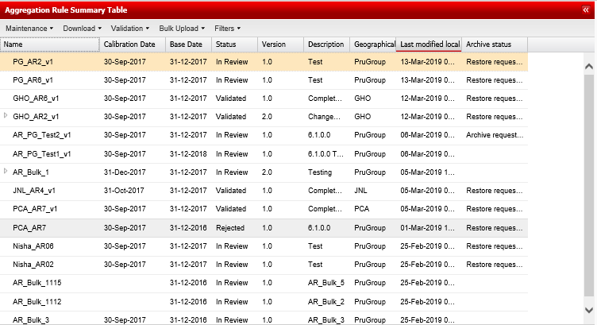

The table displays the properties of each aggregation rule such as ‘Name’, ‘Calibration Date’ etc. Note that aggregation rules can be ordered according to their properties by clicking on the header row of the appropriate column.

2. Clicking a specific aggregation rule reveals further details in the right hand pane. This includes the C++ code, which cannot be modified in-screen (the modify button available in earlier ICM releases has been removed) and a list of the properties in table format.

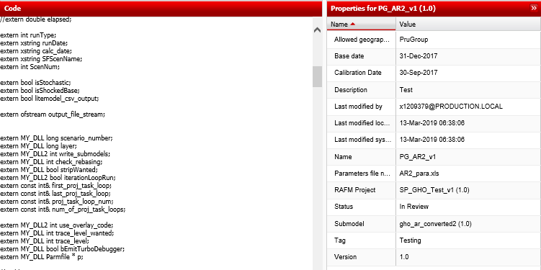

3. The five menu options are detailed below with the actions they contain:

|  |  |  |  |
| --- | --- | --- | --- |
| **Maintenance** | >> Create  >> Modify  >> Rename  >> Copy  >> Delete (only available if not assigned to an entity set)  >> Share (only available to users from an allowed geography) |  |  |
| **Download** | >> Download parameters file  >> Download validation report (only for validated components)  >> Download events |  |  |
| **Validation** | >> Validate (requires valid run completion and asset portfolio to be validated, if relevant)  >> Reject |  |  |
| **Bulk Upload** | >> Create (requires RAFM project, 1 x csv and 1 x zip file)  >> Modify (requires RAFM project, 1 x csv and 1 x zip file)  >> Download results (provides results of above operations due to no error break during live progress) |  |  |
| **Filters** | >> Enable filters (tick box)  >> Select filters (pop–up with various options – use ‘*’ for catch-all functionality) |  |  |

4. For further information on the ‘Details Table’, please refer to section 3.3.1 on the entity structure tab.

### 3.3.5 Entity set

1. On initial tab selection, the default screen displays the list of entity sets available in the system, with five drop-down menu options highlighted below:



The table displays the properties of each entity set such as ‘Name’, ‘Base Date’ etc. Note that entity sets can be ordered according to their properties by clicking on the header row of the appropriate column.

2. Clicking a specific entity set reveals further details in the right hand pane. This includes the structure of the entity set to which lite models and aggregation rules can be attached and a list of the properties in table format.

**Note:** The tree is colour-coded based on the status of attached components:

Red – no component attached or leaf node is a nesting node

Orange – non-validated component attached

Green – validated component attached

Blue – validated entity set (all components validated)



3. The five menu options are detailed below with the actions they contain:

|  |  |  |  |
| --- | --- | --- | --- |
| **Maintenance** | >> Create  >> Modify  >> Rename  >> Copy  >> Delete (only available if not assigned to an assumption set)  >> Share (only available to users from an allowed geography) |  |  |
| **Validation** | >> Validate |  |  |
| **Download** | >> Download events |  |  |
| **Bulk Upload** | >> Assign (requires 1 x csv file)  >> Download results (provides results of above operation for lite models and aggregation rules (including errors and warnings)) |  |  |
| **Filters** | >> Enable filters (tick box)  >> Select filters (pop–up with various options – use ‘*’ for catch-all functionality) |  |  |

4. The ‘Details Table’ provides information on the lite models and aggregation rules attached to a specific version of an entity set. Additional information on the components is provided including the tested indicator and the validation status as well as which node they are attached to on the entity structure tree.

As with other sections, the ‘Usage’ tab provides an overview of which assumption sets make use of the selected entity set and their run status.

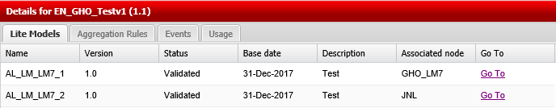

### 3.3.6 RSG Instructions

1. On initial tab selection, the default screen displays the list of translators or scenario assumption sets (depending which was accessed most recently) available in the system. The translator sub-tab has three drop-down menu options, the Scenario Assumption Set sub-tab has four. Each is highlighted below:

**Translator Sub-Tab**

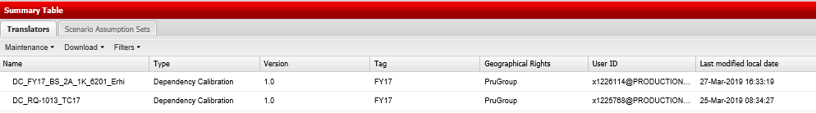

**Scenario Assumption Set Sub-tab**

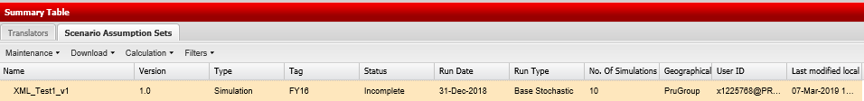

The summary table displays the properties of each ICM component, such as ‘Name’, ‘Type’, ‘Version’, ‘Tag’ etc.

2. The Details for pane is as follows:

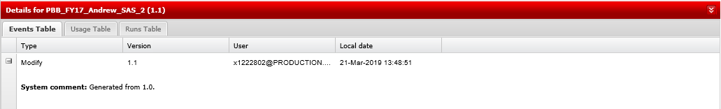

As with other sections, the ‘Usage’ and ‘Runs Table’ tabs provide an overview of which assumption sets make use of the selected component and their run status.

3. The Properties for pane is as follows:

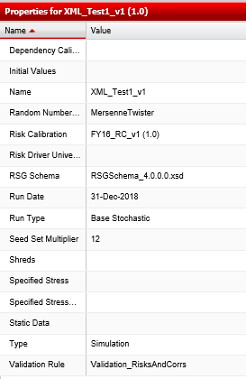

4. The menu options (for the translator) are detailed below with the actions they contain:

|  |  |  |  |
| --- | --- | --- | --- |
| **Maintenance** | >> Create  >> Modify |  |  |
| **Download** | >> Export |  |  |
| **Filters** | >> Enable filters (tick box)  >> Select filters (pop–up with various options – use ‘*’ for catch-all functionality) |  |  |

5. The menu options (for the Scenario Assumption Sets sub-tab) are detailed below with the actions they contain:

|  |  |  |  |
| --- | --- | --- | --- |
| **Maintenance** | >> Create  >> Modify |  |  |
| **Download** | >> Export  >> Download RSG |  |  |
| **Calculation** | >> Generate RSG |  |  |

|  |  |  |  |
| --- | --- | --- | --- |
| **Filters** | >> Enable filters (tick box)  >> Select filters (pop–up with various options – use ‘*’ for catch-all functionality) |  |  |

### 3.3.7 Scenario sets

1. On initial tab selection, the default screen displays the list of scenario sets available in the system, with five drop-down menu options highlighted below. Uniquely, this summary table has a tabbed feature which allows the user to view critical scenario sets separately.

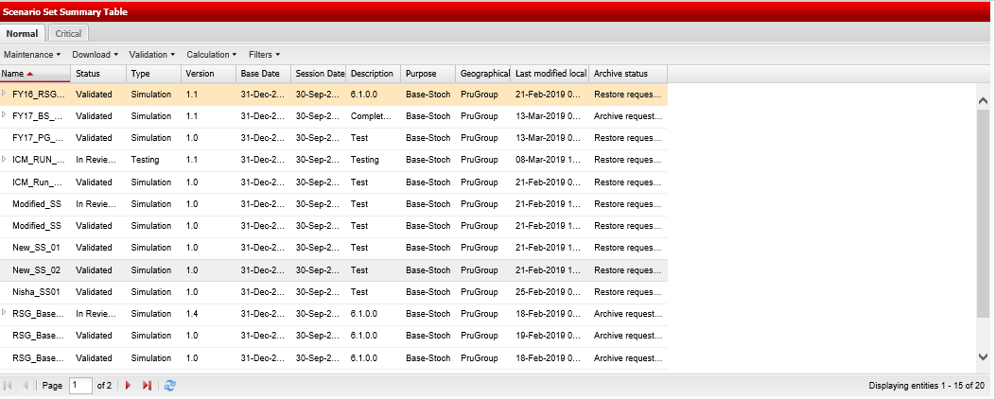

The table displays the properties of each scenario set such as ‘Name’, ‘Status’ etc. Note that scenario sets also include a ‘Details’ table that provides an overview of when they have been run and the outcome of that run.

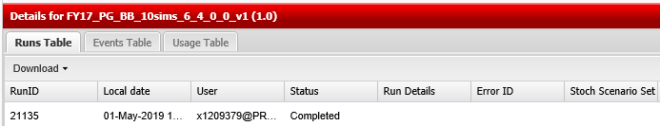

Of note in the details above is the populated ‘Status’. This indicates when a scenario set has run successfully

2. Clicking a specific scenario set reveals further details in the Properties for pane. This includes the scenario set’s Name as well as other parameters such as window details (shape, size and parameter) for a critical scenario set.

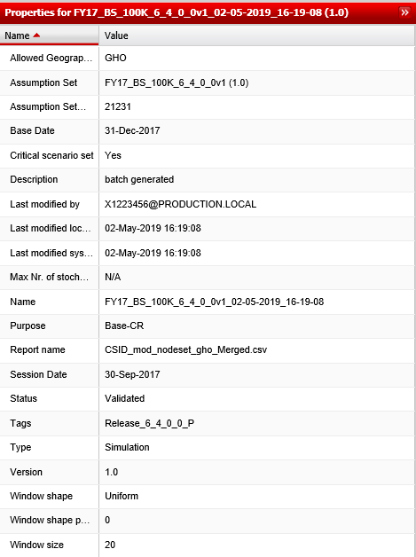

3. The five menu options are detailed below with the actions they contain:

|  |  |  |  |
| --- | --- | --- | --- |
| **Maintenance** | >> Create  >> Modify  >> Rename (only available if not assigned to an assumption set)  >> Delete (only available if not assigned to an assumption set)  >> Share (only available to users from an allowed geography) |  |  |
| **Download** | >> Download validation report (only for validated items)  >> Download events  >> Export RAFM Project |  |  |
| **Validation** | >> Validate  >> Reject |  |  |
| **Calculation** | >> Trigger validation run |  |  |
| **Filters** | >> Enable filters (tick box)  >> Select filters (pop–up with various options – use ‘*’ for catch-all functionality) |  |  |

### 3.3.8 Assumption sets

1. On initial tab selection, the default screen displays the list of assumption sets available in the system, with five drop-down menu options highlighted below.

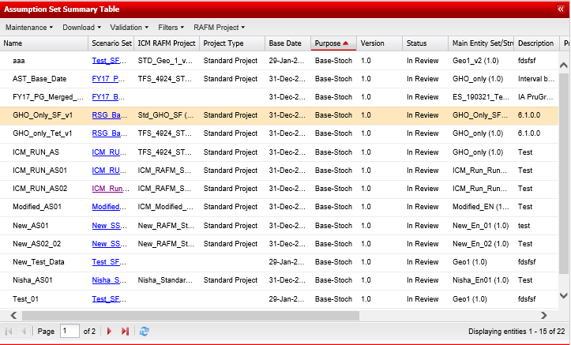

The table displays the properties of each assumption set such as ‘Name’, ‘Scenario Set’ etc. Of interest are usually the entity set, scenario set and RAFM project used for the assumption set as these are the three main data constituents of an assumption set with the rest being user-input parameters. Note that the scenario set detail is provided as a ‘clickable’ link that redirects the user directly the scenario set version (on the scenario set tab) that is attached to the assumption set.

2. The five menu options are detailed below with the actions they contain:

|  |  |  |  |
| --- | --- | --- | --- |
| **Maintenance** | >> Create  >> Modify  >> Rename  >> Copy  >> Same as  >> Delete (only if not run) |  |  |
| **Download** | >> Download lock down/sign off report  >> Download events  >> Download pre-run manifest  >> Download RAFM Projects |  |  |
| **Validation** | >> Lock down  >> Mark runs  >> Reject |  |  |
| **Filters** | >> Enable filters (tick box)  >> Select filters (pop–up with various options – use ‘*’ for catch-all functionality) |  |  |
| **RAFM Projects** | >> Assign merged project  >> Unassign merged project |  |  |

3. On clicking a selected assumption set, two additional tables are populated to the right of the summary table as below:

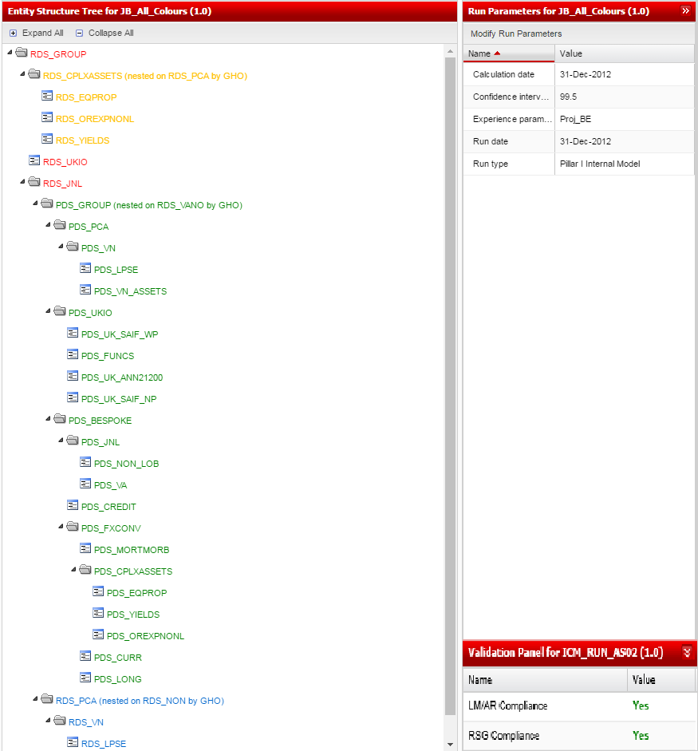

3a. The entity structure table displays the tree with the following colour conventions

Red – no component assigned

Orange – non-validated component assigned

Green – validated component assigned

Blue – validated entity set attached

In addition, the entity structure also allows runs to be launched from any node on the tree provided a component has been assigned to it. Relevant run options are ‘Run’ and ‘Batch Run’.

The options that vary depending on the type of run being performed are summarised in the table below:



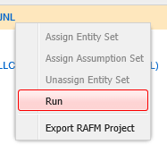

3a.1 On selecting the ‘Run’ option, the user is presented with a series of runtime parameters that have to be selected before triggering the actual run. The selection types are illustrated in the dialog box below:

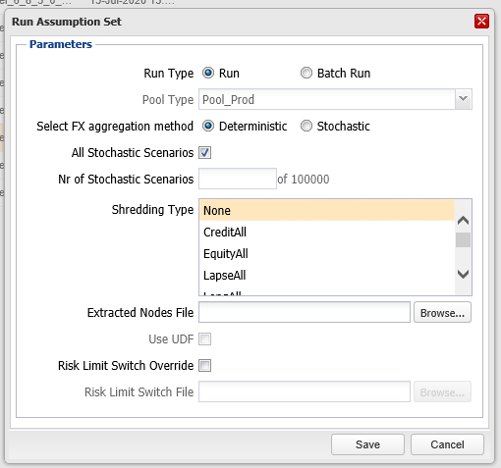

3a. 2 Alternatively, if the ‘Batch Run’ radio button is selected from ‘Run Type’ within the dialog box, the user will be presented with the below to initiate a batch run, with the option for 2-in-1 combined FX aggregation method, and/or critical scenario run.

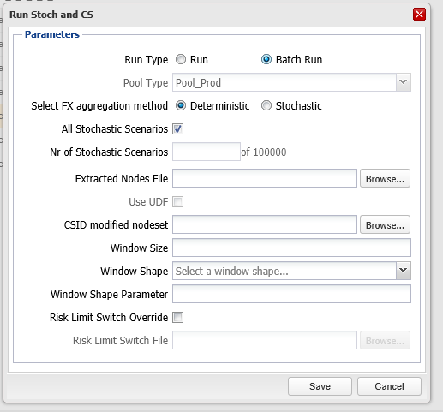

3a.3 If an available option under the ‘Run Profile’ submenu is selected, the user is presented with a list of runs under a bulk run profile and is able to modify runtime parameters of selected runs and also trigger any sub-selection of runs within the profile.

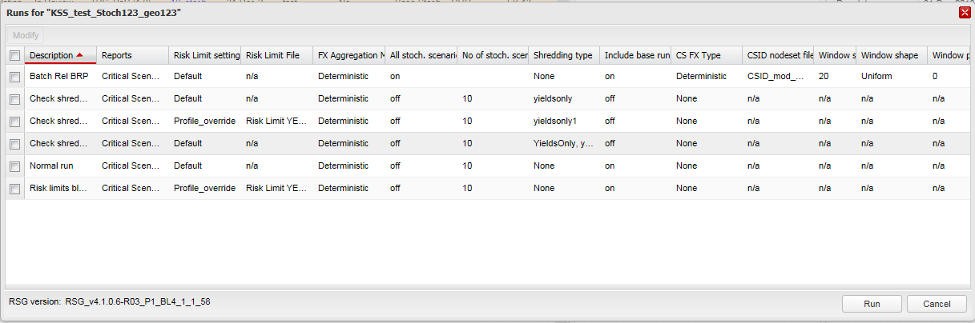

3b. The run parameters table is a relatively static set of parameters that accompany the assumption set. Modification of these parameters is not customary. Any variation of the assumption set run is usually achieved by modifying the runtime parameters as per section 3a. This has the added benefit of not invalidating any previously completed run.

4. The details table for a selected assumption set presents an additional 6 tabs displaying information as follows:

4a. Lite models – all lite model versions attached to the entity set. This also presents the option to select and validate or reject a specific lite model.



4b. Aggregation rules – all aggregation rule versions attached to the entity set. This also presents the option to select and validate a specific aggregation rule.

4c. Entity sets – all entity set versions attached to the assumption set including their status and associated node (where nested)

4d. Runs table – This provides a detailed overview of all runs triggered for that assumption set as well as their status as below:

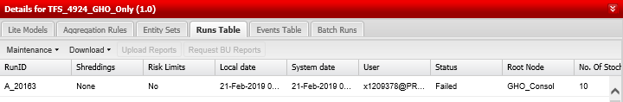

Each specific run has an additional sub-menu with five options displayed. These are detailed below.

|  |  |  |  |
| --- | --- | --- | --- |
| **Maintenance** | >> Cancel Run (only for runs in progress and only by the owner of the run |  |  |
| **Download** | >> Reports  >> Stochastic Extraction Reports  >> Run log  >> Run manifest  >> Risk Limits  >> BU Reports |  |  |
| **Upload Reports** | >> Clickable button opening a pop-up to browse for a report to upload. This is usually a trimmed down CSID_ST report retaining only nodes of interest for the generation of the critical scenario set. |  |  |
| **Request BU Reports** | >> PLACEHOLDER  >> PLACEHOLDER |  | PLACEHOLDER |

4e. Events table display the system and user actions on the assumption set selected

4f. The batch run table provides details of specific batches run (with a batch run ID) that ties the various constituent runs on a line by line basis. These constituent runs can also be accessed via clickable links as per the example below.

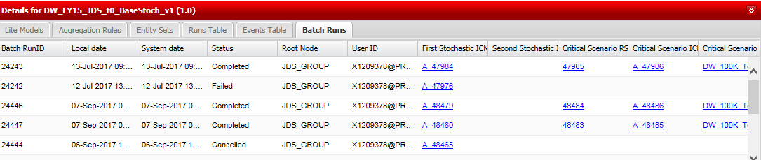

5. On clicking a selected assumption set, the ‘Validation Panel for’ pane is updated to reflect the validation results of lite models, aggregation rules and scenario set components associated with the assumption set.

The pane is illustrated below.

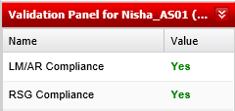

The ‘Value’ and its colour indicate the component’s status. The component status’ are described in the appendix (Section 14.4).

### 3.3.9 Bulk run profiles

1. On initial tab selection, the default screen displays the list of bulk run profiles available in the upper summary table (Bulk Run Profiles), with a single ‘Maintenance’ drop down menu as highlighted.

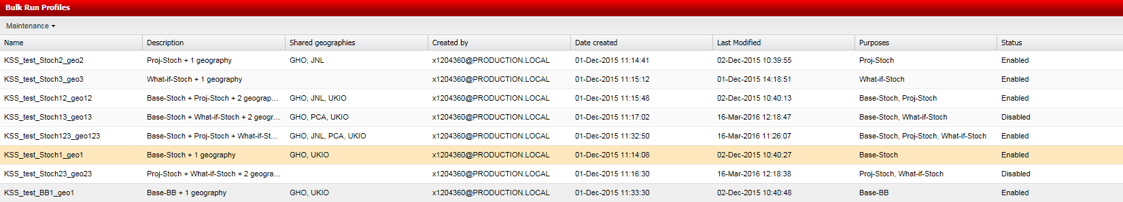

The table displays the properties of each bulk run profile – ‘Name’, ‘Description’ etc. Of interest are usually the ‘Purposes’, ‘Status’, and ‘Shared geographies’.

2. The menu options are detailed below with the actions they contain:

|  |  |  |  |
| --- | --- | --- | --- |
| **Maintenance** | >> Create  >> Modify  >> Delete  >> Share  >> Enable  >> Disable |  |  |

3. On selecting a bulk run profile, the Details for pane (Bulk Run Profile Details) is populated with a list of the runs attached to that profile. This also has a single ‘Maintenance’ drop-down menu.

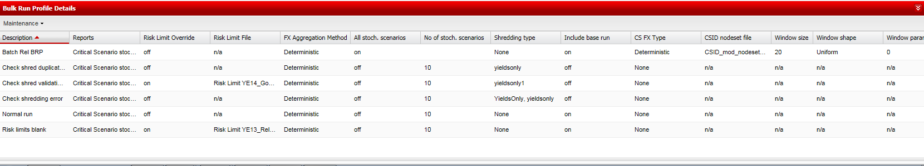

This table displays the runtime parameters of each run attached to the profile. Some of the parameters will not be relevant if the purpose of the bulk run profile is BB (BigBang).

4. The menu options are detailed below with the actions they contain:

|  |  |  |  |
| --- | --- | --- | --- |
| **Maintenance** | >> Create  >> Modify  >> Delete |  |  |

### 3.3.10 System administration

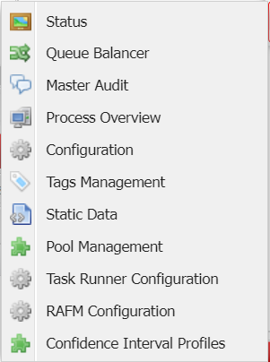

1. **Pool Management**. This presents the state of RAFM production pools at any particular point in time as below:

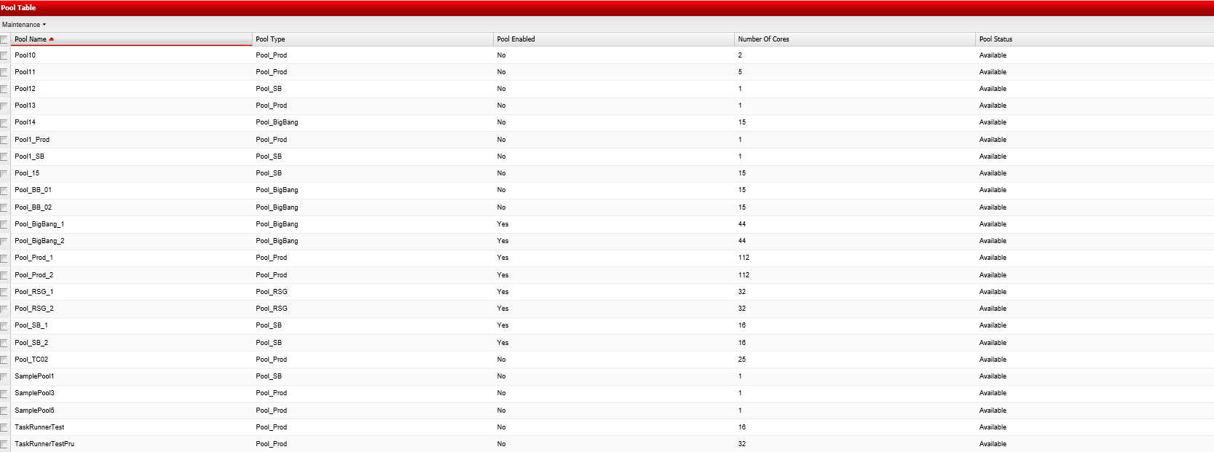

The ‘Maintenance’ menu offers authorised users the ability to create and control RAFM pools.

Users may select one or more pools for an operation at a particular time by making use of the checkbox option next to the sandbox name.

|  |  |  |  |
| --- | --- | --- | --- |
| **Maintenance** | >> Create  >> Modify  >> Enable  >> Disable  >> Delete |  |  |

2. **Process overview** table displays the list of assumption set and scenario set runs along with their status and other essential details.

It includes an activity events table that provides further details on the progress of any runs and has a sub menu which permits the download of run logs and post manifest files as highlighted below.

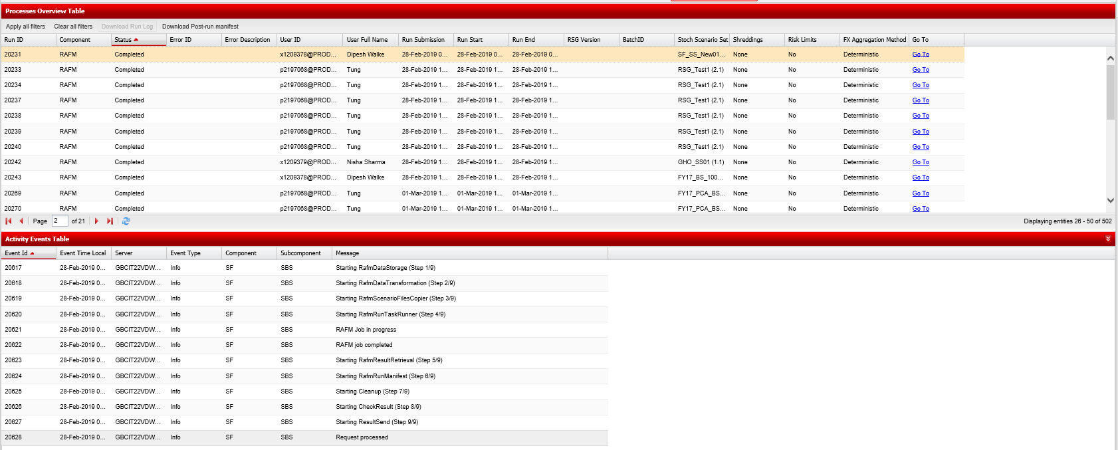

3. **Queue balancer** provides an overview of runs in progress on the interface and these can be split in terms of environments, the relevant ones being RAFM, Post-processing and RSG.

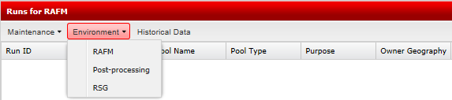

The ‘Maintenance’ menu allows authorised users to change run queuing position or cancel a specific run.

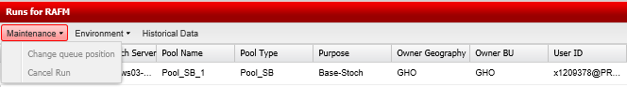

Additionally, the queue balancer has a ‘Historical Data’ feature that allows authorised users (usually system administrators) to pull up data on any relevant environment between two specific dates and either display that data on screen or download it to their local drive in pdf, xls or csv format. An example is shown below.

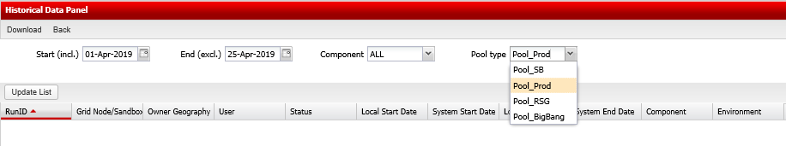



4. **Tag management** – this allows authorised users (system administrators who have access to the PruGroup geography) to define prescriptive tags that can be used by the BUs and GHO. Additionally users may also elect to create descriptive tags to further compartmentalise their work.

|  |  |  |  |
| --- | --- | --- | --- |
| **Maintenance** | >> Create  >> Modify  >> Delete |  |  |
| **Download** | >> Download usage |  |

5. **Static Data** – this allows authorised users (system administrators static data import permission) to view the static data, export static data and to import new static data into the ICM.

The static data table displays the list of static data sets and other essential details, such as ICM name and ICM tag associated with the data so it may be selected when creating and running a scenario assumption set.

The static data table includes an events and usage tables that provides further details on the progress of any imports and where the selected static data has been used by a scenario assumption set.

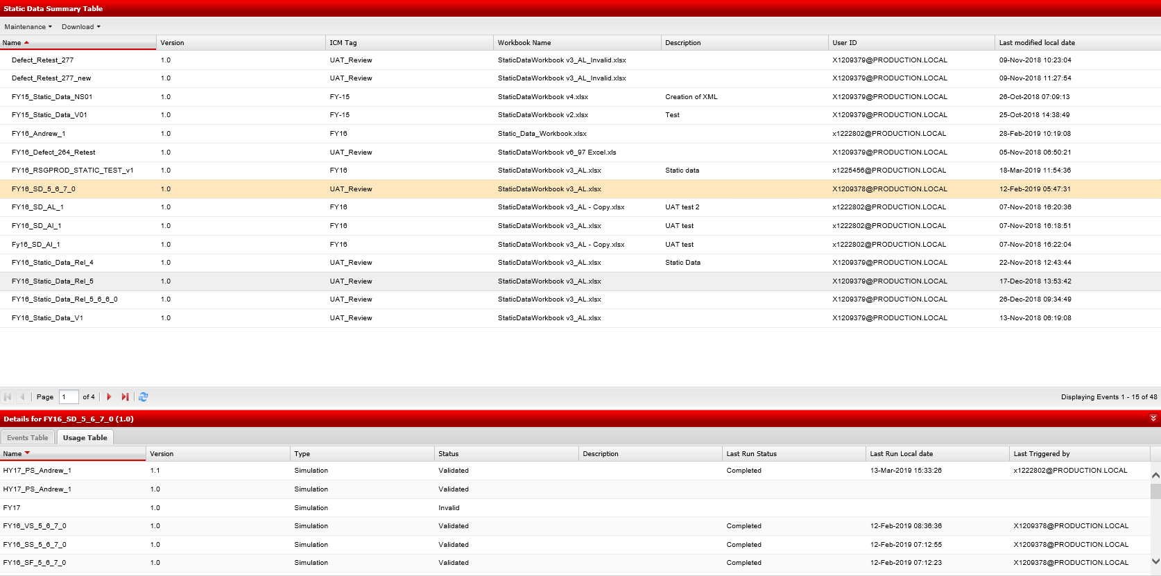

The static data table has two sub menus which permits the import (create) and export (download) of static data files as highlighted below

|  |  |  |  |
| --- | --- | --- | --- |
| **Maintenance** | >> Create |  |  |
| **Download** | >> Export |  |  |

6. **Task Runner Configuration** – this allows authorised users (with RAFM and Task Runner Configuration Manager permissions at PruGroup level only) to view the supported Task Runner configurations, and also to create new configurations, or to modify or delete existing ones. Users may also download the template Task Runner file from an existing configuration.

The Task Runner Configuration Summary Table displays the list of configuration versions, along with the location of the Task Runner executable and template file name for each version. This information is mapped against a RAFM configuration for supported versions of RAFM projects.

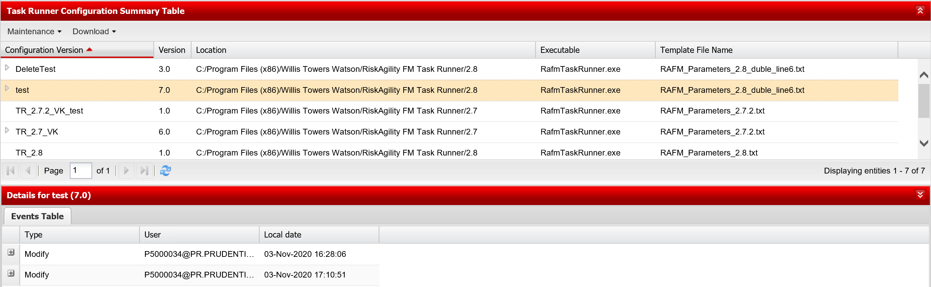

|  |  |  |  |
| --- | --- | --- | --- |
| **Maintenance** | >> Create  >> Modify  >> Delete |  |  |
| **Download** | >> Download Template File |  |  |

7. **RAFM** **Configuration** – this allows authorised users (with RAFM and Task Runner Configuration Manager permission at PruGroup level only) to view the supported RAFM versions. From this page, users may create new RAFM configurations to support particular versions of RAFM projects, and modify or delete existing RAFM configurations.

The RAFM Configuration Summary Table displays the list of supported RAFM version numbers Each version of a RAFM configuration is mapped against a particular Task Runner configuration version. The ICM uses this information to determine which Task Runner executable and template file should be used with Scenario Sets or Assumption Sets at runtime, depending on the version of the underlying RAFM project for a given run.

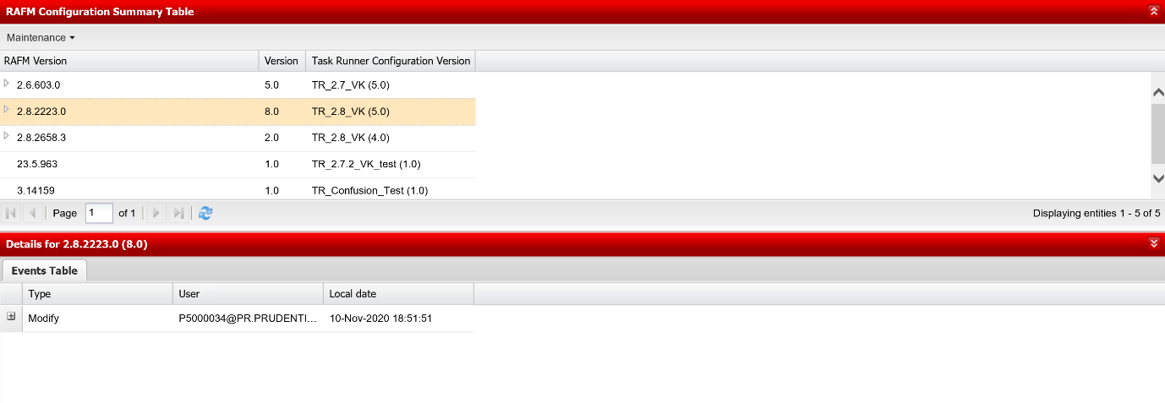

|  |  |  |  |
| --- | --- | --- | --- |
| **Maintenance** | >> Create  >> Modify  >> Delete |  |  |

8. **Confidence Interval Profiles** – this allows authorised users to view the confidence interval level profiles, and also to create new profiles, or to publish and unpublish existing ones, and filter the profiles. Once a profile is published it can be selected for use in runs for all geographies. The current list of profiles will be shown and whether they are published or unpublished. If you unpublish a profile, assumption set runs already using it remain unaffected, but you cannot run additional runs in that assumption set.

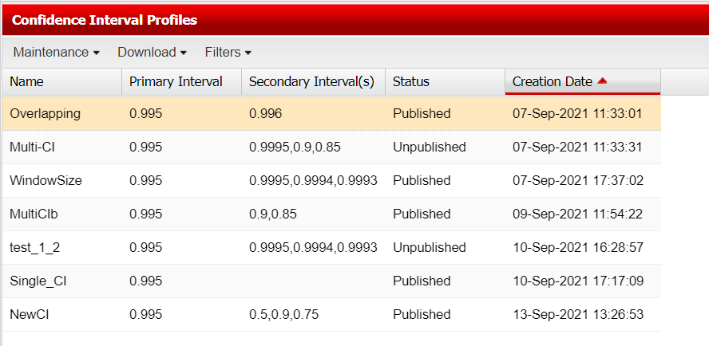

Confidence interval profiles can be created by uploading a csv file with the headers “Confidence Interval” and “Primary” in, as shown below.

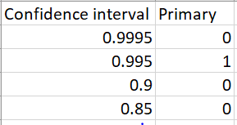

The menu options for the Confidence Interval Profiles are shown below.

|  |  |  |  |
| --- | --- | --- | --- |
| **Maintenance** | >> Create  >> Publish  >> Unpublish |  |  |
| **Download**  **Filter** | >> Download  >> Enable Filter  >> Select Filter |  |  |

Chapter 4

RAFM projects

# 4. RAFM projects

 Learning objectives**

***By the end of lesson you will have:***

***Learned what RAFM projects are, in the context of the ICM interface, and, how they are created and maintained and used by the ICM.***

***Developed an understanding of how to use RAFM projects and their interaction with other ICM components and their various workflows.***

***Worked through the following use cases:***

**4.3.1** Create an ICM RAFM base engine project

**4.3.2** Create a standard ICM RAFM project

**4.3.3** Create a merged ICM RAFM project

**4.3.4** Modify a RAFM project

**4.3.5** Delete a RAFM project

**4.3.6** Share a RAFM project

**4.3.7** Copy a RAFM project

**4.3.8** Download a RAFM project (project file)

**4.3.9** Validate a RAFM project

## 4.1 Introduction

* **What is a RAFM project?**

ICM RAFM Projects are developed locally within the RAFM application. Development allows a user to write modelling code, set parameters, define model runs with the aim of producing specific output. RAFM projects must be imported into ICM before being associated with other ICM components such as lite models, aggregation rules and scenario sets.

The ICM RAFM project on the ICM enable RAFM project storage and versioning of the code base used by the RAFM application when processing an ICM run.

The RAFM projects are categorised into three ICM RAFM project types:

1. Base engine project (only specific GHO users can create and share this type)
2. Standard ICM RAFM project
3. Merged ICM RAFM project (only specific GHO users can assign this type)

A base engine project is core functionality and is the first building block of any Standard RAFM project. The purpose of this type of project is to generate the scenario data that will be assigned to and used by a RAFM standard project and if applicable, a RAFM merged project. The RSG team must share a base engine project with other geographies so that it may be embedded into their standard RAFM project.

The base engine project code enables the creation of an ICM scenario set component which is activated when processing an ‘RSG Standalone run’.

The standard ICM RAFM project contains a base engine project, and the lite model and aggregation rule code necessary to perform the calculation of the required calibrations. This Standard RAFM project type is relevant for single geographies (GHO or PCA).

The merged ICM RAFM project consolidates standard RAFM projects for all geographies with their associated base engine. Merged RAFM project code enables a similar range of interaction as the standard ICM RAFM project but in the context of a GWAS. Prior to a merged project being created, a suitable GWAS must exist and be published to the single geographies by GHO. When the GWAS is published, single geographies can nest their entity sets or assumption sets, where relevant. GHO may then create a merged project once all entity sets and assumption sets have been nested for the GWAS.

Below is an illustration of ICM RAFM projects components:



Figure 4.1. ICM RAFM Project Components

* **Business context**

1. An ICM RAFM project holds all project files, executable files and code files. The code files are also known as code bases. The various types of code bases are: Lite model;
2. Aggregation rule;
3. Bridge aggregators;
4. RSG; and
5. API.

Code bases are developed in the RAFM application and along with executable files are imported into the ICM prior to being associated with other ICM components and run as part of an assumption set.

When a change is required to the code bases, the ICM RAFM projects can be downloaded from the ICM and imported into the RAFM application prior to making development updates. Post development, updated ICM RAFM projects are imported back into the ICM as a complete RAFM project package (.zip file format).

As changes occur in the conceptual business model, these projects will change and will need to be updated.

The examples below illustrate some of the reasons why the business may need to update ICM RAFM projects to reflect changes in the project code base:

* Where development changes are required in the lite model and aggregation rule code to reflect business requirements;
* Where risk models usage has changed;
* Where a change is required to reflect updated scenario data requirements, such as a change in the risk driver universe.
* **Key components and processes in the ICM interface**



Figure 4.1.2: RAFM Projects

* **Working with RAFM projects**

For RAFM projects the ICM interface will allow users to undertake the following tasks:

View and create ICM RAFM Projects

* View a list of available ICM RAFM projects in the summary table
* Create ICM RAFM projects by uploading a project package
* View associated ICM RAFM project associated components (Details for Table)

ICM RAFM Project Management

(Modify, Delete, Share and Copy)

* Modify and copy ICM RAFM projects, creating new versions
* Delete ‘In Review’ base engine RAFM projects or ‘Standard ICM RAFM projects not assigned to LM/AR and not run on an assumption set or Merged projects not assigned to an assumption set
* Share validated ICM RAFM projects

Download ICM RAFM Project (Project Files)

* Download an ICM RAFM Project before transferring the project into RAFM build/development

Validate RAFM Project

* Validate an ICM RAFM project to be assigned to a scenario set, lite model, aggregation rule

**Some of the key properties displayed in the ICM interface for RAFM projects are highlighted below:**

Type

Geographical Rights

Name

Lite Models

Scenario Sets

Aggregation Rules

Status

Version

## 4.2 Key inputs and outputs (RAFM projects)

**Available** **Not available**

|  |  |  |  |
| --- | --- | --- | --- |
| **Key inputs** | **Input requirements** | **On creation** | **On Validation** |
| * **Name** | * Must be set at creation, not modifiable later * Must be unique |  |  |
| * **RAFM Project Type** | * Drop down feature * Selection required |  |  |
| * **Project Package (all)** | * Browse button * .zip file extension mandatory * Zip file structure mandatory |  |  |
| * **Base Engine (standard and merged only)** | * Drop down feature * Base engine exists |  |  |
| * **Base Engine Version Number (standard and merged only)** | * Drop down feature * Base engine exists |  |  |
| * **Assumption Set (merged only)** | * Drop down feature * Assumption set exists |  |  |
| * **Download Project Files** | * Menu driven |  |  |
| **Key outputs** | | **RAFM Project** (available for validation) | **Validated RAFM Project** (available for use) |

## 4.3 Step by step approach to working with RAFM Projects

This section outlines a step by step approach for the following nine use cases:

4.3.1 Create a base engine project

4.3.2 Create a standard ICM RAFM project

4.3.3 Create a merged ICM RAFM project

4.3.4 Modify a RAFM project

4.3.5 Delete a RAFM project

4.3.6 Share a RAFM project

4.3.7 Copy a RAFM component

4.3.8 Download a RAFM project (project file)

4.3.9 Validate a RAFM project

### 4.3.1 How to create a base engine project



* ***Business context****:*
* *Base engine project is a concept to control the interaction between ICM and the RAFM calculation engine when creating the scenario data component required during an ICM run. The base engine project is designed to work across group wide geographies and as an RSG standalone run.*
* ***The following tasks must be complete before a base engine project can be created in the ICM interface:***
* *The base engine project (project package) must exist*
* ***To be able to create a base engine project the ICM interface, the following conditions must be met:***
* *All mandatory fields required should be populated by the user. These fields are identified in section 4.2*
* *Projects should be uploaded in the correct format as outlined in section 4.2*

**Step 1:** Select the ‘RAFM Projects’ tab.

**Step 2:** Select the option ‘Create’ from the ‘Maintenance’ drop-down menu and populate the mandatory fields (mandatory fields are also highlighted in section 4.2):

* **Name**
* **Version (see below)**
* **RAFM Project Type (see Step 3 below)**
* **Description (Optional)**
* **Project Package (see Step 4 below)**

The Name is always a unique value manually entered by the user at the time of creating the project in the interface. The name is chosen by the business.

The allocation of version numbers is controlled by the ICM interface and the version field is non-editable (default version number on creation is 1.0).

**Step 3:** Click on the drop down button to populate the **RAFM Project Type** field (selecting Base Engine).

**Step 4:** Click on the browse button to populate the **Project Package** field.

**Step 5:** Click ‘Save’.

You may select the ‘Cancel’ button to abort the task.

* **You will now have a newly created base engine project and the system will assign it with a version number (1.0).**
* **You will now have a newly created lite model and the system will assign it with a version number, an ‘In Review’ status, a geography, a ‘new’ default tag and a tested indicator set to ‘No’.**

Please note, if you upload a version of a RAFM base engine project which does not have an associated RAFM configuration, then you will receive a warning message on clicking ‘Save’, and you may choose to either abort or continue with the creation of the new base engine project. If you choose to continue, you will be unable to generate any Scenario Sets with this base engine project, until a RAFM configuration has been created by an admin for this version.

### 4.3.2 How to create a standard ICM RAFM project



* ***Business context****:*
* *Standard ICM RAFM project is a concept to control the interaction between ICM and the RAFM calculation engine when creating ICM output reports for a single geography. The standard ICM RAFM project is designed to work within a single geography.*
* ***The following tasks must be complete before a standard ICM RAFM project can be created in the ICM interface:***
* *The standard RAFM project (project package) must exist*
* *The associated base engine project must exist and be shared within the geography*
* ***To be able to create a RAFM standard project the ICM interface, the following conditions must be met:***
* *The correct base engine must be selected*
* *All mandatory fields required should be populated by the user. These fields are identified in section 4.2*
* *Projects should be uploaded in the correct format as outlined in section 4.2*

**Step 1:** Select the ‘RAFM Projects’ tab.

**Step 2:** Select the option ‘Create’ from the ‘Maintenance’ drop-down menu and populate the mandatory fields (mandatory fields are also highlighted in section 4.2):

* **Name**
* **Version (see below)**
* **RAFM Project Type (see Step 3 below)**
* **Base Engine and Version Number (see Step 4 below)**
* **Description (Optional)**
* **Project Package (see Step 5 below)**

The Name is always a unique value manually entered by the user at the time of creating the project in the interface. The name is chosen by the business.

The allocation of version numbers is controlled by the ICM interface and the version field is non-editable (default version number on creation is 1.0).

**Step 3:** Click on the drop down button to populate the **RAFM Project Type** field (selecting Standard ICM RAFM Project).

**Step 4:** Click on the drop down buttons to populate the **Base Engine and Version Number** fields.

**Step 5:** Click on the browse button to populate the **Project Package** field.

**Step 6:** Click ‘Save’.

You may select the ‘Cancel’ button to abort the task.

* **You will now have a newly created standard ICM RAFM project and the system will assign it with a version number (1.0).**
* **You will now have a newly created lite model and the system will assign it with a version number, an ‘In Review’ status, a geography, a ‘new’ default tag and a tested indicator set to ‘No’.**

Please note, if you upload a version of a standard ICM RAFM project which does not have an associated RAFM configuration, then you will receive a warning message on clicking ‘Save’, and you may choose to either abort or continue with the creation of the new standard ICM RAFM project. If you choose to continue, you will be unable to run any Assumption Sets with this standard ICM RAFM project, until a RAFM configuration has been created by an admin to support this version.

### 4.3.3 How to create a merged ICM RAFM project



* ***Business context****:*.
* *Merged ICM RAFM project is a concept to control the interaction between ICM and the RAFM calculation engine when creating ICM output reports for a group wide assumption set (when nesting multiple single geographies). The merged ICM RAFM project is designed to work across group wide geographies.*
* ***The following tasks must be complete before a merged ICM RAFM project can be created in the ICM interface:***
* *The merged RAFM project (project package) must exist*
* *The GWAS published nested assumption set must exist*
* *The associated validated standard ICM RAFM projects must exist*
* *The associated validated base engine project must exist*
* ***To be able to create a RAFM merged project the ICM interface, the following conditions must be met:***
* *Individual RAFM packages must be validated*
* *All mandatory fields required should be populated by the user. These fields are identified in section 4.2*
* *Projects should be uploaded in the correct format as outlined in section 4.2.*

**Step 1:** Select the ‘RAFM Projects’ tab.

**Step 2:** Select the option ‘Create’ from the ‘Maintenance’ drop-down menu and populate the mandatory fields (mandatory fields are also highlighted in section 4.2):

* **Name**
* **Version (see below)**
* **RAFM Project Type (see Step 3 below)**
* **Base Engine and Version Number (see Step 4 below)**
* **Assumption Set (see Step 5 below)**
* **Description (Optional)**
* **Project Package (see Step 6 below)**

The Name is always a unique value manually entered by the user at the time of creating the project in the interface. The name is chosen by the business.

The allocation of version numbers is controlled by the ICM interface and the version field is non-editable (default version number on creation is 1.0).

**Step 3:** Click on the drop down button to populate the **RAFM Project Type** field (selecting Merged ICM RAFM Project).

**Step 4:** Click on the drop down buttons to populate the **Base Engine and Version Number** fields.

**Step 5:** Click on the find button to populate the **Assumption Set** field.

**Step 6:** Click on the browse button to populate the **Project Package** field.

**Step 7:** Click ‘Save’.

You may select the ‘Cancel’ button to abort the task.

* **You will now have a newly created merged ICM RAFM project and the system will assign it with a version number (1.0).**
* **You will now have a newly created lite model and the system will assign it with a version number, an ‘In Review’ status, a geography, a ‘new’ default tag and a tested indicator set to ‘No’.**

Please note, if you upload a version of a merged ICM RAFM project which does not have an associated RAFM configuration, then you will receive a warning message on clicking ‘Save’, and you may choose to either abort or continue with the creation of the new merged ICM RAFM project. If you choose to continue, you will be unable to run any nested Assumption Sets with this merged ICM RAFM project assigned, until a RAFM configuration has been created by an admin to support this project version.

### 4.3.4 Modify a RAFM project



* ***Business context****:*
* *It may be necessary to modify a RAFM project to correct errors or to update the inputs to newer versions*
* ***To be able to modify a RAFM project in the ICM interface, the following conditions must be met:***
* *Users belongs to the same geography that owns the RAFM project or to a geography that has shared access rights*
* *Components should be uploaded in the correct format as outlined in section 4.2*

**Step 1:** Select the ‘RAFM Projects’ tab.

**Step 2:** Select a RAFM project from the summary screen.

**Step 3**: Select the option ‘Modify’ from the ‘Maintenance’ drop-down menu and populate the editable fields (editable fields are highlighted in section 4.2):

* **Project Package (see Step 4 below)**
* **Base Engine and Version Number (see Step 5 below)**
* **Assumption Set (see Step 6 below)**
* **Description (Optional)**

All other values presented in the dialog are non-editable.

**Step 4:** Click on the browse button to populate the **Project Package** field (All RAFM project types).

**Step 5:** Click on the drop down buttons to populate the **Base Engine and Version Number** fields (Standard and Merged Projects only).

**Step 6:** Click on the find button to populate the **Assumption Set** field (Merged Projects only).

**Step 7:** Click ‘Save’.

Please note, if in Step 4 you have upload a version of a RAFM project which does not have an associated RAFM configuration, then you will receive a warning message on clicking ‘Save’, and you may choose to either abort or continue with the creation of the new RAFM project. If you choose to continue, you will be unable to run any Scenario Sets (for base engine projects) or Assumption Sets (for standard and merged ICM RAFM projects), until a RAFM configuration has been created by an admin to support this version.

* **You will now have a newly modified RAFM project and the system will assign it with a new version number (up-versioning in 0.1 or 1.0 increments). Modification of a code file increments the version number to the next major version and resets the minor version to .0. Metadata modifications increment the version number to the next minor version**

### 4.3.5 Delete a RAFM project



* ***Business context****:.*
* *RAFM project deletion should be relatively rare as users can modify RAFM projects to make changes*
* ***To be able to delete a RAFM project in the ICM interface, the following conditions must be met:***
* *Users may delete an ‘In-Review’ base engine project*
* *Users may delete a Standard ICM RAFM project where code bases are not used in any lite model or aggregation rule and the project is not included in an assumption set run*
* *Users may delete Merged ICM RAFM projects where not assigned to an assumption set*

**Step 1:** Select the ‘RAFM Projects’ tab.

**Step 2:** Select a base engine project from the summary screen.

**Step 3**: Select the option ‘Delete’ from the ‘Maintenance’ drop-down menu.

**Step 4:** Click ‘Yes’ on the Delete RAFM Project warning message.

You may select the ‘No’ button to abort the task.

* **You will now have a newly created lite model and the system will assign it with a version number, an ‘In Review’ status, a geography, a ‘new’ default tag and a tested indicator set to ‘No’.**
* **You will now have deleted a base engine project.**

### 4.3.6 Share a RAFM project



* ***Business context****:*
* *RAFM project share functionality is an administrative process where the RAFM project is shared with users from a different geography*
* ***To be able to share a RAFM project in the ICM interface, the following conditions must be met:***
* *User belongs to the owner user geography that owns the ‘to be shared’ RAFM project. The project to be shared is either a base engine project being shared by GHO or a merged ICM RAFM project being shared by PruGroup*
* *GHO may share with PCA. PruGroup may share with GHO and PCA*
* *The ‘to be shared’ RAFM project must have a status of ‘Validated’*

**Step 1:** Select the ‘RAFM Projects’ tab.

**Step 2:** Select a RAFM project from the summary screen.

**Step 3**: Select the option ‘Share’ from the ‘Maintenance’ drop-down menu.

**Step 4:** Click on the browse button to populate the **Project Package** field (All RAFM project types).

**Step 5:** Select the Nodes from the dialog which need to share the project. This is done by clicking each relevant check box.

Please note: clicking on GHO or PCA will select all sub-geographies.

**Step 6:** Click ‘Save’.

You may select the ‘Cancel’ button to abort the task.

* **You will now have shared a RAFM project.**
* **You will now have a newly created lite model and the system will assign it with a version number, an ‘In Review’ status, a geography, a ‘new’ default tag and a tested indicator set to ‘No’.**

### 4.3.7 Copy a RAFM component



* ***Business context****:*
* *RAFM project Copy functionality is an administrative process where the RAFM project is copied. Using this function requires the user to give the newly copied RAFM project a unique name.*
* ***To be able to copy a RAFM project in the ICM interface, the following conditions must be met:***
* *Users belongs to the same geography that owns the RAFM project or to a geography that has shared access rights*

**Step 1:** Select the ‘RAFM Projects’ tab.

**Step 2:** Select a RAFM project from the summary screen.

**Step 3**: Select the option ‘Copy’ from the ‘Maintenance’ drop-down menu.

**Step 4:** Enter the **Name** of the newly copied RAFM project in the Copy RAFM Project Version dialog.

The Name is always a unique value manually entered by the user at the time of creating the project in the interface. The name is chosen by the business.

**Step 6:** Click ‘Copy’.

You may select the ‘Cancel’ button to abort the task.

* **You will now have a newly created lite model and the system will assign it with a version number, an ‘In Review’ status, a geography, a ‘new’ default tag and a tested indicator set to ‘No’.**
* **You will now have copied a RAFM project.**

### 4.3.8 Download a RAFM project (project file)



* ***Business context****:*
* *Users will need to download a set of RAFM project files when wanting to review the project files content or when wanting to export the RAFM project into the RAFM development area when preparing to update a RAFM project*
* *Users will need to download a set of RAFM project files during the debug process*
* ***To be able to download a RAFM project in the ICM interface, the following conditions must be met:***
* *Users belongs to the same geography that owns the RAFM project or to a geography that has shared access rights*

**Step 1:** Select the ‘RAFM Projects’ tab.

**Step 2:** Select a RAFM project from the summary screen.

**Step 3**: Select the option ‘Download Project File’ from the ‘Download’ drop-down menu.

**Step 4:** Select ‘Save’ in the dialog to download the project files.

You may select the ‘Cancel’ button to abort the task.

* **You will now have a newly created lite model and the system will assign it with a version number, an ‘In Review’ status, a geography, a ‘new’ default tag and a tested indicator set to ‘No’.**
* **You will now have downloaded a RAFM project (project files).**

### 4.3.9 Validate a RAFM project



* ***Business context****:*
* *RAFM project validation is a point to capture the validation information that is produced by the user during the RAFM development process. The process of proving the statistical properties of the scenarios are correct happens outside the ICM interface environment.*
* *ICM RAFM base engines/merged projects can be validated before being run, but must be validated before being shared with other geographies*
* ***To be able to validate a RAFM project in the ICM interface, the following conditions must be met:***
* *User belong to the same geography that owns the RAFM project*
* The RAFM Project is in status "In Review”
* *User is not the ‘last modified by’ user*

**Method 1:**

**Step 1:** Select the ‘RAFM Projects’ tab.

**Step 2:** Select a RAFM project from the summary screen.

**Step 3**: Select the option ‘Validate’ from the ‘Validation’ drop-down menu.

**Step 4:** Click on the browse button to populate the ‘File’ field.

**Step 5:** Enter a comment (optional).

**Step 6:** Click ‘Validate’.

You may select the ‘Cancel’ button to abort the task.

**Method 2:**

Validation of RAFM projects can also be done inherently via the ‘bulk validation’ feature when validating an Entity Set (see section 10.3.8)

* **You will now have a newly created lite model and the system will assign it with a version number, an ‘In Review’ status, a geography, a ‘new’ default tag and a tested indicator set to ‘No’.**
* **You will now have validated a RAFM project.**

Chapter 5

RSG instruction set management

# 5. RSG instruction set management

 Learning objectives**

***By the end of lesson you will have:***

***Learned what translators and scenario assumption sets are, in the context of the ICM interface, and, how they are created, maintained and used to generate instruction sets.***

***Developed an understanding of how to use translator and scenario assumption sets to help progress the various workflows.***

***Worked through the following use cases:***

**5.3.1** Create a translator

**5.3.2** Modify a translator

**5.3.3** Download a translator

**5.3.4** Create a scenario assumption set

**5.3.5** Modify a scenario assumption set

**5.3.6** Export a scenario assumption set manifest file

**5.3.7** Generate an RSG instruction set

**5.3.8** Download RSG input files

## 5.1 Introduction

* **What is a translator?**

A translator is an Excel workbook with at least one tab designated as a translator sheet, which will “translate” data in the workbook into a particular format to be read by the ICM interface.

Each workbook maintains a subset of data required to build a scenario assumption set (and ultimately required in a scenario set). Run data contained in these workbooks are specific to run type. A different range of workbooks will be required depending upon which use case is being considered.

* **What is a scenario assumption set?**

A scenario assumption set is an ICM component which is constructed by joining RSG instruction set data from two different sources plus run parameters:

1. Raw translator information (see above) transformed into ICM translators
2. System generated information, e.g. lookups against static data (see system administration); and
3. Run time parameters.

The primary objective of the scenario assumption set is to generate an RSG instruction set that can be used to trigger the RSG use case in the interface. The shape of the RSG instruction set produced in the interface is consistent across all use cases in terms of data structure and file format. Data content may change across use cases.

* **Business context**

The technique of creating translators and scenario assumption sets are similar to other ICM components. Users typically generate a range of scenario assumption sets over several reporting periods, so will have access to a wide range of translators.

The following table sets out the use cases that are applicable to scenario assumption sets:

|  |  |  |  |
| --- | --- | --- | --- |
| Run type | Description | Stochastic | Big Bang |
| Base | Standard calculation case, using no risk models | Yes | Yes |
| t = 0 What if | Simulation is based on assumptions that are different from the base assumptions | Yes | Yes |
| t > 0 | Projection use case where deterministic data is used before the scenario simulation take over | Yes | Yes |

In addition to the six runs listed in the above table, there are three additional use cases:

* **Validation scenarios**: For this use case, scenarios are specified and is not a stochastic run.
* **t = 0 Specified stress:** Stochastic run with specified stresses for some risks.
* **Key components and processes in the ICM interface**



Figure 2: Scenario Assumption Sets

* **Working with translators and scenario assumption sets via the ICM interface**

The ICM interface will allow users to undertake the following tasks:

Create, view, maintain and modify translators /scenario assumption sets/RSG input files

* Create a translator/scenario assumption set
* Modify a translator/scenario assumption set
* Download/export a translator or RSG input files
* Generate RSG input files

* **Some of the key properties displayed in the ICM interface for each translator are highlighted below:**

ICM Tag

ICM Name

Translator Type

Excel Translator

## 5.2.1 Key inputs and outputs (translators)

**Available** **Not available**

|  |  |  |  |
| --- | --- | --- | --- |
| **Key inputs** | **Input requirements** | **On creation** | **On import** |
| * **ICM Tag** | * Must be set at creation, not modifiable later |  |  |
| * **ICM Name** | * Must be set at creation, not modifiable later * Must be unique |  |  |
| * **Translator Type** | * Drop down feature |  |  |
| * **Translator (Excel)** | * Browse button * .xlsx, xlsm or .xls format |  |  |
| **Key outputs** | | **ICM Translator** (available for use) | **ICM Translator** (available for use) |

* **Some of the key properties displayed in the ICM interface for each scenario assumption set are highlighted below:**

ICM Translator RDU

ICM Tag/Name

Run Type

ICM Translator Dependency Calibration

ICM Translator Risk Calibration

Run Date

ICM Translator Shreds

Number Sims

ICM Translator Initial Values

Static Data

## 5.2.2 Key inputs and outputs (scenario assumption set)

**Available** **Not available**

|  |  |  |  |
| --- | --- | --- | --- |
| **Key inputs** | **Input requirements** | **On creation** | **On running** |
| * **ICM Tag** | * Must be set at creation, not modifiable later |  |  |
| * **ICM Name** | * Must be set at creation, not modifiable later * Must be unique |  |  |
| * **Run Type** | * Drop down feature |  |  |
| * **Number of simulations** | * Manual input |  |  |
| * **Static Data** | - Drop down feature |  |  |
| * **Translators (ICM)** | * Drop down feature |  |  |
| **Key outputs** | | **Scenario assumption set** (available for use) | **RSG instruction set** (available for use) |

## 5.3 Step by step approach to working with translators, scenario assumption sets and RSG input files

This section outlines a step by step approach for the following eight use cases:

5.3.1 Create a translator

5.3.2 Modify a translator

5.3.3 Download a translator

5.3.4 Create a scenario assumption set

5.3.5 Modify a scenario assumption set

5.3.6 Export a scenario assumption set manifest

5.3.7 Generate an RSG instruction set

5.3.8 Download RSG input files

### 5.3.1 How to create a translator



* ***Business context****:*
* *Translators are Excel workbooks that maintain a subset of scenario data that is used to build the data required by a scenario set.*
* ***The following tasks must be complete before a translator dataset can be created in the ICM interface:***
* *translators should be developed offline to be loaded into the interface*
* *translator datasets should be confirmed as consistent prior to being loaded into the interface*
* ***To be able to create a translator in the ICM interface, the following conditions must be met:***
* *All mandatory fields required should be populated by the user. These fields are identified in section 5.2.1*
* *Components should be uploaded in the correct format as outlined in section 5.2.1*

**Step 1:** Select the ‘RSG Instructions’ tab, ‘Translators’ sub-tab.

**Step 2:** Select the option ‘Create’ from the ‘Maintenance’ drop-down menu and populate the mandatory fields (mandatory fields are also highlighted in section 5.2.1):

* **ICM Tag**
* **Translator Type**
* **Translator**
* **ICM Name**

The ICM Name is always a unique value manually entered by the user at the time of creating the translator in the interface. The name is chosen by the business

**Step 3:** Click on the drop down functions or browse button to populate the mandatory fields.

**Step 4:** Manually enter a unique ICM Name.

**Step 5:** Click ‘Create’.

You may select the ‘Cancel’ button to abort the task.

**Risk Calibration Translators**

Risk calibration translator data is not available in a single csv file. A risk calibration dataset can consist of numerous xls/xlsm files. The above process is suitable for use when loading risk calibration data but as an alternative the user may simply browse and select the entire set of xls/xlsm files in a single operation. The user may browse and select a subset of risk calibration files to import. Importing a subset into a risk calibration translator requires the user to modify (see section 5.3.2) the translator to complete the upload of the entire set of xls/xlsm files

**Properties for Pane**

Loaded translator ‘file names’ and the ‘import from location’ manually entered into the translator files by the user (pre-ICM translator creation) may be viewed in the ‘Properties for’ pane. Under the Translator Files name, click on the blue I symbol  to see these details.

**Validation**

Whenever a ICM component (translator) is created, validation is applied. If the entire range of validation is passed the user will be notified that the component exists and its name and version number (1.0) are displayed in a notification dialog message. If there are any validation errors then the notification dialog message acknowledges the errors and provides a link to an error log where all validation errors can be easily viewed. If there are validation errors, then the ICM translator will not be saved in the interface and the use case is cancelled. Checks include, but are not limited to, case sensitivity.

**Naming convention and tagging**

* All translators created must have a unique name across all geographies.
* On creation, all translators have a tag assigned by the user.
* **You will now have a newly created lite model and the system will assign it with a version number, an ‘In Review’ status, a geography, a ‘new’ default tag and a tested indicator set to ‘No’.**
* **You will now have a newly created translator and the system will assign it with a version number (1.0). The user may repeat this process until all relevant translators (required for a use case) are loaded.**

### 5.3.2 How to modify a translator



* ***Business context****:*
* *Users will need to modify translators when they want to make changes to an existing translator and if they wish to re-use ICM Names. An alternative approach would be to create a new translator. It is recommended that users modify an existing translator for corrections of inputs*
* ***To be able to modify a translator in the ICM interface, the following conditions must be met:***
* *The user may modify the translator by browsing their network drive and selecting a new file (or batch of files if risk calibration translator) to upload.*
* *Components should be uploaded in the correct format as outlined in section 5.2.1*

**Step 1:** Select the ‘RSG Instructions’ tab, ‘Translators’ sub-tab.

**Step 2:** Select a translator/version from the summary screen

**Step 3**: Select the option ‘Modify’ from the ‘Maintenance’ drop-down menu and populate the mandatory fields (mandatory fields are also highlighted in section 5.2.1):

* **Translator**
* **Version (editing this field should not be required if the user has selected the correct translator from the summary pane)**

All other values presented in the dialog are non-editable.

**Step 4:** Click on the drop down functions or browse button to populate the mandatory field.

**Step 5:** Click ‘Save’.

You may select the ‘Cancel’ button to abort the task.

**Validation**

Whenever a ICM component (translator) is modified, validation is applied. If the entire range of validation is passed the user will be notified that the component exists and its name and version number are displayed in a notification dialog message. If there are any validation errors then the notification dialog message acknowledges the errors and provides a link to an error log where all validation errors can be easily viewed.

**Version Control**

When a translator modification is complete, its minor versions number is up versioned by 0.1. Translators never have their major version up versioned.

* **You will now have a newly created lite model and the system will assign it with a version number, an ‘In Review’ status, a geography, a ‘new’ default tag and a tested indicator set to ‘No’.**
* **You will now have a newly modified translator and the system will assign it with a new version number (up-versioning in 0.1 increments). The user may repeat this process until all relevant translators (required for a use case) are modified.**

### 5.3.3 How to download a translator



* ***Business context****:. Users will need to download translator data. The uploaded translator file is not maintained in the interface so if the user wishes to compare interface data with the original translator, then the interface translator data will need to be exported.*
* ***To be able to download a translator in the ICM interface, the following conditions must be met:***
* *The user must select a translator to export in the summary table*
* *The user must know which static data version is associated with the export (risk driver universe and risk calibration translators)*

**Step 1:** Select the ‘RSG Instructions’ tab, ‘Translators’ sub-tab.

**Step 2:** Select a translator/version from the summary screen

**Step 3**: Select the option ‘Export’ from the ‘Download’ drop-down menu):

Step 4: Select the static data version associated with the translator (if applicable);

**Step 5:** Click ‘Export’.

You may select the ‘Cancel’ button to abort the task.

* **You will now have downloaded (exported) an interface translator. The data will be presented in Excel and may be save on the user’s network drive. This data will not be in exactly the same format as the original translator data uploaded.**
* **You will now have a newly created lite model and the system will assign it with a version number, an ‘In Review’ status, a geography, a ‘new’ default tag and a tested indicator set to ‘No’.**

### 5.3.5 How to copy a scenario assumption set

**C:\Program Files\Microsoft Office\MEDIA\CAGCAT10\j0293236.wmf**

* ***Business context:***
* The scenario assumption set copy functionality is an administrative process where a scenario assumption set is copied. Using this function requires the user to give the newly copied scenario assumption set a unique name and description.

***To be able to copy a scenario set, the following conditions must be met:***

* The selected version of the scenario assumption set is not locked by another user.

**Step 1:** Select the ‘RSG Instructions’ tab, ‘Scenario Assumption Sets’ sub-tab.

**Step 2:** Highlight the row of the existing Scenario Assumption Set, within the summary table, that you wish to copy.

**Step 3:** Select the option ‘Copy’ from the ‘Maintenance’ drop-down menu and populate the mandatory fields (mandatory fields are also highlighted in section 5.2.2), note that the Type field cannot be changed as this is fixed to be the same as the original Scenario Assumption Set that was copied:

* **ICM Tag**
* **ICM Name**
* **Description (optional)**

The ICM Name is always a unique value manually entered by the user at the time of creating the translator in the interface. The name is chosen by the business.

**Step 4:** Review and amend if required all mandatory fields presented as a result of the ‘Type’ option copied (mandatory fields are also highlighted in section 5.2.2):

|  |  |
| --- | --- |
| **Type: Simulation** | **Type: What-If Resim** |
| Run Type | What If Value Set |
| Run Date | What-if Stretch Set |
| RSG Schema | Base Scenario Set |
| Validation Rule |  |
| Static Data Version |  |
| Risk Driver Universe |  |
| Shreds |  |

**Step 5:** . Review and amend if required all mandatory fields presented for ‘Run Type’ for Simulation in step 4 above:

* Seed Set Multiplier
* Dependency Calibration
* Risk Calibration
* Initial Values
* Random Number Scheme
* Specified Stress
* Specified Stress Underpin
* Standard Formula
* Validation Scenario

**Step 6:** Click ‘Save’ or ‘Run’.

Save will save and validate the scenario assumption set data, Run will save, validate and generate the scenario assumption set data and generate an RSG instruction set (see section 5.3.8).

Incomplete scenario assumption sets cannot be validated as all static data and translator data is required to complete validation. A incomplete scenario assumption set cannot be saved. A complete scenario assumption set will be saved despite failing validation. Reasons for validation failure could be, but is not limited to, consistency metric’ between the static data and the translator data for values and capitalisation of ‘precedent names’, ‘parameter names’ ‘model names’ and ‘risk calibration’.

Only a complete scenario assumption set that has been validated can be used to generate and download an RSG instruction set.

You may select the ‘Cancel’ button to abort the task.

**Naming convention and tagging**

* All scenario assumption sets created must have a unique name across all geographies.
* On creation, all translators have a tag assigned by the user.

**Validation**

Whenever an ICM component (scenario assumption set) is copied, validation is applied. If the entire range of validation is passed the user will be notified that the component exists and its name and version number are displayed in a notification dialog message. If there are any validation errors then the notification dialog message acknowledges the errors and provides a link to an error log where all validation errors can be easily viewed.

* **You will now have a newly created scenario assumption set and the system will assign it with a version number (1.0). The user may modify a scenario assumption set as described in section 5.3.6.**
* **If the user chose the Run option rather than the Save option, the user will have also generated an RSG instruction set for the created scenario assumption set.**

### 5.3.4 How to create a scenario assumption set



* ***Business context****:*
* *The ICM interface allows users to create scenario assumption sets for use within the ICM. The sets purpose is to transform scenario data in Excel workbooks into a RSG readable format (RSG instruction set) which can then be attached to a scenario set. The RSG processing of scenario data is detailed under the scenario set section of this user guide*
* ***The following tasks must be complete before a scenario assumption set can be created in the ICM interface:***
* *Translator data must be loaded in the interface*
* *Run characteristics associated with the scenario assumption set’s use case are known to the business*
* ***To be able to create a scenario assumption set in the ICM interface, the following conditions must be met:***
* *All mandatory fields required should be populated by the user. These fields are indicted in section 5.2.2.*
* *Components should be uploaded in the correct format as outlined in section 5.2.2*

**Step 1:** Select the ‘RSG Instructions’ tab, ‘Scenario Assumption Sets’ sub-tab.

**Step 2:** Select the option ‘Create’ from the ‘Maintenance’ drop-down menu and populate the mandatory fields (mandatory fields are also highlighted in section 5.2.2):

* **ICM Tag**
* **Type (other mandatory fields will be presented depending upon user selection)**
* **ICM Name**
* **Description (optional)**

The ICM Name is always a unique value manually entered by the user at the time of creating the translator in the interface. The name is chosen by the business.

**Step 3:** Manually enter a unique ICM Name.

**Step 4:** Populate all mandatory fields presented as a result of selecting a ‘Type’ option in step 2 above (mandatory fields are also highlighted in section 5.2.2):

|  |  |
| --- | --- |
| **Type: Simulation** | **Type: What-If Resim** |
| Run Type | What If Value Set |
| Run Date | What-if Stretch Set |
| RSG Schema | Base Scenario Set |
| Validation Rule |  |
| Static Data Version |  |
| Risk Driver Universe |  |
| Shreds |  |

**Step 5:** . Populate all mandatory fields presented as a result of selecting ‘Run Type’ for Simulation in step 4 above:

* Seed Set Multiplier
* Dependency Calibration
* Risk Calibration
* Initial Values
* Random Number Scheme
* Specified Stress
* Specified Stress Underpin
* Standard Formula
* Validation Scenario

**Step 6:** Click ‘Save’ or ‘Run’.

Save will save and validate the scenario assumption set data, Run will save, validate and generate the scenario assumption set data and generate an RSG instruction set (see section 5.3.8).

Incomplete scenario assumption sets cannot be validated as all static data and translator data is required to complete validation. A incomplete scenario assumption set cannot be saved. A complete scenario assumption set will be saved despite failing validation. Reasons for validation failure could be, but is not limited to, consistency metric’ between the static data and the translator data for values and capitalisation of ‘precedent names’, ‘parameter names’ ‘model names’ and ‘risk calibration’.

Only a complete scenario assumption set that has been validated can be used to generate and download an RSG instruction set.

You may select the ‘Cancel’ button to abort the task.

**Naming convention and tagging**

* All scenario assumption sets created must have a unique name across all geographies.
* On creation, all translators have a tag assigned by the user.

**Validation**

Whenever an ICM component (scenario assumption set) is created, validation is applied. If the entire range of validation is passed the user will be notified that the component exists and its name and version number are displayed in a notification dialog message. If there are any validation errors then the notification dialog message acknowledges the errors and provides a link to an error log where all validation errors can be easily viewed.

* **You will now have a newly created scenario assumption set and the system will assign it with a version number (1.0). The user may modify a scenario assumption set as described in section 5.3.6.**
* **If the user chose the Run option rather than the Save option, the user will have also generated an RSG instruction set for the created scenario assumption set.**

### 5.3.6 How to modify a scenario assumption set



* ***Business context****:*
* *Users will need to modify scenario assumption sets when they want to make changes to an existing set and if they wish to re-use ICM Names. An alternative approach would be to create a new set. It is recommended that users modify an existing set for corrections of inputs*
* ***The following tasks must be complete before a scenario assumption set can be created in the ICM interface****:*
* *Modified translator data must be loaded in the interface*
* *Modified run characteristics associated with the scenario assumption set’s use case are known to the business*
* ***To be able to create a scenario assumption set in the ICM interface, the following conditions must be met:***
* *Any editable mandatory fields required may be updated by the user. Mandatory fields are indicted in section 5.2.2*
* *Components should be uploaded in the correct format as outlined in section 5.2.2*

**Step 1:** Select the ‘RSG Instructions’ tab, ‘Scenario Assumption Sets’ sub-tab.

**Step 2:** Select the option ‘Modify’ from the ‘Maintenance’ drop-down menu and update any editable mandatory field(s) (mandatory fields are also highlighted in section 5.2.2). All fields (please see section 4.3.4, steps 2, 4 and 5) are editable except for:

* **ICM Tag**
* **Type**
* **ICM Name**

**Step 3:** Manually update any editable field.

**Step 4:** Click ‘Save’ or ‘Run’.

Save will save and validate the scenario assumption set data, Run will save, validate and generate the scenario assumption set data and generate an RSG instruction set (see section 5.3.8).

Incomplete scenario assumption sets cannot be validated as all static data and translator data is required to complete validation. A incomplete scenario assumption set cannot be saved. A complete scenario assumption set can be saved despite failing validation.

Only a complete scenario assumption set that has been validated can be used to generate and download an RSG instruction set.

You may select the ‘Cancel’ button to abort the task.

**Naming convention and tagging**

* All scenario assumption sets created must have a unique name across all geographies.
* On creation, all translators have a tag assigned by the user.

**Validation**

Whenever an ICM component (scenario assumption set) is modified, validation is applied. If the entire range of validation is passed the user will be notified that the component exists and its name and version number are displayed in a notification dialog message. If there are any validation errors then the notification dialog message acknowledges the errors and provides a link to an error log where all validation errors can be easily viewed.

* **You will now have a newly created lite model and the system will assign it with a version number, an ‘In Review’ status, a geography, a ‘new’ default tag and a tested indicator set to ‘No’.**
* **You will now have a modified scenario assumption set and the system will assign it a new version number (up-versioning in 0.1 increments). The user may repeat this process until all relevant translators (required for a use case) are validated and the scenario assumption set may generate an RSG instruction set**
* **If the user chose the Run option rather than the Save option, the user will have also generated an RSG instruction set for the modified scenario assumption set.**

### 5.3.7 How to export a scenario assumption set manifest file



* ***Business context****:*
* *Users will need to export scenario assumption set manifest data when they want to include run characteristics as part of their run governance sign-off process*

**Step 1:** Select the ‘RSG Instructions’ tab, ‘Scenario Assumption Sets’ sub-tab.

**Step 2**: Select a scenario assumption set from the summary table.

**Step 3:** Select the option ‘Export’ from the ‘Download’ drop-down menu.

The interface presents an un-editable dialog which illustrates which translators and run characteristics are associated with the chosen set.

**Step 4:** Click ‘Export’.

The interface will present the scenario assumption set manifest data in Excel.

You may select the ‘Cancel’ button to abort the task.

* **You will now have a newly created lite model and the system will assign it with a version number, an ‘In Review’ status, a geography, a ‘new’ default tag and a tested indicator set to ‘No’.**
* **You will now have a downloaded a scenario assumption set’s manifest data.**

### 5.3.8 How to generate an RSG instruction set



* ***Business context****:*
* *The user will need to have generated an RSG instruction set before it can be associated with a scenario assumption set prior to being run in the RSG. There are two methods to generate an RSG instruction set*
  + *Run during the creation or modification of a scenario assumption set (see section 5.3.4 and 5.3.5 for a description of how this is transacted) or*
  + *Run from the summary table (which will described in this section as a standalone use case).*
* ***To be able to generate an RSG instruction set in the ICM interface, the following conditions must be met:***
* *A validated scenario assumption set with all the necessary run characteristics must be available in the interface*
* *The available scenario must not have already generated an RSG instruction set*

**Step 1:** Select the ‘RSG Instructions’ tab, ‘Scenario Assumption Sets’ sub-tab.

**Step 2**: Select a validated scenario assumption set which has not generated an RSG instruction set from the summary table.

**Step 3**: Select the option ‘Generate RSG’ from the ‘Calculation’ drop-down menu.

**Validation**

Whenever a ICM component (RSG instruction set) is generated, validation is applied. If the entire range of validation is passed the user will be notified that the scenario assumption set run has completed and the RSG instruction set is available to download. If the run has failed validation, a notification dialog message is presented on screen which advises that errors exist and provides a link to the appropriate error log, where all validation errors can be easily viewed.

* **You will now have a newly created lite model and the system will assign it with a version number, an ‘In Review’ status, a geography, a ‘new’ default tag and a tested indicator set to ‘No’.**
* **You will now have a generated a scenario assumption set’s RSG instruction set in the stand alone use case.**

### 5.3.9 How to download an RSG input files



* ***Business context****:*
* *Users will need to download RSG instruction set when they want to review RSG input data content*
* ***The following tasks must be complete before an RSG instruction set may be downloaded from the ICM interface:***
* *A validated scenario assumption set must have used run functionality to generate an RSG instruction set*

**Step 1:** Select the ‘RSG Instructions’ tab, ‘Scenario Assumption Sets’ sub-tab.

**Step 2**: Select a validated scenario assumption set which has already generated an RSG instruction set from the summary table.

**Step 3**: Select the option ‘Download RSG’ from the ‘Download’ drop-down menu.

The interface will present the scenario assumption set’s RSG input files to the user. This download contains all RSG input files (and excludes the additional files needed to form an RSG instruction set.

* **You will now have a newly created lite model and the system will assign it with a version number, an ‘In Review’ status, a geography, a ‘new’ default tag and a tested indicator set to ‘No’.**
* **You will now have a downloaded a scenario assumption set’s RSG input files.**

Chapter 6

Scenario sets

**Chapter objectives**

*By the end of this chapter you will have:*

* ***Learned how to work with scenario sets via the ICM interface***
* ***Developed an understanding of scenario sets in relation to the overall results production process flow***
* ***Worked through the following use cases:***

6.3.1 How to create a scenario set

6.3.2 How to delete a scenario set

6.3.3 How to validate a scenario set

6.3.4 How to modify a scenario set

6.3.5 How to rename a scenario set

6.3.6 How to share a scenario set

6.3.7 How to export a RAFM project (base engine)

6.3.8 How to download Validation Reports

6.3.9 How to trigger a validation run (RSG Standalone Run)

# 6. Scenario sets

## 6.1 Introduction

* **What are Risk Scenario Generator (RSG) scenario sets?**

The RSG engine produces a set of future possible scenarios for all the risk drivers across the group (e.g. market risk drivers, insurance risk drivers and operational risk drivers). The RSG scenario production process requires the key inputs to be agreed between GHO and the BU teams before the GHO-RSG operations team can commence work to produce the scenario data.

The ICM interface allows users to create scenario sets for use within the ICM to calculate results for various capital metrics, using a base engine project and the RSG engine. The RSG engine can be used to produce various types of scenario sets which include GIECA scenarios, stress scenario packs, manual testing scenarios and other ad-hoc analysis scenarios.

* **Business context**

Scenario sets are based on the different risk drivers a business faces and are assigned to assumption sets to produce results. The scenarios capture the state of each of the risks depending on the distributions used to model them. By capturing these scenarios in scenario sets it is possible to use the ICM system to swap groups of scenarios to produce results for different purposes. The risk drivers feeding into a group risk profile may change over time which will also give rise to a requirement for the Group to create new scenario sets to be used to produce results. The examples below illustrate some of the reasons why the business may need to create new scenario sets:

* *Use of an additional risk driver: Businesses may wish to model additional risk drivers in their Lite Models and would therefore need to create new scenario files to incorporate these as well as the RSG files required for each of the P&L steps*
* *Reflect new ways of risk modelling and methodology specifications*
* *For the purposes of performing various “What If?” stresses e.g. an equity market of 40% from the base scenario*
* *When the scenario calibration inputs have changed*
* *When a scenario set needs to be associated with a different base engine*
* **Key components and processes in the ICM interface**



Figure 3: Scenario Sets

* **Working with scenario sets via the ICM interface**

The ICM interface will allow users to undertake the following tasks:

View and create   
scenario sets

* View a list of available scenario sets in the summary table
* Create scenario sets by associating a scenario assumption set and associated base engine
* Generate scenario sets via the interface through RSG

* Download validation reports and events
* Export RAFM projects (base engine project)
* RSG run manifest file

Export and download data

* Create a copy of a scenario set
* Delete a scenario set if it has not been submitted to an assumption set
* Modify, rename and share scenario sets

Maintain scenario sets

Validate scenario sets

* Trigger a scenario set validation run
* Validate a scenario set to be assigned to an assumption set

* **Some of the key properties displayed in the ICM interface for scenario sets are highlighted below** (boxes outlined in red are defined by the user).

Associated base engine

Scenario assumption set

Name

Tags

Status

Purpose

Geographical rights

Version

File name/location

Base date

Session date

Description

Uploaded date & time

Max no. of stochastic scenarios

## 6.2 Key inputs and outputs

**Mandatory Optional**

|  |  |  |
| --- | --- | --- |
| **Key inputs** | **Input requirements** | **Creating a scenario set** |
| * **Unique name for scenario set** | * Unique component name assigned by the user |  |
| * **Scenario assumption set** | * Drop down feature * Selected by user |  |
| * **Associated base engine / version** | * Drop down feature * Selected by user |  |
| * **Geographical rights** | * Defaulted from the user geographical rights (but selected by user if user has more than one geography), unless shared with another geography |  |
| * **Purpose** | * This data is defaulted based on data contained in the associated scenario assumption set |  |
| * **Session date** | * This data is defaulted based on data contained in the associated scenario assumption set |  |
| * **Base date** | * Calendar drop down feature * Selected by user |  |
| * **Tag** | * This data is defaulted based on data contained in the associated scenario assumption set |  |
| * **Type** | * User always to select Simulation |  |
| **Key outputs** | | **Scenario set which can be assigned to an assumption set** |

## 6.3 Step by step approach to working with Scenario Sets

This section outlines a step by step approach for the following nine use cases:

6.3.1 How to create a scenario set

6.3.2 How to copy an scenario set

6.3.3 How to delete a scenario set

6.3.4 How to validate a scenario set

6.3.5 How to modify a scenario set

6.3.6 How to rename a scenario set

6.3.7 How to share a scenario set

6.3.8 How to export a RAFM project (base engine)

6.3.9 How to download Validation Reports

6.3.10 How to download the Run Manifest file

6.3.11 How to trigger a validation run (RSG Standalone Run)

6.3.12 How to mark an RSG run as a failed

### 6.3.1 How to create a scenario set

* ***Business context:***
* *The RSG scenario files capture the state of the risk drivers across many different simulations. The files may contain as little as 10 simulation and scenarios used in group-wide runs usually contain maximum allowable simulations (such as 200K). This maximum number of simulations may be subject to future change*
* *Scenario assumption sets will contain a stipulated maximum number of simulated scenarios (such as 200K) from which the user will be able to select the required number of scenarios to be run. This implies the production of only 1 file designed for multiple purposes (from testing code to full group wide runs)*
* *RSG scenario files are created in stand-alone. These scenario files, once generated/created, are available in ICM and available to be used in the ICM interface through a drop-down menu*
* ***The following conditions must be met before creating a scenario set:***
* *A valid RSG instruction set must exist in the ICM interface. This process is undertaken by the RSG generation team and not under the remit of BU users*
* *A associated base engine must exist in the ICM interface. This process is undertaken by the RSG generation team and not under the remit of BU teams*
* *All mandatory fields will need to be populated by the user*
* *Purpose, Tag and Session Date are defaulted from the scenario assumption set assigned to the scenario set being created*
* *Max Nr. of stochastic scenarios is defaulted from the scenario assumption set assigned to the scenario set (if stochastic)*

***C:\Program Files\Microsoft Office\MEDIA\CAGCAT10\j0293236.wmf***

**Step 1**: Select the ‘Scenario Sets’ tab

**Step 2**: Select ‘Create’ from the ‘Maintenance’ drop-down list

**Step 3:** The system will display a pop-up window for the user to populate the following fields:

* + **Scenario Assumption Set** (Select from available sets (using Find, brings up a menu that you have to sort and filter on). ‘Find’ button brings up a menu that you have to sort and filter on. ‘Find’ button allows the user to search for a scenario set using its exact name and display all versions. The Base Date field is populated automatically to be the same as the Base Date of the selected Scenario Assumption Set.

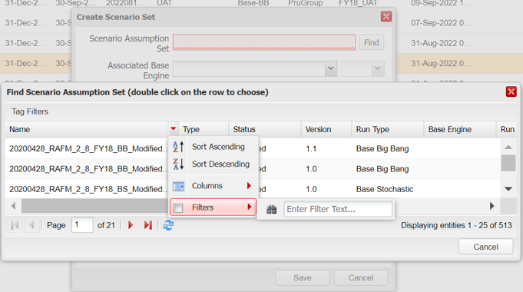

* + **Associated Base Engine** (selected from the drop-down list)
  + **Associated Base Engine Version** (selected from the drop-down list)
  + **Purpose** (defaulted from the scenario assumption set)
  + **Tag** (defaulted from the scenario assumption set)
  + **Session date** (defaulted from the scenario assumption set)
  + **Max Nr. Of stochastic scenarios (**defaulted from the scenario assumption set if stochastic)
  + **Name** (chosen and manually entered by the user)
  + **Base Date** (chosen and entered via a calendar button by the user)
  + **Description** (optional)
  + **Type** (always select ‘Simulation’)

**Step 4**: Select the ‘Save’ button

You may select the ‘Cancel’ button to abort the task.

* **Upon completion of the above tasks, a new scenario set is created and stored in the system.**
* **The system will assign a version number to the scenario set, and assign it an ‘In Review - Calibrated’ status.**
* **Scenario sets that are created will need to be manually validated, see use case 6.3.3 for instructions.**



**Scenario set naming conventions and format of uploaded files**

* The ICM Name is always a unique value manually entered by the user at the time of creating the translator in the interface. The name is chosen by the business
* At the point of entering a name for a new scenario set, the system will show an error message if the user enters a name for a new scenario set which is not unique.

### 6.3.2 How to copy an scenario set

**C:\Program Files\Microsoft Office\MEDIA\CAGCAT10\j0293236.wmf**

* ***Business context:***
* The scenario set copy functionality is an administrative process where a scenario set is copied. Using this function requires the user to give the newly copied scenario set a unique name, description and associated base engine.
* ***To be able to copy a scenario set, the following conditions must be met:***
* The selected version of the scenario set is not locked by another user.
* The selection version of the scenario set must not have rejected status.

*Please note that the copy process updates the library by creating a duplicate version of the selected scenario set.*

The steps describing the process of copying a scenario set are not the same for all types of scenario set runs. Specifically, the process of copying a scenario set run is the same for all types, excluding the What-if stochastic and what-if big bang scenario sets. The steps for these two run types are identical with the rest run types, apart from the Step 4. To address this, the step 4.b will be the alternative for the what-if cases, while the step 4.a will be the guide for the other run types.

**Step 1**: Select the ‘Scenario Sets’ tab.

**Step 2**: Select a version of the scenario set in the scenario sets summary table.

**Step 3**: Select the option ‘Copy’ from the ‘Maintenance’ drop-down list.

**Step 4.a**: For all the non What if Use cases, when the user copies a scenario set must select the base engine with which want to associate the new scenario set. The system will display a pop-up window with the field ‘Name’, ‘Description’ and associated ‘Base Engine’ and version to be filled. Fill in the requested fields and choose a unique name.

**Step 4.b:** In the case of copying aWhat if scenario set, the user must selecta What-if Scenario Assumption Set to be used with the new scenario set with. The system will display a pop-up window with the field ‘Name’, ‘Description’ and associated ‘What-if Scenario Assumption Set’. Fill in the requested fields and choose a unique name.

**Step 5**: Select the ‘Copy’ button.

You may select the ‘Cancel’ button to abort the task.

* **Upon completion of the above steps, the selected scenario set will be copied. The copied scenario set will appear under the unique name entered during Step 4 and will include all details from the original version and the base engine selected at ‘point of copy’ run type dependant.**

**Notes**

* The copied scenario set inherits the tag of the original scenario set.
* The copied scenario set will be saved with the status in-review-calibrated.
* The copied scenario set will be saved as version 1.0.
* A scenario set can be copied only in the geography where it was originally created.

### 6.3.3 How to delete a scenario set

**C:\Program Files\Microsoft Office\MEDIA\CAGCAT10\j0293236.wmf**

* ***Business context:***
* *Scenario set deletion should be relatively rare as users can modify scenario sets to make changes.*
* *A user can only delete a scenario set if it has not been submitted to an assumption set.*
* *If the scenario set has been created as part of a batch run functionality, it will not be available for deletion*
* *The selected version of the scenario set is not in use in any processing RSG run*

**Step 1**: Select the ‘Scenario Sets’ tab.

**Step 2**: Select a scenario set from the summary table.

**Step 3:** Select ‘Delete’ from the ‘Maintenance’ drop-down list.

**Step 4:** The system will display confirmation messages. Select ‘Yes’ to delete.

You may select ‘No’ to abort the task.

* **Upon completion of the above tasks, the selected scenario set will be removed from the system and the summary table will be updated.**

**ICM warning message**

* The system will show a warning message and abort the task if the scenario set selected for deletion by the user has already been submitted to an assumption set or was created as part of a batch run.

### 6.3.4 How to validate a scenario set

* ***Business context:***
* *Scenario set validation is a point to capture the validation information that is produced by the RSG scenario creation process. The process of proving the statistical properties of the scenarios are correct happens outside the ICM interface environment.*
* *To be able to ‘validate’ a scenario set, the selected scenario set should have an ‘In Review - Validated’ status and unlocked*

**C:\Program Files\Microsoft Office\MEDIA\CAGCAT10\j0293236.wmf**

**Step 1**: Select the ‘Scenario Sets’ tab

**Step 2**: Select a version of a scenario set in the summary table.

**Step 3**: Select the option ‘Validate’ from the ‘Validation’ drop-down list

**Step 4**: The system will display a pop-up window with the following fields to populate:

* + **Comment** *(optional)*
  + **File** (*optional – users can use the ‘Browse’ feature next to the field and upload a validation report from a the network location)*

**Step 5**: Select the ‘Validate’ button.

You can select ‘Reject’ option at Step 2.

You can select the ‘Cancel’ button to abort the task.

* **Upon completion of the above tasks, the selected scenario set is validated and the system will change the status of the scenario set from ‘In Review-Validated’ to ‘Validated’.**

**Validation: user criterion**

The user validating the scenario must be different from the ‘Last modified by’ user.

### 

### **6**.3.5 How to modify a scenario set

C:\Program Files\Microsoft Office\MEDIA\CAGCAT10\j0293236.wmf

* ***Business context:***
* *It may be necessary to modify a scenario set to correct errors or to update the inputs to newer versions.*
* ***To be able to modify a scenario set, the following conditions must be met:***
* *The selected version of the scenario set should not be locked.*
* *The selected version of the scenario set is not in use in any processing RSG run.*

**Step 1**: Select the ‘Scenario Sets’ tab

**Step 2**: Select ‘Modify’ from the ‘Maintenance’ drop-down list

**Step 3:** The system will display a pop-up window for the user to modify the following fields:

* + **Scenario Assumption Set** (Select from available sets (using Find, brings up a menu that you have to sort and filter on). ‘Find’ button brings up a menu that you have to sort and filter on. ‘Find’ button allows the user to search for a scenario set using its exact name and display all versions. The Base Date field is populated automatically to be the same as the Base Date of the selected Scenario Assumption Set.



* + **Associated Base Engine** (reselect from the drop-down list)
  + **Associated Base Engine Version** (reselect from the drop-down list)
  + **Purpose** (modified if the scenario assumption set is reselected)
  + **Tag** (modified if the scenario assumption set is reselected)
  + **Session date** (modified if the scenario assumption set is reselected)
  + **Max Nr. Of stochastic scenarios (modified if the scenario assumption set if reselected and is stochastic)**
  + **Description** (optional)
  + **Type** (should not be modified)
  + **Comment** (optional)

**Step 4**: Select the ‘Save’ button

You may select the ‘Cancel’ button to abort the task.

* **Upon completion of the above steps, the selected scenario set will have been modified.**

### 6.3.6 How to rename a scenario set

**C:\Program Files\Microsoft Office\MEDIA\CAGCAT10\j0293236.wmf**

* ***Business context:***
* *Scenario set rename functionality is an administrative process where the name of a scenario set is changed*
* ***To be able to rename a scenario set, the following conditions must be met:***
* *All versions of the selected scenario set are unlocked.*
* *All versions of the selected scenario set have a status of “In Review – Calibrated”, “In Review – Validated” or “Validated”*
* *No version of the scenario set is attached to an assumption set*
* *No version of the scenario set is being used in an RSG run that has a status of ‘Processing’*

*Please note that the rename process updates the library by renaming all versions of the selected scenario set.*

**Step 1**: Select the ‘Scenario Sets’ tab and select a version of the scenario set in the scenario set summary table.

**Step 2**: Select the option ‘Rename’ from the ‘Maintenance’ drop-down list.

**Step 3**: The system will display a pop-up window with the field ‘Name’ to be filled. Fill in the requested field with a unique name.

**Step 4**: Select the ‘Rename’ button.

You may select the ‘Cancel’ button to abort the task.

* **Upon completion of the above steps, the selected scenario set will be renamed. The renamed scenario set will appear in the library under the unique name entered during Step 3.**

### 6.3.7 How to share a scenario set

**C:\Program Files\Microsoft Office\MEDIA\CAGCAT10\j0293236.wmf**

* ***Business context:***
* *Scenario set share functionality is an administrative process where the scenario set is shared with users from a different geography.*
* ***To be able to share a scenario set, the following conditions must be met:***
* *The scenario set library is populated with at least one scenario set.*
* *The user belongs to the owner user group.*

*Please note that the share process will share all versions of the selected scenario set with the selected geographies.*

* ***User permissions:***
* *It is necessary for the user to have scenario set level 2 permissions under this use case.*

**Step 1**: Select the ‘Scenario Sets’ tab and select a version of the scenario set in the scenario set summary table.

**Step 2**: Select the option ‘Share’ from the ‘Maintenance’ drop-down list.

**Step 3**: The system will display a pop-up window showing the Prudential Group geographic structure. Geography input boxes are incorporated into the structure. Click on the input boxes for the geographic locations that need to share the scenario set selected in Step 1.

Alternatively, the user has the option to select all geographies present in the system by clicking the ‘Select all’ button in the top-right corner of the dialog box.

**Step 4**: Select the ‘Save’ button.

You may select the ‘Cancel’ button to abort the task.

* **Upon completion of the above steps, the selected scenario set will be accessible by users from geographies selected during Step 3.**

### 6.3.8 How to export a RAFM Project (Base engine)

**C:\Program Files\Microsoft Office\MEDIA\CAGCAT10\j0293236.wmf**

* ***Business context:***
* *Export RAFM projects functionality is an administrative process where the base engine project can be exported from the ICM interface and a copy of the base engine project placed on a network drive.*
* *This functionality is useful when needing to import the base engine*
* ***To be able to export a base engine project, the following conditions must be met:***
* *The base engine must exist and be available in the scenario set user’s geography*
* *The base engine project .zip package is exported*
* *The base engine project export consists of:*
  + Base Engine project package assigned to the selected scenario set version
  + RSG Instruction set assigned to the selected version of scenario set
  + Worker Distribution files
  + RAFM_ICM_Run_Settings.csv
  + RSG control file.csv
  + Extracted_Nodes.csv
  + Risk_Limit_Static.csv

**Step 1**: Select the ‘Scenario Sets’ tab and select a version of the scenario set in the scenario set summary table.

**Step 2**: Select the option ‘Export RAFM Project’ from the ‘Download’ drop-down list.

**Step 3**: The system will display a pop-up window titled Export RAFM Project subheading RSG run.

**Step 4**: Click on the tick box to select generate scenario set.

**Step 5**: Select the ‘Export’ button.

You may select the ‘Cancel’ button to abort the task.

* **Upon completion of the above steps, the selected base engine project will be available to be saved on a network drive.**

### 6.3.9 How to download the validation reports of a stochastic scenario set

**C:\Program Files\Microsoft Office\MEDIA\CAGCAT10\j0293236.wmf**

* ***Business context:***
* *Report outputs are used by the RSG Production Team for the validation of stochastic Scenario Sets outputs.*
* ***To be able to download Val Reports, the following condition must be met:***
* *A stochastic scenario set run must have been previously completed successfully.*

**Step 1**: Select the ‘Scenario Sets’ tab and select a version of scenario set in the scenario set summary table on the ‘Normal’ tab.

**Step 2**: Select a specific RunID in the ‘Runs Table’ tab in the Details tab.

**Step 3**: The system will enable the download of Validation Reports by clicking the ‘Download’ button.

**Step 4:** Select the download type.

**Step 5:** Click the ‘Download’ button.

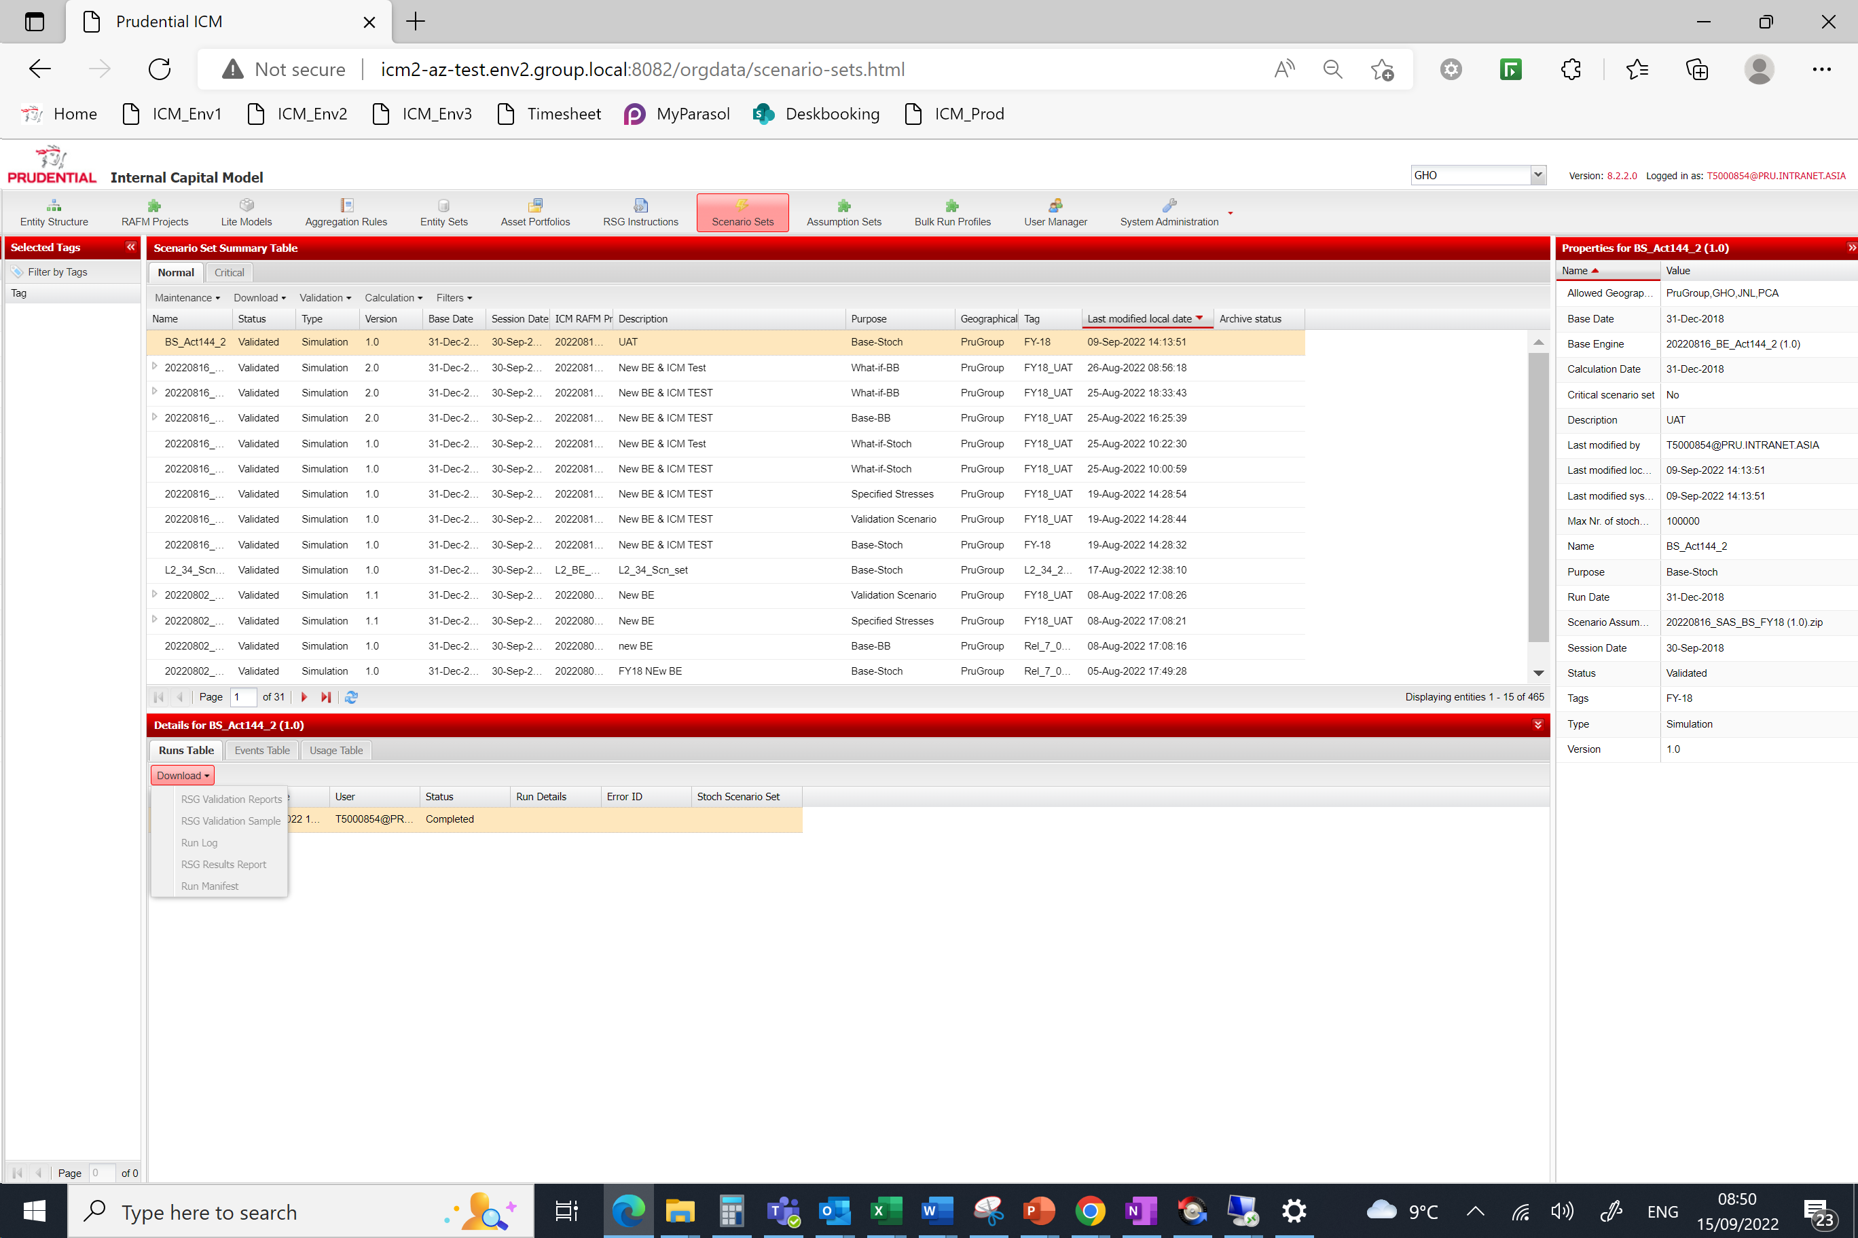

You may select the ‘Cancel’ button to abort the task.

* **Upon completion of the above steps, the selected Val Reports will be available for use.**

**Availability of scenario files**

* This functionality is only available for users with the ‘Scenario Set Validation’ permission.

### 6.3.10 How to download the Run Manifest file

**C:\Program Files\Microsoft Office\MEDIA\CAGCAT10\j0293236.wmf**

* ***Business context:***
* *The Run Manifest file provides contextual information about a Scenario Set run, including theScenario Set Name, Version, Status, Purpose, Base Date, Session Date, Max Nr of Stochastic Scenarios, Base Engine, Scenario Assumption Set, and Assigned Tag  Run manifest outputs are also used to confirm which RAFM configuration and Task Runner version which were used to complete the Scenario Set run.*
* ***To be able to download the Run Manifest, the following condition must be met:***
* *A scenario set run must have been previously completed successfully.*

**Step 1**: Select the ‘Scenario Sets’ tab and select a version of scenario set in the scenario set summary table on the ‘Normal’ tab.

**Step 2**: Select a specific RunID in the ‘Runs Table’ tab in the Details tab.

**Step 3**: The system will enable the download of Run Manifest file by clicking the ‘Download’ drop-down menu.

**Step 4:** Click the ‘Run Manifest’ option on the menu.

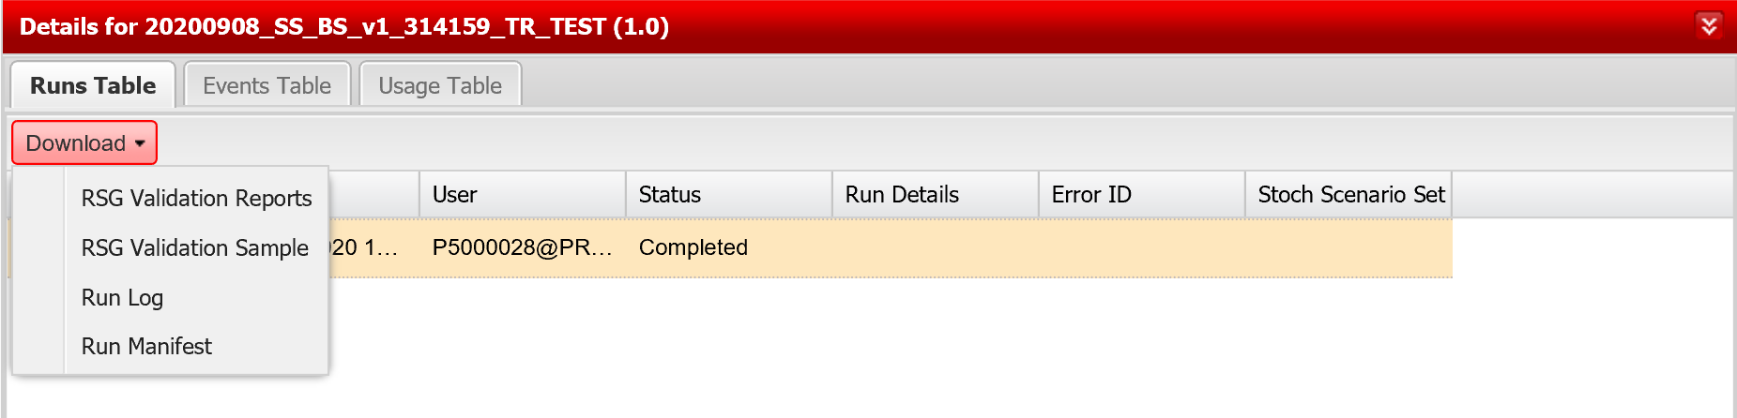

You may select the ‘Cancel’ button from the local browser download menu options to abort the task.

* **Upon completion of the above steps, the selected Run Manifest file will be available for use.**

### 6.3.11 How to trigger a validation run (RSG Standalone Run)

**C:\Program Files\Microsoft Office\MEDIA\CAGCAT10\j0293236.wmf**

* ***Business context:***
* *The business will want confidence that the scenario sets produce valid and complete outputs. To confirm this a user will run an RSG Standalone run and verify the run results. The process of obtaining run results (RSG validation reports, RSG validation sample and run logs) is described in the previous section. The verification of run results is an external ICM process.*
* ***To be able to trigger a validation run, the following condition must be met:***
* *The selected version of the scenario set is not locked*
* *The selected version of the scenario set is in status "In Review - Calibrated".*

**Step 1**: Select the ‘Scenario Sets’ tab and select a version of scenario set in the scenario set summary table of the ‘Normal’ tab.

**Step 2**: Select ‘Trigger Validation Run’ from the ‘Calculation’ drop-down list.

**Step 3**: The system will display a pop-up window. The RSG output is generated automatically for non-stochastic scenario sets. For stochastic scenario sets, the user may select the Generate scenario set tick box if they wish to generate a file that contains the RSG output. Additionally, the user may specify the number of stochastic scenarios used to perform the validation run, in the ‘Number of stochastic scenarios’ field. Finally, for all scenario sets, the user may choose the Task Runner configuration they want to associate with the run by checking the Task Runner Section box. This will provide the user with a list of Task Runner configurations (and available versions of each configuration) that are associated with the RAFM project version. Alternatively, if he or she does not check the Task Runner Section box, then the run will be triggered with the Task Runner configuration version assigned to the latest RAFM configuration associated with the RAFM base engine project version.

**Step 4:** Click the ‘Trigger’ button.

You may select the ‘Cancel’ button to abort the task.

* **Upon completion of the above steps, you will have triggered a scenario set validation run (RSG Standalone run).**

Please note, when a user triggers a Scenario Set run, the ICM will check whether the underlying RAFM base engine project version has an associated RAFM configuration. If a RAFM configuration does not exist for this version, the run will be rejected and user will receive an error message.

### 6.3.12 How to download the RSG Results Report

**C:\Program Files\Microsoft Office\MEDIA\CAGCAT10\j0293236.wmf**

* ***Business context:***
* *The RSG Results Report is generated each time a Scenario Set run is completed successfully, it contains the risk model calculation for each given risk driver and scenario.*
* ***To be able to download the RSG Results Report, the following condition must be met:***
* *A scenario set run must have been previously completed successfully.*

**Step 1**: Select the ‘Scenario Sets’ tab and select a version of scenario set in the scenario set summary table on the ‘Normal’ tab.

**Step 2**: Select a specific RunID in the ‘Runs Table’ tab in the Details tab.

**Step 3**: The system will enable the download of the RSG Results Report by clicking the ‘Download’ drop-down menu.

**Step 4:** Click the ‘RSG Results Report’ option on the menu.

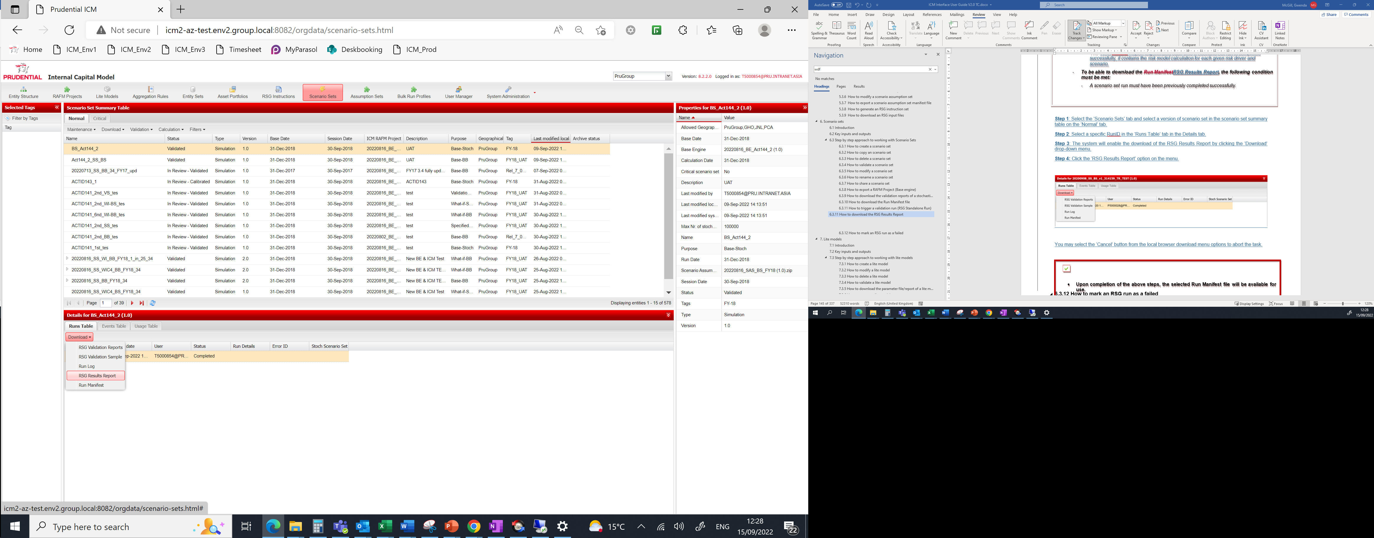

**Step 5:** If the RunID selected has been run with a large number of scenarios a warning message may appear to alert the user of the size of the download. Press yes to proceed.

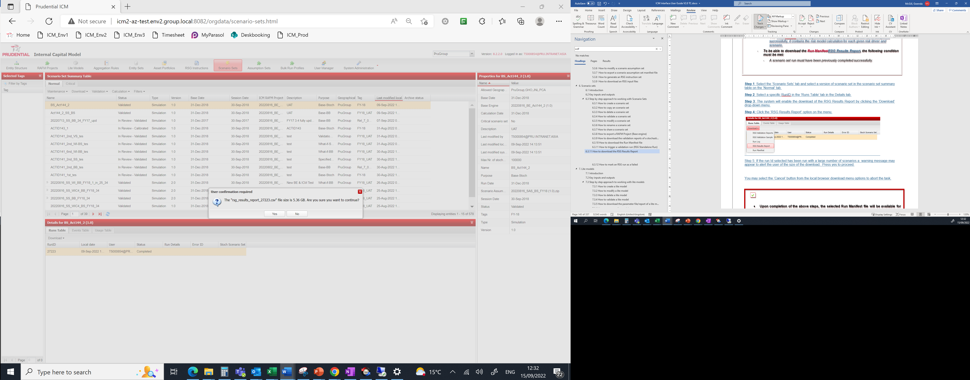

You may select the ‘Cancel’ button from the local browser download menu options to abort the task.

* **Upon completion of the above steps, the selected RSG Results Report file will be available for use.**

### 6.3.13 How to mark an RSG run as a failed

**C:\Program Files\Microsoft Office\MEDIA\CAGCAT10\j0293236.wmf**

* ***Business context:***
* *An admin user can manually update the status of an RSG run bymarking the run as failed. This would be required as a safety measure in isolated cases where a run has stalled or normal processing cannot be completed, e.g. due to a fault or interruption in IT infrastructure or services. This does not cancel a run if it was running.*

**Step 1**: Select the ‘Queue Balancer’ option from the ‘System Administration’ tab.

**Step 2**:Select a processing run from the ‘Runs For RAFM’ summary screen.

**Step 3**:Select the option ‘’Mark as failed’ from the ‘Maintenance’ menu.

**Step 4:** The system displays a pop-up asking the user to confirm the action.

**Step 5**: Select the ‘Yes’ button.

You can select the ‘No’ button to abort the task.

* **Upon completion of the above steps, a validation scenario run for a scenario set run will be marked as failed and the run entry will no longer be visible in the queue balancer table. The run will still be maintained in the process overview table with a status of ‘Failed’.**

Chapter 7

Lite models

# 7. Lite models

 Learning objectives**

*By the end of this chapter you will have:*

* ***Learned how to work with lite models via the ICM interface***
* ***Developed an understanding of lite models in relation to the overall results production process flow***
* ***Worked through the following use cases:***

7.4.1 How to create a lite model

7.4.2 How to modify a lite model

7.4.3 How to delete a lite model

7.4.4 How to validate a lite model

7.4.5 How to download a parameter file/report of a lite model

7.4.6 How to rename a lite model

7.4.7 How to copy a lite model

7.3.8 How to bulk upload lite models

7.3.9 How to bulk modify lite models

7.3.10 How to download results of the bulk upload process

## 7.1 Introduction

* **What is a lite model?**

A lite model (LM) is a simplified valuation tool for rapid calculation of assets and liabilities in a given simulation, with projection capability, specified by business units consistent with group standards. Through a process of calibration, lite models are created to replicate heavy model output under a range of different conditions. It involves running the heavy models under different scenarios and setting up lite model parameters and C++ code to fit the output.

Lite models are a key input to the ICM interface and RAFM application, and are maintained by business units. They may be adapted over time to reflect improved modelling approaches, changes in legislation or use, and changed demographics/markets. Changes to lite models are made in the RAFM development application. The ICM interface does not have the facility to change lite model code.

* **Business context**

Lite models are representations of homogenous groupings of a business’ assets and liabilities and can produce quick re-calculations of the asset and liability positions based on changes to the risks to which the business is exposed. The illustrative examples provided below provide examples of when businesses may work with lite models and update its key components in the RAFM development application:

* ***New line of business - create a new lite model***

Where groups of business have similar risk profiles, they are often grouped together within a lite model. A new line of business (e.g. new product launch) may not necessarily have the same risk profile as the existing lines of business, in which case it would not fit under the existing lite model and would give rise to the need to create a new lite model.

* ***Change in risk profile – recalibrate a lite model***

Lite models are calibrated to replicate the results produced by heavy models under a range of different scenarios. When the heavy model results change due to, for example, changes in economic conditions it is necessary to recalibrate the lite models. A change in the risk exposure may require a lite model to be updated through a process of recalibration (updating of the coefficients associated with a particular lite model formula).

* ***Process timing – true-up of a lite model***

Often businesses may re-calibrate a lite model a couple of months before a year-end exercise due to the time required for the calibration processes. It may be necessary to perform a ‘true-up’ process to reflect changes in the risk exposure between the re-calibration date and the year-end valuation date. Typically, this would be done by the use ‘true-up’ factors which scale the results of the lite models to the results produced by Heavy models under defined stress scenarios. The ‘true-up’ factors are stored in a specific tab of the experience parameters file associated with a lite model.

* ***Extraordinary experience in a particular month – recalibrate or ‘true-up’ a lite model***

Significant unexpected or external changes may lead to a change in the demographic risk profile for lite models - for instance, a lapse shock or a sudden increase in new business volumes. These change the in-force volume during a year and, rather than recalibrating or performing a true-up, experience parameters can be adjusted to reflect this change.  This would lead to a revised experience parameters workbook which would be used thereafter until the next recalibration.

* ***Year-end P&L results – update lite model’s experience parameters***

The experience parameters associated with a lite model reflect both actual historical experience (used for a P&L attribution exercise) and expected future experience (used for a projection calculation run). Depending on the purpose of the calculation run, one or both sets of experience parameters will need to be updated by businesses.

* ***Change in business profile - recode lite model***

A change in the business profile (typically over a number of years) may give rise to a need to re-assess the risk profile reflected within a lite model in a more fundamental way than performing a re-calibration process. This re-assessment may involve the addition of new risk drivers and / or the removal of existing risk drivers. This would require the lite model to be recoded, which would involve re-creating the formula within the lite model and establishing the appropriate coefficients so that the lite model represents the results of the heavy model under defined stresses.

* **Key components and processes in the ICM interface**



Figure 4: Lite Models

* **Working with lite models via the ICM interface**

The ICM interface will allow Users to undertake the following tasks:

* The Interface will allow users to view a list of lite models (showing only those available to a particular user), along with their key properties (outlined below)

View a list of lite models

* Create individual lite models
* Bulk upload lite models to the system using pre-defined template
* Copy lite models or modify components, creating new versions
* Delete lite models

Create, copy and delete lite models

* Manage lite model components via the Interface and group them into entity sets for inclusion in ICM simulation runs
* Bulk assign lite models to entity sets using pre-defined template
* Unassign/replace lite models from entity sets where required

Manage & maintain lite model components

Validate lite models

* Validate a lite model after results are satisfactory
* Bulk validate lite models via an entity set validation

* **Some of the key properties displayed in the ICM interface for each lite model are highlighted below** (boxes outlined in red are defined by the user).

Archive status

Name of lite model

Description

Calibration date

Base date

Version number

Usage

RAFM Project

Geographical rights

LM Code base

Events

Tag (inherited/automatic)

Parameters

## 7.2 Key inputs and outputs

**Mandatory Optional**

|  |  |  |  |
| --- | --- | --- | --- |
| **Key inputs** | **Input requirements** | **Creating a lite model** | **Using a lite model** |
| * **Name** | * File name must be unique * Less than 15 characters |  |  |
| * **Version** | * Non-editable field |  |  |
| * **Base Date** | * Date button feature |  |  |
| * **Description** | * Free text field |  |  |
| * **RAFM Project/Version** | * Drop down features |  |  |
| * **LM code base** | * Drop down feature |  |  |
| * **General parameters** | * Browse button feature * File must be in excel format |  |  |
| * **Experience parameters** | * Browse button feature * File must be in excel format |  |  |
| **Key outputs** | | **Lite model in summary screen list** | **Validated lite model** |

## 7.3 Step by step approach to working with lite models

This section outlines a step by step approach for the following eleven use cases:

7.4.1 How to create a lite model

7.4.2 How to modify a lite model

7.4.3 How to delete a lite model

7.4.4 How to validate a lite model

7.4.5 How to download a code file/report of a lite model

7.4.6 How to rename a lite model

7.4.7 How to copy a lite model

7.3.8 How to bulk upload lite models

7.3.9 How to bulk modify lite models

7.3.10 How to download results of the bulk upload process

### 7.3.1 How to create a lite model

***C:\Program Files\Microsoft Office\MEDIA\CAGCAT10\j0293236.wmf***

* ***Business context:***
* *Lite models are a concept to provide a simplified method for valuing the assets and liabilities of the company.*
* ***The following tasks must be complete before a lite model can be created in the ICM interface:***
* *lite models should to be developed offline to be loaded into the Interface.*
* *lite models should be calibrated prior to being loaded into the Interface.*
* *Prior to any work in the ICM, the relevant modelling team will undertake investigations into the risks that are applicable and some investigation into the form of the lite model.*
* ***To be able to create a lite model in the ICM interface , the following conditions must be met:***
* *All of the mandatory fields should be populated by the user. These fields are indicated in section 7.2.*
* *Components should be uploaded in the correct format as outlined in section 7.2.*

**Step 1:** Select the ‘Lite Models’ tab.

**Step 2:** Select the option ‘Create’ from the ‘Maintenance’ drop-down menu and populate the mandatory fields (mandatory fields are also highlighted in section 7.2).

**Step 3:** Manually enter the following fields:

* **Name**
* **Description**

**Step 4:** Click the date feature to enter the **Base Date**.

**Step 5:** Click the drop down feature to enter the following:

* **RAFM Project/Version**
* **LM code base**

**Step 6**: Click on the ‘Browse’ button next to enter the following:

* **General Parameters**
* **Experience Parameters**

Please note that the ‘Find’ **Asset Portfolio** feature is disabled.

**Step 7:** Click ‘Create’.

You may select the ‘Cancel’ button to abort the task.

* **You will now have a newly created lite model and the system will assign it with a version number, an ‘In Review’ status, a geography, and a ‘new’ default tag.**

**Naming convention and tagging**

* All lite models created must have a unique name across all geographies.
* On creation, all lite models have a default tag assigned of ‘New’. This cannot be modified as tag management of lite models is not a feature of the ICM. The lite model will therefore inherit the tag of any Entity Set and subsequent Assumption Set it is assigned to, with the ‘New’ tag being replaced on the first assignment to an entity set.

**Validation of lite model input data**

* The system will validate:
  + General parameter mandatory field values
  + Calibration date in the general parameters standard input sheet
  + General parameter variables exceeding the maximum length

### 7.3.2 How to modify a lite model

C:\Program Files\Microsoft Office\MEDIA\CAGCAT10\j0293236.wmf

* ***Business context:***
* *It may be necessary to modify a lite model to correct errors or to update the inputs to newer versions.*
* ***To be able to modify a lite model, the following conditions must be met:***
* *The selected version of the model should not be locked*
* *The user belongs to the user group that owns the lite model*

**Step 1**: Select the ‘Lite Models’ tab.

**Step 2**: Select a version of a lite model in the lite model summary table.

**Step 3**: Select the option ‘Modify’ from the ‘Maintenance’ drop-down list.

**Step 4**: The system will display a pop up window with the fields (listed above as key inputs) plus a comment box. You can then modify those fields that you deem necessary, except those that cannot be modified such as ‘Name’.

You can use the drop down features or the ‘Browse’ button to navigate to the local drive for the fields code file, general and experience parameters.

Enter the details of the change in the ‘Comment Box’.

**Step 5:** Select the ‘Save’button**.**

You may select the ‘Cancel’ button to abort the task.

* **Upon completion of the above steps, the lite model will be updated (if it is in the ‘In Review’ status) or a new version for the lite model is created if it is validated or rejected.**
* **The new version of the lite model will be displayed in the lite model summary screen.**
* **By default the latest version is shown in the list and previous versions can be revealed by clicking on the arrow next to the latest version.**

**Validation of lite model input data**

* The system will validate:
  + General parameter mandatory field values
  + Calibration date in the general parameters standard input sheet
  + General parameter variables exceeding the maximum length

**Versioning**

* If the selected version of the lite model is in status “In Review” the system should not update the version number.
* If the selected version of the lite model is validated or rejected the system creates a new version and increase the version number according to the following rules:
  + If the base date is modified and/or RAFM Project version / LM code base is modified, increment the principal digit to the next natural number and if any other change: increment to next digit. Example: 1.1 -> 1.2, 1.10 -> 1.11
  + If the version number that should be created already exists, the system shall create the next available version number. E.g. versions 1.0, 1.1, 1.2, 1.3, 1.4, 2.0, 2.1, 3.0 exist in the system and the user modifies version 1.1. The system will create version 1.5 or 4.0 depending of what is modified).
* When a new version is created by modifying a validated lite model, the system shall assign the default ‘New’ tag to the new version created.

**Modification of a lite model – other aspects**

* Any modification to a validated lite model will result in a new version of the lite model being produced and assigned a tag of ‘New’. This is because the new version is not assigned to an entity set.
* Any change to an existing in review version of a lite model will invalidate the run results of assumption sets it is associated to. Any batch use case will also have all its runs invalidated, including the Critical Scenario set run triggered as part of that batch. Validated lite models are not affected by this change, nor are other lite models where the only changes are those that only update the description or comments boxes.

### 7.3.3 How to delete a lite model

C:\Program Files\Microsoft Office\MEDIA\CAGCAT10\j0293236.wmf

* ***Business context:***
* *Deletion is to be used for setup mistakes that are identified early.*
* ***Deleting a lite model:***
* *A lite model can only be deleted if none of its versions are currently:*
  + *assigned to an assumption set*
  + *none of the versions of the selected lite model are locked*
  + *None of the versions of the selected lite model are marked as being modified.*

**Step 1**: Select the ‘Lite Models’ tab.

**Step 2**: Select a version of a lite model in the lite model summary table.

**Step 3**: Select the option ‘Delete’ from the ‘Maintenance’ drop-down list.

**Step 4**: The system will display a confirmation message.

**Step 5:** Click the ‘Delete’ button and then ‘Yes’.

You may also select the ‘Cancel’ button to abort the task.

* **Upon completion of the above steps, the deleted lite model including all of its versions will not be visible to any users in the lite model library.**

### 

### **7**.3.4 How to validate a lite model

**C:\Program Files\Microsoft Office\MEDIA\CAGCAT10\j0293236.wmf**

* ***Business context:***
* *Lite model validation is a control process where components are confirmed to be ‘correct’ for their intended use. Alternatively the User may opt to Reject a lite model.*
* ***To be able to validate a lite model, the following conditions must be met:***
* *The selected version of the lite model should be in the ‘In Review’ status and the version should be unlocked.*
* *The user logged on to validate the version should be different from the ‘Last Modified by’ user.*
* *The selected lite model to be validated should have a LM code base, a General and Experience parameter file.*
* *The lite model should be part of an Assumption Set with valid run results.*

*The user who validates the lite model must be different from the user who successfully ran the assumption set containing the lite model of interest*

* ***User permissions:***
* *It is necessary for the user to have lite models level 2 permissions to perform these actions.*

**Step 1**: Select the ‘Lite Models’ tab.

**Step 2**: Select a version of a lite model in the lite model summary table.

**Step 3:** Select the option ‘Validate’ from the ‘Validation’ drop-down menu. The system will display a pop-up window with the fields ‘Comments’ to be filled and ‘Upload File’ to be browsed for and uploaded.

A lite model may be rejected by a user, by selecting ‘Reject’ from the ‘Validation’ drop down menu.

You may select the ‘Cancel’ button to abort the task.

**Note on bulk validation**

It is possible to validate multiple lite models in a single action, if all selected lite models have been included in the same successful assumption set run. Bulk lite model validation is done via the inherent ‘bulk validation’ feature of the associated entity set. Validating an entity set with attached lite models will also validate the associated lite models.

* **Upon completion of the above steps, the selected lite model will appear in the summary table as ‘Validated’.**

### **7**.3.5 How to download the parameter file/report of a lite model

The following set of instructions relates specifically to code files but can equally be applied to parameter files, validation reports and events too.

**C:\Program Files\Microsoft Office\MEDIA\CAGCAT10\j0293236.wmf**

* ***Business context:***
* *Users may want to download a component of a lite model (e.g. a Code File) to use it as a basis for developing another lite model or making changes.*
* ***To be able to download the parameter files of a lite model, the following conditions should be met:***
* *The selected version of the lite model must have a parameter file attached.*

**Step 1**: Select the ‘Lite Models’ tab.

**Step 2**: Select a version of a lite model in the lite model summary table.

**Step 3**: Select the option ‘Download Parameter File’ from the ‘Download’ drop-down list.

**Step 4:** The system will display a confirmation message. Select the ‘Save’ button.

**Step 5**: Specify a location on your local network or desktop to download (save) the file.

You may select the ‘Cancel’ button to abort the task

For Download Events, the user selects the format of the download from the following list:

* PDF
* XLS
* CSV
* **Upon completion of the above steps, you will have the code file (or other download) available to use.**

### 7.3.6 How to rename a lite model

**C:\Program Files\Microsoft Office\MEDIA\CAGCAT10\j0293236.wmf**

* ***Business context:***
* *Lite model rename functionality is an administrative process where the name of a lite model is changed.*
* ***To be able to rename a lite model, the following conditions must be met:***
* *All of the versions of the selected lite model are unlocked.*
* *All of the versions of the selected lite model have a status of “In Review”.*

*Please note that the rename process updates the library by renaming the selected lite model.*

**Step 1:** Select the ‘Lite Models’ tab.

**Step 2:** Select a version of the lite model in the lite model summary table.

**Step 3:** Select the option ‘Rename’ from the ‘Maintenance’ drop-down list.

**Step 4:** The system will display a pop-up window with the field ‘Name’ to be filled. Fill in the requested field with a unique name.

**Step 5:** Select the ‘Rename’ button.

You may select the ‘Cancel’ button to abort the task.

* **Upon completion of the above steps, the selected lite model will be renamed. The renamed lite model will appear in the library under the unique name entered during Step 4.**

### 7.3.7 How to copy a lite model

**C:\Program Files\Microsoft Office\MEDIA\CAGCAT10\j0293236.wmf**

* ***Business context:***
* *Lite model Copy functionality is an administrative process where the lite model is copied. Using this function requires the user to give the newly copied lite model a unique name.*
* ***To be able to copy a lite model, the following conditions must be met:***
* *The selected version of the lite model is unlocked.*

*Please note that the copy process updates the library by creating a duplicate version of the selected lite model.*

**Step 1:** Select the ‘Lite Models’ tab.

**Step 2:** Select a version of the lite model in the lite model summary table.

**Step 3:** Select the option ‘Copy’ from the ‘Maintenance’ drop-down list.

**Step 4:** The system will display a pop-up window with the field ‘Name’ to be filled. Complete the requested field with a unique name.

**Step 5:** Select the ‘Copy’ button.

You may select the ‘Cancel’ button to abort the task.

* **Upon completion of the above steps, the selected lite model will be copied. The copied lite model will appear under the unique name entered during Step 4.**

### **7**.3.8 How to bulk upload lite models

**C:\Program Files\Microsoft Office\MEDIA\CAGCAT10\j0293236.wmf**

* ***Business context:***
* *The bulk upload functionality allows the user to instruct the ICM interface via a control sheet to create lite models automatically from a set of source data. This reduces set-up times considerably and frees up staffing resources for other concurrent tasks.*

**Step 1:** Select the ‘Lite models’ tab.

**Step 2:** Select the option ‘Create’ from the ‘Bulk Upload’ dropdown list.

**Step 3:** The system displays a pop-up window with the following fields:

* **RAFM Project and Version:** Mandatory drop down box fields to associate all bulk upload lite models to a Standard ICM RAFM project
* **Upload csv file**: Mandatory field for user to browse to a local drive to retrieve the csv instruction file
* **Upload zip file**: Mandatory field for user to browse to a local drive to retrieve the zipped file with source data contents

Please note:

* All experience parameter and general parameter files included in the csv need to be included in the zip

If a required code base file is not in the bulk upload, the ‘download results’ show individual code base Result Status of ‘Failed’ and a description of the error

**Step 4:** The user selects the button “Upload”

The system processes the uploaded files and creates the lite models and updates the lite model summary screen.

You may select the ‘Cancel’ button to abort the task.

* **Upon completion of the above steps, the uploaded lite models are available for use in the lite model summary screen.**

**Additional specifications and tagging**

* The data required in the csv file uploaded is the same as that required for creation of lite model. Where files are required, these should be set up as paths which direct the system to the folder structure in the uploaded zipped file. The headers required are as follows (not all are required to be filled):

Name (mandatory), Base Date (mandatory), Description (mandatory), RAFM Project/Version (mandatory), LM code base (mandatory), General Parameter (mandatory) and Experience Parameter (mandatory).

* The zipped file should contain an internal folder structure containing code bases, general parameter files and experience parameter files.
* All lite models created by the Bulk Upload functionality will have a tag of ‘New’.

### 7.3.9 How to bulk modify lite models

**C:\Program Files\Microsoft Office\MEDIA\CAGCAT10\j0293236.wmf**

* ***Business context:***
* *As with ‘Bulk Upload’, this functionality allows for automatic updates to the lite model data via an instruction sheet thus generating similar synergistic benefits in terms of human resources.*

**Step 1:** Select the ‘Lite models’ tab.

**Step 2:** Select the option ‘Modify’ from the ‘Bulk Upload’ dropdown list.

**Step 3:** The system displays a pop-up window with the following fields:

* **Update if “In Review”**: Tick box feature
* **RAFM Project and Version:** Mandatory drop down box fields to associate all bulk upload lite models to a Standard ICM RAFM project
* **Upload csv file**: Mandatory field for user to browse to a local drive to retrieve the csv instruction file
* **Upload zip file**: Mandatory field for user to browse to a local drive to retrieve the zipped file with source data contents which include any required changes

Please note:

* All experience parameter and general parameter files included in the csv need to be included in the zip

If a required file is not in the bulk upload, the ‘download results’ show individual code base Result Status of ‘Failed’ and an error description

**Step 4:** Set the ‘Update if ‘In Review’’ option to ‘yes’ by ticking the box.

This allows lite models with a status of ‘In Review’ to be modified by the process. The modification will result in the invalidation of any runs that used these lite models before the modification. Additionally, any lite model included within the bulk modify use case with a status of either ‘Validated’ or ‘Rejected’, won’t be ‘modified’ but will have a new version of the lite model created.

**Step 5:** Upload csv file and also the zip file

**Step 6:** Select the “Upload” button.

You may select the ‘Cancel’ button to abort the task.

The system processes the uploaded files and updates the most recent versions of the lite models and updates the lite model Summary Screen.

All objects that have a status in review are updated at their current version and any objects which are validated or rejected have a new version created with the modified details.

* **Upon completion of the above steps, the updated lite models are available for use in the lite model summary screen.**

**Data requirements and tagging**

* The data required in the csv file uploaded is the same as that required for bulk creation of lite model. Where files are required, these should be set up as paths which direct the system to the folder structure in the uploaded zipped file.
* All validated lite models that are modified by this process will create a new in review version with a tag of 'New'.

### 7.3.10 How to download results of the bulk upload process

**C:\Program Files\Microsoft Office\MEDIA\CAGCAT10\j0293236.wmf**

* ***Business context:***
* *When lite models are created via bulk upload, any error or permission issues on individual lite models during the upload does not result in the process being aborted.*
* *In order to ascertain that all lite models have been successfully created, the user must download the results of the bulk upload process and verify that the result status is as expected based on the use case performed (e.g. created or updated).*
* ***To be able to download results of the bulk upload process, the following conditions must be met:***
* *The bulk upload process must have fully completed.*

**Step 1:** Select the ‘Lite Models’ tab.

**Step 2:** Select the option ‘Download results’ from the ‘Bulk Upload’ dropdown list.

The system displays a pop-up window listing the available log files (Excel format) in a drop down feature.

**Step 3:** Select the report required.

The report is in an excel format and has a naming convention that describes the bulk action performed (create or modify), the geography at which the upload was performed and the date/time stamp of the upload. This list of reports is always the full list (i.e. it is not filtered if a specific lite model version is selected to include only the report/s which resulted in the creation or modification of said lite model version).

**Step 4:** Select the button “Download” and save to an appropriate location on the local drive.

You may select the ‘Cancel’ button to abort the task.

The format of the file downloaded contains the properties of the lite model in a tabular format and displays the values as entered by the user in the instruction file for the bulk upload process. In addition, the following information is also available:

**Result status:** Possible values are ‘Created’, ‘Updated’ or ‘Failed’.

**Error description:** Only available for a ‘Failed’ record where the first error encountered is displayed.

**Warning:** This contains a list of assumption set RunIDs that were invalidated/cancelled for those lite models that were modified with a status of ‘In review’.

* **Upon completion of the above steps, the log file is available to the user for inspection.**

Chapter 8

Entity structures

# 8. Entity structures

 Learning objectives**

*By the end of this chapter you will have:*

* ***Learned how to work with entity structures via the ICM interface***
* ***Developed an understanding of entity structures in relation to the overall results production process flow***
* ***Worked through the following use cases:***

8.3.1 How to create an entity structure

8.3.2 How to modify an entity structure

8.3.3 How to modify an entity structure on screen

8.3.4 How to delete an entity structure

8.3.5 How to validate an entity structure

8.3.6 How to download the tree file of an entity structure

8.3.7 How to rename an entity structure

8.3.8 How to copy an entity structure

8.3.9 How to share an entity structure

8.3.10 How to submit an entity structure to an entity set

8.3.11 How to assign geographies to an entity structure

8.3.12 How to mark ‘nesting nodes’ within an entity structure

8.3.13 How to unmark ‘nesting nodes’ within an entity structure

8.3.14 How to download validation reports

## 8.1 Introduction

* **What is an entity structure**

An entity structure is a mechanism for tying different lite models and aggregation rules together as a set of parent-child relationships. The interface allows entity structures to be broken up into layers for different parts of the business to specify and maintain their own sections as appropriate. Ultimately, the entity structure should link up all the lite models at leaf nodes and aggregation rules at non-leaf nodes and combine them into the group structure. This is all done through the entity set management interface.

Entity structures can be created offline, with respect to the ICM interface, or from within the interface. An entity structure has a geographical user group and is used in assumption sets to help organise the other modelling components.

Responsibility for maintaining the entity structure falls to different parts of the group – i.e. GHO is responsible for the overall group structure, RHOs for their own local sub-structure, and local BUs for their own local structure.

* **Business context**

Defining the entity structure to be modelled is the start of the process to calculate capital requirements through the ICM. The entity structure describes the relationship between lite models and Aggregation Rules and forms a view of how the business is modelled.

The illustrative examples provided below describe typical situations where businesses may have to change their entity structures:

* *Addition or removal of a lite models as a result of re-structuring or mergers and acquisitions activity;*
* *Investigative work to understand the capital implications of proposed mergers and acquisitions activity;*
* *Investigative work to understand the capital implications of possible entity structures;*
* *Dividing a lite model into two lite models due to more granular modelling of risk profiles; and*
* *Combining two lite models into a single lite model due to modelling simplification work.*
* **Key components and processes in the ICM interface**



Examined in this chapter

Figure 5: Entity Structures

* **Working with entity structures via the ICM interface**   
    
  The ICM interface will allow users to undertake the following tasks:

* Create an entity structure using the interface and an *.agg file
* View the entity structure library and elements of an entity structure

Create and view elements of an entity structure

* Modify an entity structure offline
* Modify an entity structure graphically within the interface itself
* Copy or delete an entity structure

Maintain an entity structure

* Verify an entity structure via validation
* Upload a validation report

Validate an entity structure

* **Some of the key properties displayed in the ICM interface for each entity structure are highlighted below** (boxes outlined in red are defined by the user).

Name

Description

Version number

Base date

Status

Usage

Geographical rights

Tag

Archive status

## 8.2 Key inputs and outputs

**Mandatory Optional**

|  |  |  |  |
| --- | --- | --- | --- |
| **Key inputs** | **Input requirements** | **Creating an entity structure** | **Creating a validated entity structure** |
| * **Unique name for entity structure** | * File Name must be unique * Fewer than 15 characters |  |  |
| * **Entity structure file** | * Find feature to allow user to upload file * File must be in *.agg format |  |  |
| * **Base date** | * Date selection feature |  |  |
| * **Description** | * Free Text |  |  |
| * **Validation report** | * Validation report is not required to validate the entity structure |  |  |
| **Key outputs** | | **Entity structure** | **Validated entity structure** |

## 8.3 Step by step approach to working with entity structures

This section outlines a step by step approach for the following fourteen use cases:

**8.3.1** How to create an entity structure

**8.3.2** How to modify an entity structure

**8.3.3** How to modify an entity structure tree on screen

**8.3.4** How to delete an entity structure

**8.3.5** How to validate an entity structure

**8.3.6** How to download the tree file of an entity structure

**8.3.7** How to rename an entity structure

**8.3.8** How to copy an entity structure

**8.3.9** How to share an entity structure

**8.3.10** How to submit an entity structure to an entity set

**8.3.11** How to assign geographies to an entity structure

8.3.12 How to mark ‘nesting nodes’ within an entity structure

8.3.13 How to unmark ‘nesting nodes’ within an entity structure

8.3.14 How to download validation reports

### 8.3.1 How to create an entity structure

***C:\Program Files\Microsoft Office\MEDIA\CAGCAT10\j0293236.wmf***

* ***Business context:***
* *The entity structure is a modelling component used to link lite models and aggregation rules in a pre-specified hierarchy.*
* ***To be able to create an entity structure, the following conditions should be met:***
* *The entity structure tree file to be uploaded into the Interface must be in the correct format. Please refer to section 7.2 for format details.*

*Note: Entity structures are created offline and then uploaded to be visible and usable on the interface.*

**Step 1**: Select the ’Entity Structure’ tab

**Step 2:** Select ‘Create’ from the ‘Maintenance’ drop-down list. In the pop-up window enter details for:

* **Name**
* **Tree file: Select the browse feature to navigate to the local drive to select an entity structure**
* **Base date:** use the date picker feature to select a date
* **Description**

**Step 3:** Select the ‘Save’ button

You can select the ‘Cancel’ button to abort the task.



* **You will now have a newly created entity structure which is stored in the system and available for further use for allowed users.**

**Tagging**

* Upon creation of the entity structure, it is assigned a tag of ‘New’ by the interface.

### 8.3.2 How to modify an entity structure

C:\Program Files\Microsoft Office\MEDIA\CAGCAT10\j0293236.wmf

* ***Business context:***
* *Once an entity structure exists within the ICM interface it is possible to modify its tree file, base date and description. The system allows the user to enter a comment (optional) in relation to the modification.*
* ***To be able to modify an entity structure, the following conditions must be met:***
* *The selected version of the entity structure must be unlocked.*
* *If a node is being used as the root node of an assumption set or is a node where nesting has been done, then it cannot be modified as part of this use case.*

**Step 1**: Select the ’Entity Structure’ tab

**Step 2:** Select a version of an entity structure in the entity structure summary table.

**Step 3:** Select the ‘Modify’ option from the ‘Maintenance’ drop-down list

If the selected version is ‘In Review’ the system will lock it to other users. If it is in ‘Validated’ or ‘Rejected’ status, the system will mark it for editing.

**Step 4:** the system will display a pop-up window which with the following field:

* **Name** (This cannot be modified)
* **Tree File** (use the Browse feature to navigate to the local drive)
* **Base Date**
* **Description**
* **Comment** (you may enter a reason for modifying the entity structure)

**Step 5:** Select the ‘Save’ button.

You can select the ‘Cancel’ button to abort the task. This will unlock the selected version of the entity structure.



* **Upon completion of the above steps, the entity structure will be updated if the selected version of the entity structure had an ‘In Review’ status. A new version of the entity structure will be created if it had a ‘Validated’ or ‘Rejected’ status.**

### **8**.3.3 How to modify an entity structure tree on screen

**C:\Program Files\Microsoft Office\MEDIA\CAGCAT10\j0293236.wmf**

* ***Business context:***
* *The system allows the user to change the entity structure on screen rather than uploading a new entity structure file.*
* ***To change an entity structure on screen, the following conditions must be met:***
* *The selected version of the entity structure must be unlocked.*
* *If a node is being used as the root node of an assumption set or is a node where nesting has been done, then it cannot be modified as part of this use case.*

**Step 1**: Select the ’Entity Structure’ tab

**Step 2**: Select a version of an entity structure in the entity structure summary table

**Step 3**: Under the entity structure tree for <selected entity structure>’ subsection, click ‘Modify Tree’.

If the selected version has an ‘In Review’ status, the system will lock the version to other users. If the selected version has a ‘Validated’ or ‘Rejected’ status, the system will create a new version.

**Step 4**: In the pop-up window, select a node.

**Step 5a**: Right-click and select the ‘Add node’ option. The system will display a pop-up window with the field ‘Name’ where the user may enter a description for the new node or;

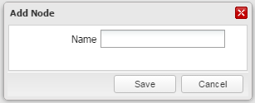

**Step 5b**: Right-click and select the ‘Rename Node’ option. The system will provide a pop-up window for the user to enter a new name or;

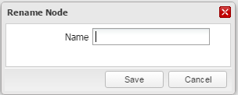

**Step 5c**: Right-click and select the ‘Delete Node’ option. The system will display a pop-up window displaying a confirmation message.

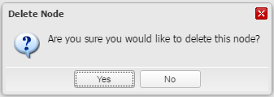

**Step 6**: Select the ‘Save’ button for step 5a/5b and ‘Yes’ button for step 5c. This will respectively create a new node as a child of the selected node, rename a node and delete a node.

* **Upon completion of the above steps, the selected entity structure will be updated if it had an ‘In Review’ status.**
* **A new version of the entity structure will be created if the status of the selected version was ‘Validated’ or ‘Rejected’.**

### 8.3.4 How to delete an entity structure

C:\Program Files\Microsoft Office\MEDIA\CAGCAT10\j0293236.wmf

* ***Business context:*** 
  + *Deletion is to be used for setup mistakes that are identified early. Once an entity structure has been assigned to an entity set, it cannot be deleted.*
* ***To be able to delete an entity structure, the following conditions must be met:***
  + *None of its versions should have been assigned to an entity set.*
  + *The version should be unlocked and should not be marked for editing.*

**Step 1**: Select the ’Entity Structure’ tab

**Step 2**: Select a version of an entity structure from the summary table

**Step 3**: Select the option ‘Delete’ from the ‘Maintenance’ drop-down menu

**Step 4**: The system will display a confirmation message. Click on the ‘Delete’ button again.

You may also select the ‘Cancel’ button to abort the task.



* + **Upon completion of the above steps, the deleted entity structure including all of its versions will be removed from the entity structure library and summary table.**

### **8**.3.5 How to validate an entity structure

**C:\Program Files\Microsoft Office\MEDIA\CAGCAT10\j0293236.wmf**

* ***Business context:*** 
  + *Entity structure validation is a control process where components are confirmed to be ‘correct’ for their intended use.*
* ***To be able to validate an entity structure, the following conditions must be met:*** 
  + *The selected version must have an ‘In Review’ status and the version must be unlocked.*
  + *The logged in user should be different than the ‘Last Modified’ user.*
* ***User permissions:*** 
  + *It is necessary for the user to have entity structure level 2 permissions to perform these actions.*

**Step 1**: Select the ’Entity Structure’ tab

**Step 2**: Select a version of an entity structure from the entity structure summary table

**Step 3**: Select the option ‘Validate’ from the ‘Validation’ drop-down menu

**Step 4**: The system will display a pop-up window with the fields ‘Comments’ and ‘Upload File’ to be filled. Fill in the requested fields, using the browse feature to navigate to the disk and select the relevant file.

**Step 5**: Select the ‘Validate’ button. This will change the status of the selected entity structure to ‘Validated’ and will be updated in the summary table.

An entity structure may be rejected by a user, by selecting ‘Reject’ from the ‘Validation’ drop down menu.

You may select the ‘Cancel’ button to abort the task.



* **Upon completion of the above steps, the selected entity structure will appear in the summary table as ‘Validated’.**

### 8.3.6 How to download the tree file of an entity structure

**C:\Program Files\Microsoft Office\MEDIA\CAGCAT10\j0293236.wmf**

* ***Business context:*** 
  + *Users may choose to download the tree file of an entity structure to use as a basis for a new entity structure.*

**Step 1:** Select the ’Entity Structure’ tab

**Step 2**: Select a version of an entity structure in the entity structure summary table

**Step 3:** Select the option ‘Download Tree File’ from the ‘Download’ drop-down menu. Select ‘Save’ and specify a location on your local network to save the file.

**Step 4:** Select the option ‘Save’. The system will display a confirmation message.

You may select the ‘Cancel’ button to abort the task.

* **Upon completion of the above steps, a tree file of the selected version of the entity structure will be downloaded on your local network.**

### 8.3.7 How to rename an entity structure

**C:\Program Files\Microsoft Office\MEDIA\CAGCAT10\j0293236.wmf**

* ***Business context:***
* *Entity structure rename functionality is an administrative process where the name of an entity structure is changed.*
* ***To be able to rename an entity structure, the following conditions must be met:***
* *All versions of the selected entity structure are unlocked.*
* *All versions of the selected entity structure have a status of “In Review”.*

*Please note that the rename process updates the library by renaming all versions of the selected entity structure.*

**Step 1:** Select the ’Entity Structure’ tab.

**Step 2:** Select a version of the entity structure in the entity structure summary table.

**Step 3:** Select the option ‘Rename’ from the ‘Maintenance’ drop-down list.

**Step 4:** The system will display a pop-up window with the field ‘Name’ to be filled. Complete the requested field with a unique name.

**Step 5:** Select the ‘Rename’ button.

You may select the ‘Cancel’ button to abort the task.

* **Upon completion of the above steps, the selected entity structure will be renamed. The renamed entity structure will appear in the library under the unique name entered during Step 4.**

### 8.3.8 How to copy an entity structure

**C:\Program Files\Microsoft Office\MEDIA\CAGCAT10\j0293236.wmf**

* ***Business context:***
* *Entity structure copy functionality is an administrative process where the entity structure is copied. Using this function requires the user to give the newly copied entity structure a unique name.*
* ***To be able to copy an entity structure, the following conditions must be met:***
* *The selected version of the entity structure is unlocked.*

*Please note that the copy process updates the library by creating a duplicate version of the selected entity structure.*

**Step 1:** Select the ‘Entity structures’ tab.

**Step 2:** Select a version of the entity structure in the entity structure summary table.

**Step 3:** Select the option ‘Copy’ from the ‘Maintenance’ drop-down list.

**Step 4:** The system will display a pop-up window with the field ‘Name’ to be filled. Fill in the requested field with a unique name.

**Step 5:** Select the ‘Copy’ button.

You may select the ‘Cancel’ button to abort the task.

* **Upon completion of the above steps, the selected entity structure will be copied. The copied entity structure will appear under the unique name entered during Step 4.**

### 8.3.9 How to share an entity structure

**C:\Program Files\Microsoft Office\MEDIA\CAGCAT10\j0293236.wmf**

* ***Business context:***
* *Entity structure ‘Share’ functionality is an administrative process where the entity structure is shared with users from a different geography.*
* ***To be able to share an entity structure, the following conditions must be met:***
* *The entity structure library is populated with at least one entity structure.*
* *The user belongs to the owner user group.*

*Please note that the share process will share all versions of the selected entity structure with the selected geographies.*

**Step 1:** Select the ’Entity Structure’ tab.

**Step 2:** Select a version of the entity structure in the entity structure summary table.

**Step 3:** Select the option ‘Share’ from the ‘Maintenance’ drop-down list.

**Step 4:** the system will display a pop-up window showing the Prudential Group geographic structure. Geography input boxes are incorporated into the structure. Click on the input boxes for the geographic locations that need to share the entity structure selected in Step 2.

**Step 5:** Select the ‘Save’ button.

You may select the ‘Cancel’ button to abort the task.

Please note: Once an entity set has been shared the effect cannot be reversed and the shared entity set will remain shared permanently.

* **Upon completion of the above steps, the selected entity structure will be accessible by users from geographies selected during Step 4.**

### 8.3.10 How to submit an entity structure to an entity set

**C:\Program Files\Microsoft Office\MEDIA\CAGCAT10\j0293236.wmf**

* ***Business context:***
* *The submit functionality is an administrative process whereby the entity structure is used to initiate the creation of an entity set. The “tree” of the entity structure selected is used to provide the hierarchical structure of the newly created component.*
* ***To be able to submit an entity structure, the following conditions must be met:***
* *The selected version of the entity structure’s status is either "In Review" or "Validated".*
* *The selected version of the entity structure is unlocked.*

**Step 1:** Select the ’Entity Structure’ tab.

**Step 2:** Select a version of the entity structure in the entity structure summary table.

**Step 3:** Select the option ‘Submit’ from the ‘Validation’ drop-down list. The system will display a pop-up window with the option to create a new entity set.

**Step 4:** Enter mandatory information needed when creating a new entity set, including the relevant tag required.

**Step 5:** Select the ‘Save’ button.

* **Upon completion of the above steps, a new entity set is created in the ‘Entity Sets’ tab with the structure of the component used above.**

### 8.3.11 How to assign geographies to an entity structure

**C:\Program Files\Microsoft Office\MEDIA\CAGCAT10\j0293236.wmf**

* ***Business context:***
* *‘Assigning’ a geography to a leaf node of an entity structure is what allows the node to become an attachment point for the entity sets of BU users in the assigned child geography. These users are able to attach their entity set to the leaf node on a published assumption set for GWAS runs.*

*Users should note that the entity structure screen is the only place where the geographic assignment of the leaf node can be seen. All other screens such as entity set or assumption set only provide information about the leaf node itself, not the assigned geography.*

* ***To be able to assign geographies to an entity structure, the following conditions must be met:***
* *The selected version of the entity structure is unlocked.*
* *The node selected for assignment must be a leaf node.*
* *The node selected for assignment must not be marked as a ‘nesting node’.*

**Step 1:** Select the ’Entity Structure’ tab.

**Step 2:** Select a version of the entity structure in the entity structure summary table.

**Step 3:** Select the required leaf node from the entity structure tree.

**Step 4:** Right-click on the node and select ‘Assign geographies’.

The system displays a list of available geographies.

**Step 5:** Select the geography required by ticking the appropriate box next to the geography name.

**Step 6:** Select ‘Save’

The system assigns the geography to the selected node (the full hierarchical name of the geography appears in square brackets to the right of the node name in the entity structure tree) .

You may select ‘Cancel’ to abort the process.

* **Upon completion of the above steps, the required geography is assigned to the leaf node, allowing users of said geography to nest onto the entity structure tree when it is attached to a published GWAS via either the ‘Assign Entity Set’ or ‘Assign Assumption Set’ functionality.**

**Additional rules**

* + Only one geography can be assigned to a particular leaf node.
  + Geographies assigned to the leaf node must be on a lower or same level hierarchically as the geography in which the entity structure is.

### 8.3.12 How to mark ‘nesting nodes’ within an entity structure

**C:\Program Files\Microsoft Office\MEDIA\CAGCAT10\j0293236.wmf**

* ***Business context:***
* *Marking a ‘nesting node’ of an entity structure makes the node of the associated BU-level assumption set available for nesting onto by other LBU entity sets within the same geography.*

*Users should note that the nodes which are marked as ‘nesting nodes’ are distinguishable from nodes which have been assigned geographies only on the entity structure screen and the entity set screen. The assumption set screen only provides information about the leaf node itself, and the geography which nests onto that leaf node, where relevant.*

* ***To be able to mark ‘nesting nodes’ within an entity structure, the following conditions must be met:***
* *The selected version of the entity structure is unlocked.*
* *The node selected for assignment must be a leaf node.*
* *The node selected for assignment must not be assigned a geography.*
* *The node selected for assignment must not already be marked as a ‘nesting node’.*
* *The node selected for assignment must not be assigned a lite model in an associated entity set where it is already being used.*

**Step 1:** Select the ’Entity Structure’ tab.

**Step 2:** Select a version of the entity structure in the entity structure summary table.

**Step 3:** Select the required leaf node from the entity structure tree.

**Step 4:** Right-click on the node and select ‘Mark as nesting node’.

The system marks the selected node as a ‘nesting node’ (identified in square brackets appearing to the right of the node name in the entity structure tree).

* **Upon completion of the above steps, the leaf node is marked as a ‘nesting node’, allowing LBU users within the geography to nest onto the entity structure tree when it is attached to a BU-level assumption set via the ‘Assign Entity Set’ functionality.**

**Additional rules**

* + Double-nesting is not allowed, i.e., if the entity structure underlies an entity set which itself is already attached to the nesting node of another assumption set, no nodes of the entity structure will be available for marking as ‘nesting nodes’.

### 8.3.13 How to unmark ‘nesting nodes’ within an entity structure

**C:\Program Files\Microsoft Office\MEDIA\CAGCAT10\j0293236.wmf**

* ***Business context:***
* *Unmarking a ‘nesting node’ of an entity structure makes the nesting node of the associated BU-level assumption set unavailable for nesting onto by other LBU entity sets within the same geography.*
* *This can be used to reverse the process in section 8.3.12 in order to correct the accidental marking of a node, or to make the entity structure available for assigning geographies instead.*
* ***To be able to unmark ‘nesting nodes’ within an entity structure, the following conditions must be met:***
* *The selected version of the entity structure is unlocked.*
* *The node selected must already be marked as a ‘nesting node’..*

**Step 1:** Select the ’Entity Structure’ tab.

**Step 2:** Select a version of the entity structure in the entity structure summary table.

**Step 3:** Select the required leaf node from the entity structure tree which is marked as a ‘nesting node’.

**Step 4:** Right-click on the node and select ‘Unmark as nesting node’.

The system removes the ‘Marked as Nesting Node’ postfix in square brackets from the node name in the entity structure tree).

* **Upon completion of the above steps, the leaf node is will no longer be marked as a ‘nesting node’**.

**Additional rules**

* + The node being unmarked as a ‘nesting node’ must not already have an LBU entity set attached to it via any BU-level assumption set which uses the entity structure.

### 8.3.14 How to download validation reports

**C:\Program Files\Microsoft Office\MEDIA\CAGCAT10\j0293236.wmf**

* ***Business context:***
* *Users may want to download an entity structure’s validation report when reviewing the statistical properties of the entity structure*
* ***To be able to download an entity structure validation report, the following conditions must be met:***
* *The entity structure status is ‘Validated’*
* *The entity structure’s validation report has been uploaded*

**Step 1:** Select the ’Entity Structure’ tab.

**Step 2:** Select a version of the entity structure in the entity structure summary table.

**Step 3:** Select the option ‘Download validation report’ from the ‘Download’ drop-down list. The system will display a pop-up window requesting user confirmation to proceed to download the validation report.

**Step 4:** Select ‘Yes’ to download the validation report.

You may select ‘No’ to abort the process.

* **Upon completion of the above steps, you will have downloaded an entity structure validation report.**

Chapter 9

Aggregation rules

# 9. Aggregation rules

## 9.1 Introduction

****Learning objectives**

*By the end of this chapter you will have:*

* ***Learned how to work with aggregation rules via the ICM interface***
* ***Developed an understanding of aggregation rules in relation to the overall results production process flow***
* ***Worked through the following use cases:***

*9.3.1 How to create aggregation rules*

*9.3.2 How to modify aggregation rules*

*9.3.3 How to delete aggregation rules*

*9.3.4 How to validate aggregation rules*

*9.3.5 How to download parameter file/report of aggregation rules*

*9.3.6 How to rename aggregation rules*

*9.3.7 How to copy aggregation rules*

*9.3.8 How to bulk upload aggregation rules*

*9.3.9 How to bulk modify aggregation rules*

*9.3.10 How to download results of the bulk upload process*

* **What are aggregation rules?**

Aggregation rules are the means of “summing up” and modifying asset, liability and capital figures as they flow up the entity structure. Each non-leaf node in the entity structure will have an aggregation rule associated with it (even if it is a simple “sum-of-children” rule) to define how capital metrics from child entities (including lite models at the leaf nodes of the entity structure tree) are combined. Many nodes will use simple “sum-of-children” functionality; others will be more complex.

An aggregation rule consists of an aggregation rule code base and a parameter file, both of which are associated with the same Standard ICM RAFM project. Over time, some aggregation rules will evolve and multiple versions will be created. As any component is updated, the version number will change so that any given run of the ICM records the exact version run in its manifest file.

Aggregation rules have unique names (enforced by the ICM interface). They can be renamed so long as no version has been used in a reporting exercise. Modification of an aggregation rule component creates a new version, which is by default given the “In Review” status**.**

* **Business context**

As mentioned above, aggregation rules combine the results of different lite models and/or other lower aggregation rules and are the means of “summing up” and modifying asset, liability and capital figures as they flow up the entity structure. The illustrative examples provided below describe typical situations where businesses, in the face of evolving circumstances, may need to change their aggregation rules:

* + Aggregation rules are a fundamental part of entity structures, and therefore, there are likely to be changes to aggregation rules to reflect the illustrative changes to entity structures. Whenever an entity structure changes to include/exclude aggregation rule nodes, businesses will need to update their aggregation rules accordingly.
  + Changes in tax treatment and deferred tax recoverability caps; and
  + New intra-group transactions.
* **Key components and processes in the ICM interface**



Figure 6: Aggregation Rules

* **Working with aggregation rules via the ICM interface**   
    
  The ICM interface will allow users to undertake the following tasks:

* The interface will allow users to view a list of aggregation rules and their properties in a summary table

View the aggregation rules library

* Create aggregation rules by uploading relevant components (code file and parameters)
* Create a copy of aggregation rules
* Delete an aggregation rule if none of its versions have been used in an assumption set run
* Bulk upload aggregation rules using pre-defined template

Create, copy and delete aggregation rules

capture docvalidation documentation

* Manage and maintain aggregation rules and group them into entity sets for inclusion in ICM simulation runs
* Download aggregation rule components for modification
* Bulk assign aggregation rules to entity sets using pre-defined template
* Unassign/replace aggregation rules from entity sets where required

Manage and maintain aggregation rules on

* Authorise aggregation rule (legacy only)
* Validate an aggregation rule after results are satisfactory
* bulk validate aggregation rules via an entity set validation

Validate rules and capture documentation

* **Some of the key properties displayed in the ICM interface for each aggregation rule are highlighted below** (boxes outlined in red are defined by the user).

Description

Name

RAFM Project

Base date

Version number

Usage

Geographical rights

Status

Tag (inherited/system)

Archive status

## 9.2 Key inputs and outputs

**Mandatory Optional**

|  |  |  |  |
| --- | --- | --- | --- |
| **Key inputs** | **Input requirements** | **Creating an aggregation rule** | **Running an aggregation rule** |
| * **Name** | * Unique file name * Name should be less than 15 characters |  |  |
| * **Base Date** | * Date button feature |  |  |
| * **Version** | * Non-editable field |  |  |
| * **Description** | * Free text field |  |  |
| * **RAFM Project/Version** | * Drop down features |  |  |
| * **AR code base** | * Drop down feature |  |  |
| * **Parameters file** | * Browse button feature * File must be in excel format |  |  |
| **Key outputs** | | **Aggregation rule in summary screen list** | **Validated aggregation rule** |

## 9.3 Step by step approach to working with aggregation rules

This section outlines a step by step approach for the following ten use cases:

**9.3.1** How to create aggregation rules

**9.3.2** How to modify aggregation rules

**9.3.3** How to delete aggregation rules

**9.3.4** How to validate aggregation rules

**9.3.5** How to download component files of aggregation rules

**9.3.6** How to rename aggregation rules

**9.3.7** How to copy aggregation rules

**9.3.8** How to bulk upload aggregation rules

**9.3.9** How to bulk modify aggregation rules

**9.3.10** How to download results of the bulk upload process

### 9.3.1 How to create aggregation rules

* ***Business context:***
* *Aggregation rules are the means of “summing up” and modifying asset, liability and capital figures as they flow up the entity structure*
* ***Before creating an aggregation rule in the interface, the following steps should be completed:***
* *Aggregation rules should be developed offline and loaded into the interface*
* ***To create an aggregation rule in the interface, the following data and information must be available, ready to be input:***
* *The parameters file to be uploaded as a component of an aggregation rule should be in the correct format. This is outlined in section 9.2*
* *All mandatory fields will need to be populated. This is outlined in section 9.2*

***C:\Program Files\Microsoft Office\MEDIA\CAGCAT10\j0293236.wmf***

**Step 1**: Select the ‘Aggregation Rules’ tab

**Step 2**: Select ‘Create’ from the ‘Maintenance’ drop-down list

**Step 3:** Manually enter he following fields:

* **Name**
* **Description**

**Step 4:** Click the date feature to enter the **Base Date**.

**Step 5:** Click the drop down feature to enter the following:

* **RAFM Project/Version**
* **AR code base**

**Step 6**: Click on the ‘Browse’ button next to enter the following:

* **Parameters File**

**Step 7**: Select the ‘Create’ button

You may select the ‘Cancel’ button to abort the task.

* **Upon completion of the above tasks, a new aggregation rule is created and stored in the system and is available for use to other users in the same geography.**
* **The system will assign a version number to the aggregation rule, and assign it an ‘In Review’ status.**

**Tags and names of aggregation rules**

* Any new aggregation rule created will have the tag ‘New’ assigned to it. This cannot be modified as tag management of aggregation rules is not a feature of the ICM. The aggregation rule will inherit the tag of any entity set and subsequent assumption sets it is assigned to, with the ‘New’ tag being replaced on the first assignment to the entity set.
* All aggregation rules must have a unique name across all geographies.

### 9.3.2 How to modify aggregation rules

**C:\Program Files\Microsoft Office\MEDIA\CAGCAT10\j0293236.wmf**

* ***Business context:***
* *It may be necessary to modify an aggregation rule to reflect amendments or changes in aggregation methodology (both business and regulatory), changes in entity structures or what-if scenarios*
* ***To be able to modify an aggregation rule in the interface, the following conditions must be met:***
* *The user belongs to the user group that owns the aggregation rule*
* *The status of the selected version should have an ‘In Review’ status. If the version has a ‘Validated’ or ‘Rejected’ status, a new version will be created*

**Step 1**: Select the ‘Aggregation Rules’ tab

**Step 2**: Select a version of an aggregation rule in the summary table.

**Step 3:** Select the option ‘Modify’ from the ‘Maintenance’ drop-down list

**Step 4:** The system will display a pop up window with the fields (listed above as key inputs) plus a comment box. You can then modify those fields that you deem necessary, except those that cannot be modified such as ‘Name’ and ‘Calibration Date’.

You can use the drop down features or the ‘Browse’ button to navigate to the local drive for the fields Base Date, RAFM Project, AR code base and Parameters.

Enter the details of the change in the ‘Comment Box’.

**Step 5**: Select the ‘Save’ button. This will update the aggregation rule which will appear in the summary table.

You may select ‘Cancel’ to abort the task.

* **Upon completion of the above tasks, the aggregation rule will be updated if it had an ‘In Review’ status. A new version will be created if it had a status of ‘Validated’ or ‘Rejected’.**

**Run invalidation**

* Any modification to an existing in-review version of an aggregation rule will invalidate the run results of assumption sets it is associated to. Any batch use case will also have all its runs invalidated, including the Critical Scenario set run triggered as part of that batch.
* Modifications to validated aggregation rules do not invalidate ICM runs (as a new version is created), nor do other aggregation rules changes that only update the description or comments boxes.

### **9**.3.3 How to delete aggregation rules

* ***Business context:***
* *Users may want to delete aggregation rules from the ICM interface if it is no longer required.*
* ***To be able to delete an aggregation rule, the following conditions must be met:***
* *None of the versions of the selected aggregation rule should be assigned to an assumption set.*
* *None of the versions of the selected aggregation rule should be locked or marked for being modified.*

C:\Program Files\Microsoft Office\MEDIA\CAGCAT10\j0293236.wmf

**Step 1**: Select the ‘Aggregation Rules’ tab

**Step 2**: Select a version of an aggregation rule in the summary table

**Step 3:** Select the option ‘Delete’ from the ‘Maintenance’ drop-down list

**Step 4:** The system will display a confirmation message. Click ‘Yes’ in the ‘Delete Aggregation Rule’ pop up.

You may select the ‘No’ button to abort the task.

* **Upon completion of the above tasks, the aggregation rule including all of its versions will be deleted.**

### **9**.3.4 How to validate aggregation rules

**C:\Program Files\Microsoft Office\MEDIA\CAGCAT10\j0293236.wmf**

* ***Business context:***
* *Aggregation rule validation is a control process where components are confirmed to be ‘correct’ for their intended use*
* ***To be able to validate aggregation rules, the following conditions must be met:***
* *The selected version of the aggregation rule should have an ‘In Review’ status*
* *The selected version of the aggregation rule should be unlocked*
* *The logged in user should be different than the ‘Last Modified by’ user*
* *The validation report to be uploaded must be in either .pdf or .doc format*
* ***User permissions:***
* *It is necessary for the user to have aggregation rules level 2 permission to perform these actions*

**Step 1**: Select the ‘Aggregation Rules’ tab.

**Step 2**: Select a version of an aggregation rule in the summary table.

**Step 3:** Select the option ‘Validate’ from the ‘Validation’ drop-down menu. The system will display a pop-up window with the following fields to populate:

* + **Comments** (free text format)
  + **Upload file** (To upload a file use the ‘Browse’ feature next to the fields and select the file from the network location (.pdf or .doc format)

**Step 4**: Select the ‘Validate’ button.

An aggregation rule may be rejected by a user, by selecting ‘Reject’ from the ‘Validation’ drop down menu.

You can select the ‘Cancel’ button to abort the task.

* **Upon completion of the above tasks, the selected version of the aggregation rule will have a ‘Validated’ status and this will be updated in the summary table.**

**Note on bulk validation**

It is possible to validate multiple aggregation rules in a single action, if all selected aggregation rules have been included in the same successful assumption set run. Bulk aggregation rule validation is done via the inherent ‘bulk validation’ feature of the associated entity set. Validating an entity set with attached aggregation rules will also validate the associated aggregation rules.

### 9.3.5 How to download parameter file of aggregation rules

The following set of instructions relates specifically to code files but can equally be applied to parameter files, validation reports and events too .

* ***Business context:***
* *Users may want to download components of an aggregation rule such as a code file to use it as a component for a new aggregation rule.*
* ***To be able to download the code file of an aggregation rule, the following conditions must be met:***
* *The selected version of the aggregation rule must have a code file attached.*

**C:\Program Files\Microsoft Office\MEDIA\CAGCAT10\j0293236.wmf**

**Step 1**: Select the ‘Aggregation Rules’ tab.

**Step 2**: Select a version of an aggregation rule in the summary table.

**Step 3**: Select the option ‘Download Parameter File’ from the ‘Download’ drop-down list.

**Step 4:** The system will display a confirmation message. Select the ‘Save’ button.

**Step 5**: Specify a location on your local network or desktop to download (save) the file.

You may select the ‘Cancel’ button to abort the task

For Download Events, the user selects the format of the download from the following list:

* PDF
* XLS
* CSV
* **Upon completion of the above steps, the user will have a code, or other component, file available on their local drive.**

### 9.3.6 How to rename aggregation rules

**C:\Program Files\Microsoft Office\MEDIA\CAGCAT10\j0293236.wmf**

* ***Business context:***
* *Aggregation rules rename functionality is an administrative process where the name of an aggregation rule is changed.*
* ***To be able to rename an aggregation rule, the following conditions must be met:***
* *All of the versions of the selected aggregation rules are unlocked.*
* *All of the versions of the selected aggregation rules have a status of “In Review”.*

*Please note that the rename process updates the library by renaming all versions of the selected aggregation rules. Using this function requires the user to give the newly copied aggregation rules a unique name.*

**Step 1:** Select the ‘Aggregation Rules’ tab.

**Step 2:** Select a version of the aggregation rule in the summary table.

**Step 3:** Select the option ‘Rename’ from the ‘Maintenance’ drop-down list.

**Step 4:** The system will display a new parameters pop-up window with the field ‘Name’ to be populated. Complete the requested field with a unique name.

**Step 5:** Select the ‘Rename’ button.

You may select the ‘Cancel’ button to abort the task.

* **Upon completion of the above steps, the selected aggregation rule will be renamed. The renamed aggregation rule will appear in the library under the unique name entered during Step 4.**

### 9.3.7 How to copy aggregation rules

**C:\Program Files\Microsoft Office\MEDIA\CAGCAT10\j0293236.wmf**

* ***Business context:***
* *Aggregation rules copy functionality is an administrative process where the aggregation rules are copied. Using this function requires the user to give the newly copied aggregation rules a unique name.*
* ***To be able to copy an aggregation rule, the following conditions must be met:***
* *The selected version of the aggregation rule is unlocked.*

*Please note that the copy process updates the library by creating a duplicate version of the selected aggregation rule.*

**Step 1:** Select the ‘Aggregation Rules’ tab.

**Step 2:** Select a version of the aggregation rules in the aggregation rules summary table.

**Step 3:** Select the option ‘Copy’ from the ‘Maintenance’ drop-down list.

**Step 4:** The system will display a new parameters pop-up window with the field ‘Name’ to be populated. Complete the requested field with a unique name.

**Step 5:** Select the ‘Copy’ button.

You may select the ‘Cancel’ button to abort the task.

* **Upon completion of the above steps, the selected aggregation rule will be copied. The copied aggregation rule will appear under the unique name entered during Step 4.**

### 9.3.8 How to bulk upload aggregation rules

**C:\Program Files\Microsoft Office\MEDIA\CAGCAT10\j0293236.wmf**

* ***Business context:***
* *The bulk upload functionality allows the user to instruct the ICM interface via a control sheet to create aggregation rules automatically from a set of source data. This reduces set-up times considerably and frees up staffing resources for other concurrent tasks.*

**Step 1:** Select the ‘Aggregation Rules’ tab.

**Step 2:** Select the option ‘Create’ from the ‘Bulk upload’ dropdown list

**Step 3:** The system displays a pop-up window with the following fields:

* **RAFM Project/Version**
* **Upload csv file:** Mandatory field for user to browse to a local drive to retrieve the csv instruction file
* **Upload zip file:** Mandatory field for user to browse to a local drive to retrieve the zipped file with source data contents

**Step 4:** The user populates all fields identified in step 3

**Step 5:** The user selects the “Upload” button.

You may select the ‘Cancel’ button to abort the task.

When selecting ‘Upload’, the system processes the uploaded files and creates the aggregation rulesand updates the aggregation rule summary screen.

* **Upon completion of the above steps, the uploaded aggregation rules are available for use in the aggregation rules Summary Screen.**

**Data requirements**

* The data required in the csv file uploaded is the same as that required for the creation of individual aggregation rules. Where files are required, these should be set up as paths which direct the system to the folder structure in the uploaded zipped file.
* The zipped file should contain an internal folder structure containing code files and parameter files.

**Tagging**

* All new aggregation rulescreated by the bulk upload functionality will have a tag of ‘New’.

### 9.3.9 How to bulk modify aggregation rules

**C:\Program Files\Microsoft Office\MEDIA\CAGCAT10\j0293236.wmf**

* ***Business context:***
* *As with ‘bulk upload’, this functionality allows for automatic updates to the aggregation rules data via an instruction sheet thus generating similar synergistic benefits in terms of human resources.*

**Step 1:** Select the ‘Aggregation Rules’ tab.

**Step 2:** Select the option ‘Modify’ from the ‘Bulk upload’ dropdown list.

**Step 3:** The system displays a pop-up window with the following fields:

* **Update if “In Review”:** Tick box feature
* **RAFM Project/Version:** Mandatory field
* **Upload csv file:** Mandatory field for user to browse to a local drive to retrieve the csv instruction file
* **Upload zip file:** Optional field for user to browse to a local drive to retrieve the zipped file with source data contents which include any required changes

**Step 4:** Set the ‘Update if ‘In Review’’ option to ‘Yes’ by ticking the box.

This allows aggregation rules with a status of ‘In Review’ to be modified by the process. The modification will result in the invalidation of any runs that used these aggregation rules before the modification. Additionally, any aggregation rule included within the bulk modify use case with a status of either ‘Validated’ or ‘Rejected’, won’t be ‘modified’ but will have a new version of the aggregation rule created.

**Step 5:** Select appropriate inputs for each relevant field

**Step 6:** Select the button “Upload”

You may select the ‘Cancel’ button to abort the task.

The system processes the uploaded files and updates the most recent versions of the aggregation rules and updates the aggregation rulessummary screen.

All objects that have a status in review are updated at their current version and any objects which are validated or rejected have a new version created with the modified details.

* **Upon completion of the above steps, the updated aggregation rules are available for use in the aggregation rules summary screen.**

**Data requirements**

* The data required in the csv file uploaded is the same as that required for bulk creation of aggregation rules. Where files are required, these should be set up as paths which direct the system to the folder structure in the uploaded zipped file.

**Tagging**

* All previously validated aggregation rules modified by the bulk modify functionality, resulting in a new version, will have a tag of ‘New’.

### 9.3.10 How to download results of the bulk upload process

**C:\Program Files\Microsoft Office\MEDIA\CAGCAT10\j0293236.wmf**

* ***Business context:***
* *When aggregation rules are created via bulk upload, any error or permission issues on individual aggregation rules during the upload does not result in the process being aborted.*
* *In order to ascertain that all aggregation rules have been successfully created, the user must download the results of the bulk upload process and verify that the result status is as expected based on the use case performed (e.g. created or updated).*
* ***To be able to download results of the bulk upload process, the following conditions must be met:***
* *The bulk upload process must have fully completed.*

**Step 1:** Select the ‘Aggregation Rules’ tab.

**Step 2:** Select the option ‘Download results’ from the ‘Bulk Upload’ dropdown list.

The system displays a pop-up window listing the bulk upload logs (Excel format) in a drop down feature.

**Step 3:** Select the report required.

**Step 4:** Select the button “download” and save to an appropriate location on the local drive.

You may select the ‘Cancel’ button to abort the task.

The format of the file downloaded contains the properties of the aggregation rulein a tabular format and displays the values as entered by the user in the instruction file for the bulk upload process. In addition, the following information is also available:

**Result status:** Possible values are ‘Created’, ‘Updated’ or ‘Failed’.

**Error description:** Only available for a ‘Failed’ record where the first error encountered is displayed.

**Warning:** This contains a list of assumption set RunIDs that were invalidated/cancelled for those aggregation rulesthat were modified with a status of ‘In review’.

* **Upon completion of the above steps, the log file is available to the user for inspection.**

Chapter 10

Entity sets

# 10. Entity sets

 Learning objectives**

*By the end of this lesson you will have:*

* ***Learned how to work with entity sets via the ICM interface***
* ***Developed an understanding of an entity set in relation to the overall results production process flow***
* ***Worked through the following use cases:***

**10.3.1** How to create an entity set

**10.3.2** How to modify an entity set

**10.3.3** How to delete an entity structure

**10.3.4** How to rename an entity set

**10.3.5** How to copy an entity set

**10.3.6** How to bulk assign components to an entity set

**10.3.7** How to download results of a bulk assignment

**10.3.8** How to validate an entity set

**10.3.9** How to download the events of an entity set

## 10.1 Introduction

* **What is an entity set?**

Entity sets are groups of lite models and aggregation rules attached to an entity structure. Their primary purpose is to facilitate the re-use of sets of lite models and aggregation rules in different assumption sets in the ICM. They also allow for rapid validation of lite models and aggregation rules through their own validation.

The smallest possible entity set is a single node of an entity structure with a single lite model attached to it; the largest possible entity set is the whole group, with all aggregation rules and lite models. When an entity set is associated with a scenario set through an assumption set, it can then be run with relevant run parameters to suit the purpose of the run type.

An entity set can be created at any time so long as an entity structure is available. Users are able to view the status of the nodes and associated components based on the colour coding of the entity set.

* **Node Colour Codes**

**- Red:** if there is no lite model/aggregation rule assigned;

**- Amber:** if the node has a component associated with status “In Review” or “Rejected”;

**- Green:** if the aggregation rule or the lite model assigned is validated.

**- Blue:** if the entity set has been validated.

* **Business context**

The entity set is solely an ICM interface concept and is a collection of ICM components including an entity structure, lite models and aggregation rules.

Please note: ICM RAFM projects are associated at the lite model/aggregation rule/scenario set not an entity set.

The entity set is an essential component of an assumption set along with a scenario set and run parameters. When the assumption set is run in the ICM it will produce the various capital metrics for reporting purposes.

* **Key components and processes in the ICM interface**



Figure 7: Entity Set

* **Working with entity sets via the ICM interface**

The ICM interface will allow users to undertake the following tasks:

* Create an entity set using the ICM interface
* View the entity set and corresponding details in the ICM interface
* Assign components to an entity set
* Bulk assign components to an entity set

Create and view elements of an entity set

* Modify an entity set
* Copy an entity set
* Delete an entity set
* Unassign components from an entity set

Maintain an entity set

* **Some of the key properties displayed in the ICM interface for each entity set are highlighted below (**boxes outlined in red are defined by the user).

Name

Description

Version number

Base date

Status

Usage

Geographical rights

Archive status

Tag(s)

Entity structure

## 10.2 Key inputs and outputs

**Mandatory** **Optional**

|  |  |  |  |
| --- | --- | --- | --- |
| **Key inputs** | **Input requirements** | **Creating an entity set** | **Using an entity set** |
| * **Name** | * File name must be unique |  |  |
| * **Base date** | * Date picker feature |  |  |
| * **Description** | * Free text |  |  |
| * **Tag** | * Select from dropdown list |  |  |
| * **Entity structure file** | * Select from the list of available entity structures in the system |  |  |
| * **Lite model** | - Lite models will be assigned to the entity set tree structure once the entity set has been created |  |  |
| * **Aggregation rule** | * Aggregation rules will be assigned to the entity set tree structure once the entity set has been created |  |  |
| **Key outputs** | | **Entity set** (created with structure displayed) | **Entity set** (can be used in an assumption set) |

## 10.3 Step by step approach to working with entity sets

This section outlines a step by step approach for the following nine use cases:

**10.3.1** How to create an entity set

**10.3.2** How to modify an entity set

**10.3.3** How to delete an entity structure

**10.3.4** How to rename an entity set

**10.3.5** How to copy an entity set

**10.3.6** How to bulk assign components to an entity set

**10.3.7** How to download results of a bulk assignment

10.3.8 How to bulk download parameter and experience files

**10.3.9** How to validate an entity set

**10.3.10** How to download the events of an entity set

### 10.3.1 How to create an entity set



* ***Business context:***
* *Entity sets are used in the context of creating assumption sets for the purposes of performing an ICM run. The entity set allows the same combination of entity structure, lite models and aggregation rules to be easily reused with different scenario sets or run parameters. It also allows for nesting of lower geographies to the group structure.*
* ***The following tasks must be complete before an entity set can be created in the ICM interface:***
* *The individual components to be added to an entity set (entity structure (mandatory), aggregation rules and lite models) must already be available in the interface before they can be added to an entity set*

**Step 1**: Select the ‘Entity Sets’ tab

**Step 2:** Select ‘Create’ from the ‘Maintenance’ drop-down list. In the pop-up window enter details for:

* **Name**
* **Base date:** Use the date picker feature to select a date
* **Description:** Free text
* **Tag:** Drop-down feature to select an appropriate tag. This field is mandatory
* **Entity structure**: Select the browse feature to select an appropriate entity structure

**Step 3:** Select the ‘Save’ button to complete the steps required for the creation of a basic entity set without attached components.

You may select the ‘Cancel’ button to abort the task.

**Step 4:** If you wish to assign lite models and aggregation rules to the entity structure at this point select the entity set from the entity set summary table. The associated tree structure will be shown in the entity structure tree table to the right of the summary table. (In addition, please refer to assignment rules after the steps). You may need to ‘Expand All’ to see the entire structure.

**Step 5:** Right-click on the node of the entity structure tree to which you wish to add an aggregation rule (to a non-leaf node) or lite model (to a leaf node). Click on ‘Assign’ from the menu generated. The system will display a list of available lite models or aggregation rules depending on the type of node selected. The ‘Assign’ option will be unavailable for any nodes which have been marked as ‘nesting nodes’. Such nodes can be identified by the grey font and postfix ‘Marked as Nesting Node’ in square brackets to the right of the node name in the entity structure tree.

**Step 6:** Select the required aggregation rule or lite model by double clicking the version you need. You can also filter by the appropriate tag.

**Step 7:** Repeat steps 6-7 for remaining nodes of the entity structure as required.



* **By following Steps 1-3, you will now have a newly created entity set which can be assigned to an assumption set. By following the additional Steps 4-7, you will have components attached to the entity set.**

**Additional assigning requirement**

Both ‘validated’ and ‘in review’ lite models and aggregation rules can be assigned to an entity set but they must be owned by the user group or have been shared to it.

**Tagging**

Assignment

* All objects assigned to the entity set will automatically inherit the tag associated with the entity set.
* If the only tags on the components were ‘new’ or ‘historical’, they will be replaced by the tag associated with the entity set. If they contain other tags, then the tag of the entity set will merely be appended to the existing list of tags (i.e. no replacement will take place).

Unassignment

* As well as being assigned to an entity set, lite model and aggregation rule objects can also be unassigned from it via the same menu (right-clicking on a node and clicking on ‘Unassign’). Unassigning an object from an entity set will result in the object losing the tag associated with the entity set. If that tag was the only tag of the object, it is then assigned a default tag of ‘rejected’ by the system. See section 10.3.2 for the full process.

Filtering

* When selecting lite models or aggregation rules to assign to the entity set, the table displayed allows the user to filter the components displayed via their tags. This is a useful way to reduce the list of components being displayed.

### **10**.3.2 How to modify an entity set

**

* ***Business context:***
* *Once an entity set exists within the ICM interface it is possible to modify most aspects of it (such as the properties, including the entity structure used and the lite models and aggregation rules assigned to the entity structure. The system also allows the user to enter a comment (optional) in relation to the modification.*
* *It is suggested that an entity set is modified, rather than a new one created, to make corrections to the combination of components or to update the components to the latest version. Alternatively, a new entity set should be created when a different combination of base components are needed.*
* ***The following tasks must be complete before an entity set can be modified in the ICM interface:***
* *To be able to modify an entity set the selected version of the entity set must be unlocked*
* *The user belongs to the user group that owns the entity set or to a geography to which the entity set has been manually shared with.*
* *The new components needed to modify the entity set (entity structure, aggregation rules and lite models) must already be available in the interface before they can be added to an entity set*
* *The user belongs to the geography that owns the new components*

**Step 1**: Select the ‘Entity Sets’ tab

**Step 2:** Select a version of an entity set in the entity set summary table

**Step 3:** Select ‘Modify’ from the ‘Maintenance’ drop-down list

If the selected version is ‘In Review’ the system will lock it to other users. If it has a ‘Validated’ status, the system will mark it as being edited.

**Step 4:** The system will display a pop up window with the fields (listed above as key inputs) plus a comment box. You can then modify those fields that you deem necessary, except those that cannot be modified such as ‘Name’’.

**Step 5:** Select the ‘Save’ button.

You may select the ‘Cancel’ button to abort the task.

The additional steps below detail what process should be followed if the lite models or aggregation rules assigned to the entity structure need to be changed. Note the invalidation rules in the section below.

**Step 6:** Select the entity set required from the summary table.

**Step 7**: In the ‘Entity Structure Tree’ pane within the ‘Entity Sets’ tab, right click on the node of the entity structure tree to which you wish to add an aggregation rule or lite model and click ‘Assign’.

The system will display a list of available lite models or aggregation rules depending on the selected node (lite model for a leaf node, aggregation rule for a non-leaf node).

**Step 8:** Double click to select the required aggregation rule or lite model.

The system will overwrite the lite model or aggregation rule previously attached to the node and replace it with the component chosen in Step 7.

**Step 9:** Repeat steps 6-8 for any other nodes that require a new component.

Note that the user also has the option to unassign a component from the node without re-attaching a new one. This is done by selecting ‘Unassign’ from the right-click menu at a specific node.

**

* **Upon completion of the above steps, the entity set will be updated for the required modifications if the selected version of the entity set had an ‘In Review’ status. The changes will be reflected in the corresponding assumption set (if the entity set is assigned to one – see below).**
* **A new version of the entity set will be created if it had a ‘Validated’ status.**

**Tagging**

* The new version of an entity set (after modifying a validated entity set) will have the same ‘tag’ that was assigned to the validated entity set.
* Assigning a new tag to an entity set will result in that tag propagating to all assigned components if they do not hold that tag already

**Run invalidation rules for changes to an entity set**

* If the entity structure is modified, the following runs will be invalidated:
  + All runs triggered from the nodes of the modified entity set
  + All runs triggered from direct parent and grandparent nodes if the entity set is nested as a lower node (if any)
  + All runs triggered from nodes of entity sets that will be removed, which were formerly nested on the lower nodes of the modified entity set (if any)
* Any critical scenario run triggered as part of a batch will also result in that run being invalidated
* If only the lite models or aggregation rules assigned are modified for an ‘In review’ entity set assigned to, and used in, an assumption set (without modifying the entity structure), then the runs nested on lower hierarchical levels on the modified entity set are not invalidated. Only those runs triggered from the modified node and those from direct parent and grandparent nodes will be invalidated.
* Note that modifying the description, tag or comments fields do not result in runs being invalidated

### **10**.3.3 How to delete an entity set



* ***Business context:*** 
  + *A user may wish to delete an entity set if it was created by mistake. Deletion is only possible if the entity set has not been used elsewhere in the system and therefore it will likely only be infrequently use*
* ***To be able to delete an entity set, the following conditions must be met:***
  + *None of the versions of the selected entity set is currently assigned to a calculation assumption set*
  + *None of the versions of the entity set is locked and or marked as being edited*

**Step 1**: Select the ‘Entity Sets’ tab

**Step 2**: Select a version of an entity set from the summary table that you wish to delete.

**Step 3**: Select the option ‘Delete’ from the ‘Maintenance’ drop-down menu.

**Step 4**: The system will display a confirmation message. Click on the ‘Yes’ button.

You may select the ‘No’ button to abort the task



* **Upon completion of the above steps, all versions of the deleted entity set will be removed from the entity set database and summary table and will no longer be available for use.**

### **10**.3.4 How to rename an entity set

**C:\Program Files\Microsoft Office\MEDIA\CAGCAT10\j0293236.wmf**

* ***Business context:***
* *Entity set rename functionality is an administrative process where the name of an entity set is changed.*
* ***To be able to rename an entity set, the following conditions must be met:***
  + *All of the versions of the selected entity set are unlocked.*
  + *All of the versions of the selected entity set have a status of “In Review”.*

*Please note that the rename process updates the library by renaming all versions of the selected entity set.*

**Step 1:** Select the ‘Entity Sets’ tab.

**Step 2:** Select a version of the entity set in the entity sets summary table.

**Step 3:** Select the option ‘Rename’ from the ‘Maintenance’ drop-down list.

**Step 4:** The system will display a new parameters pop-up window with the field ‘Name’ to be filled. Fill in the requested field with a unique name.

**Step 5:** Select the ‘Rename’ button.

You may select the ‘Cancel’ button to abort the task.

* **Upon completion of the above steps, the selected entity set will be renamed. The renamed entity set will appear in the summary table under the unique name entered in Step 4.**

### 10.3.5 How to copy an entity set

**C:\Program Files\Microsoft Office\MEDIA\CAGCAT10\j0293236.wmf**

* ***Business context:*** 
  + *Entity set copy functionality is an administrative process where the entity set is copied.*
  + *Using this function requires the user to give the newly copied entity set a unique name.*
* ***To be able to copy an entity set, the following conditions must be met:***
* *The selected version of the entity set is unlocked.*

*Please note that the copy process updates the library by creating a duplicate version of the selected entity set.*

**Step 1:** Select the ‘Entity Sets’ tab.

**Step 2:** Select a version of the entity set in the entity sets summary table.

**Step 3:** Select the option ‘Copy’ from the ‘Maintenance’ drop-down list.

**Step 4:** The system will display a new parameters pop-up window with the field ‘Name’ to be filled. Fill in the requested field with a unique name.

**Step 5:** Select the ‘Copy’ button.

You may select the ‘Cancel’ button to abort the task.

* **Upon completion of the above steps, the selected entity set will be copied. The copied entity set will appear under the unique name entered in Step 4.**

**Tagging**

* The newly copied entity set will have the same ‘tag’ as the entity set from which it was copied.

### 10.3.6 How to bulk assign components to an entity set

**C:\Program Files\Microsoft Office\MEDIA\CAGCAT10\j0293236.wmf**

* ***Business context:***
* *Assigning components to an entity set on an individual basis can be fairly resource intensive, especially for BUs with a large number of nodes. The bulk assignment process allows for this process to be simplified by using an instruction sheet for the ICM to assign components to the entity structure automatically, thus freeing up resources for other concurrent tasks.*
* ***Important:***
* *Bulk assignment to an entity set that is ‘in review’ will result in lite models and aggregation rules being overwritten and therefore existing runs being invalidated in the system (see section 10.3.2 for more specific invalidation rules)*
* ***To be able to bulk assign components to an entity set, the following conditions must be met:***
* *The selected version of the entity set is unlocked*
* *The user belongs to the user group that owns the entity set.*

*Please note that the bulk assignment process is not interrupted by any exceptions in the upload process and users must review the log file to ascertain the outcome of the bulk assignment in detail (see section 10.3.7).*

**Step 1:** Select the ‘Entity Sets’ tab.

**Step 2:** Select a version of an entity set in the entity sets summary table.

**Step 3:** Select the option ‘Bulk Assign’ from the ‘Bulk Upload’ drop-down menu.

**Step 4:** The system will display a Bulk assign pop-up window with the following:

* **Upload csv file:** This is a browse feature allowing the user to select a file on the local/shared drive. The name of the selected file is not validated. The format of this file is as follows:

The csv file uploaded should contain a row with the following headers and below the instructions for each lite model or aggregation rule to be assigned to the entity set:

* Entity Set Node Name: the name of the entity structure’s node which is assigned to the selected entity set.
* Lite Model/ Aggregation Rule name: the name of the lite model or aggregation rule to be assigned to the node defined above.
* Lite Model/ Aggregation Rule version: the version number of the lite model or aggregation rule to be assigned

Select the appropriate file which must have been previously filled offline.

**Step 5:** Select the ‘Upload’ button.

The system processes the information contained within the csv file and attaches the required components to the nodes on the entity set.

You may select the ‘Cancel’ button to abort the task.

* **Upon completion of the above steps, the selected entity set will be fully updated with the required lite models and aggregation rules as per the csv file uploaded.**

**Additional notes**

* If the entity set is in review and already has components assigned, then the bulk assignment will overwrite those components with runs being invalidated per the ‘Note’ section in 10.3.2.
* Nodes which are marked as ‘nesting nodes’ will not be assigned any components, even if they are specified in the bulk assignment csv file.

### 10.3.7 How to download results of a bulk assignment

**C:\Program Files\Microsoft Office\MEDIA\CAGCAT10\j0293236.wmf**

* ***Business context:***
* *The bulk assignment process (section 10.3.7) is not interrupted in the case of process exceptions, so the user is required to inspect the download results log to confirm whether any errors have been registered against one or more nodes.*
* ***To be able to download the results, the following conditions must be met:***
* *The bulk assignment process is complete.*

*Please note that the log file of the bulk assignment process is available to users in Excel format.*

**Step 1:** Select the ‘Entity Sets’ tab.

**Step 2:** Select a version of the entity set in the entity sets summary table.

**Step 3:** Select the option ‘Download results’ from the ‘Bulk Upload’ drop-down list.

**Step 4:** The system will display a Bulk upload logs pop-up window listing the available log files. Select the required log file.

**Step 5:** Select the ‘Download’ button and save the file to the desired location

You may select the ‘Cancel’ button to abort the task.

* **Upon completion of the above steps, the download results log file is available for use.**

### 

### 10.3.8 How to bulk download parameter and experience files

**C:\Program Files\Microsoft Office\MEDIA\CAGCAT10\j0293236.wmf**

* ***Business context:***
* Downloading original parameter files from the ICM interface can time consuming. Users can download the original parameter and experience files (which are uploaded or bulk uploaded in the aggregation rule and lite model tab) from a version of the Entity Set via a bulk download feature.

**Step 1:** Select the ‘Entity Sets’ tab.

**Step 2:** Select a version of the entity set in the entity sets summary table.

**Step 3**: Select the option ‘Download bulk files’ from the ‘Download’ drop-down list.

**Step 4:** A zip file will be downloaded at the ribbon of your browser.

The downloaded zip file will be named automatically “bulk_files_*the name of your entity set*” and will include the following files:

* Lite model creation bulk upload file;
* Aggregation rule bulk upload file;
* Entity set bulk assign upload file;
* Entity structure tree file; and
* The zipped input files;
* The nesting_nodes_info (optional).

Please note, in the special case of an entity structure which includes nesting notes, the downloaded zip files will not include any associated parameter or experience files from the nesting nodes. Instead, a text file named nesting_nodes_info will be included in the downloaded zip file listing the nesting nodes. This information needs to be manually updated in the ICM in the entity structure tab.

* **Upon completion of the above steps, you will have the original pre ICM transformed inputs, uploaded for the lite models and aggregation rules. The content of the downloaded zip can be used to recreate the entity set.**

### 10.3.9 How to validate an entity set

**C:\Program Files\Microsoft Office\MEDIA\CAGCAT10\j0293236.wmf**

* ***Business context:***
* *Validating an entity set provides confirmation that BUs are satisfied with the results of their runs and are confident to lock down the current structure. Additionally, it is also a pre-requisite to locking down an assumption set (also see chapter 12).*
* ***To be able to validate an entity set, the following conditions must be met:***
* *The selected version of the entity set is unlocked and in review*
* *The associated lite models, aggregation rules and entity structure are not locked and are in review or validated*
* *The user validating the entity set is different to the ‘Last modified by’ user for all the components attached to the entity set, including the entity set version being validated*
* *If the entity set does not contain nesting nodes, there is at least one run with status ‘Completed’ that includes the entire entity set*
* *If the entity set contains nesting nodes, there is at least one run with status ‘Completed’ that includes the entire entity set, wherein the associated assumption set has been fully nested, and the run was performed using a 'Validated’ Standard RAFM Project.*

*Please note that validating the entity set will result in all relevant associated components being validated, if they were in review. If the entity set does not contain nesting nodes, validating the entity set will also validate the lite models, aggregation rules, standard RAFM project and entity structure components. If the entity set contains nesting nodes, validating the entity set will validate the lite models, aggregation rules and all LBU entity sets which have been nested onto any assumption set associated with the particular entity set. As such, validating an entity set can be construed as a means to bulk validate these components.*

**Step 1:** Select the ‘Entity Sets’ tab.

**Step 2:** Select a version of the entity set in the entity sets summary table.

**Step 3:** Select the option ‘Validate’ from the ‘Validation’ drop-down menu.

**Step 4:** The system will display a validation parameters pop-up window with the following optional fields:

**File:** Browse feature for uploading any relevant file (all formats accepted)

**Comments:** Text field for user to input relevant details

**Step 5:** Select the ‘Validate’ button.

The system validates the entity set and any associated in review components. This results in the whole of the entity set turning blue (in the Entity Structure Tree pane) indicating that the full entity set has been validated as well as any assigned ‘in review’ components.

You may select the ‘Cancel’ button to abort the task.

* **Upon completion of the above steps, the selected entity set and all associated components, if previously in review, are validated.**

### 10.3.10 How to download the events of an entity set

**C:\Program Files\Microsoft Office\MEDIA\CAGCAT10\j0293236.wmf**

* ***Business context:***
* *Users may want to download a historical events log file to assist in validation of the entity set .*
* ***To be able to download the historical events log file, the following conditions must be met:***
* *The entity set must exist*

**Step 1:** Select the ‘Entity Sets’ tab.

**Step 2:** Select a version of the entity set in the entity sets summary table.

**Step 3:** Select the option ‘Download Events’ from the ‘Download’ drop-down list.

**Step 4:** The system will display a Download Data pop-up window. The pop up window prompts the user to select the download’s format. Select the required format.

For Download Events, the user selects the format of the download from the following list:

* PDF
* XLS
* CSV

**Step 5:** Select the ‘Download’ button and save the file to the desired location

You may select the ‘Cancel’ button to abort the task.

* **Upon completion of the above steps, the historical events log file for the entity set is available for review.**

Chapter 11

Bulk Run Profiles

# 11. Bulk Run Profiles

 Learning objectives**

*By the end of this lesson you will have:*

* ***Learned how to work with Bulk Run Profiles via the ICM interface***
* ***Developed an understanding of how a Bulk Run Profile can be used to simplify the run process management***
* ***Worked through the following use cases:***

**11.3.1** How to create a bulk run profile

**11.3.2** How to modify a bulk run profile

**11.3.3** How to delete a bulk run profile

**11.3.4** How to share a bulk run profile

**11.3.5** How to enable a bulk run profile

**11.3.6** How to disable a bulk run profile

**11.3.7** How to create a run attached to a bulk run profile

**11.3.8** How to modify a run attached to a bulk run profile

**11.3.9** How to delete a run attached to a bulk run profile

## 11.1 Introduction

* **What is a Bulk Run Profile?**

A Bulk Run Profile (“BRP”) is a collection of “runs” which can be triggered from particular types of assumption set. A run in this context represents a particular configuration of runtime parameters, the representations of which are defined by the purposes of the BRP.

A BRP must be defined with associated purposes, corresponding to the purposes of the assumption set types from which it is intended to be triggered. There are two classes of assumption set purposes which can be associated with a BRP - Stochastic and BigBang. Within each of these purposes, an assumption set can be “Base”, “Proj”, or “What-if”, which is meant to correspond to the underlying scenario set. A BRP must be of a singular class (either Stochastic or BigBang, but not both). However, within a class, it can be assigned multiple purposes from any of “Base”, “Proj”, or “What-if”.

For a Stochastic purpose BRP, the configuration of a run is broadly equivalent to those which are presented to the user when he/she triggers the “Run Stoch & CS” option of the node menu within an assumption set.

For a BigBang purpose BRP, the configuration of a run is broadly equivalent to those which are presented to the user when he/she triggers the “Run” option of the node menu within an assumption set.

Once enabled and shared to the relevant geography, a BRP can be triggered against an assumption set with the same purpose, from a single node. This means that all the runs defined within the BRP will be triggered against that node.

* **Business context**

A BRP is an operational tool for process management which can be used to simplify the repeated triggering of assumption set runs with a standard setup. A typical reporting cycle will involve creating a balance sheet from the outputs of a set of runs. The runtime settings used for each run would normally be fixed, with only the node and/or scenario set used varying between each set of runs. A single BRP offers the user a template for these sets of runs, which can be controlled by a designated administrator or business champion. Additionally, a BRP allows the user the flexibility to modify any of the runs again prior to triggering the entire sequence, without affecting the original BRP template.

* **Working with Bulk Run Profiles via the ICM interface**

The ICM interface will allow users to undertake the following tasks:

* Create a bulk run profile using the ICM interface
* View the bulk run profile details in the ICM interface
* Enable/disable a bulk run profile
* Share a bulk run profile across geographies

Create, modify, and make available to users a BRP

* Create a run attached to a bulk run profile
* View details of the runtime parameters for a given run within a bulk run profile
* Modify a run attached to a bulk run profile
* Delete a run within a bulk run profile

Manage the runs within a BRP

* **Some of the key properties displayed in the ICM interface for each bulk run profile are highlighted below (**boxes outlined in red are defined by the user).

Name

Description

Date created

Shared geographies

Last Modified

Created by

Purposes

Status

## 11.2 Key inputs and outputs

**Mandatory** **Optional**

|  |  |  |
| --- | --- | --- |
| **Key inputs** | **Input requirements** | **Creating a bulk run profile** |
| * **Name** | * File name must be unique |  |
| * **Description** | * Free text |  |
| * **Purposes** | * Select from the list of available purposes (a warning icon will be displayed if the user attempts to select both a Stochastic and BB purpose simultaneously) |  |
| **Key outputs** | | **Bulk run profile in summary screen list** |

## 11.3 Step by step approach to working with bulk run profiles

This section outlines a step by step approach for the following nine use cases:

**11.3.1** How to create a bulk run profile

**11.3.2** How to modify a bulk run profile

**11.3.3** How to delete a bulk run profile

**11.3.4** How to share a bulk run profile

**11.3.5** How to enable a bulk run profile

**11.3.6** How to disable a bulk run profile

**11.3.7** How to create a run attached to a bulk run profile

**11.3.8** How to modify a run attached to a bulk run profile

**11.3.9** How to delete a run attached to a bulk run profile

### 11.3.1 How to create a bulk run profile



* ***Business context****:*
* *Bulk run profiles can be used as templates for setting up combinations of runs which are triggered from the same node within an assumption set.*
* ***The following user permissions must be assigned before a bulk run profile can be created in the ICM interface:***
* The user has the right to manage the Bulk Run Profiles tab

**Step 1**: Select the ‘Bulk Run Profiles’ tab

**Step 2:** Select ‘Create’ from the ‘Maintenance’ drop-down list in the upper ‘Bulk Run Profiles’ summary table. In the pop-up window enter details for:

* **Name:** (mandatory)
* **Description:** Free text
* **Purposes:** Menu items. Multiple selections can be made by using the ‘Ctrl’ key and left-clicking on each required item. A red warning icon appears to the right of the list if the user attempts to select simultaneously items with Stochastic and BB purpose. This field is mandatory .

**Step 3:** Select the ‘Save’ button

You may select the ‘Cancel’ button to abort the task.

This completes the steps required for the creation of a basic bulk run profile template shell without any attached runs. Please refer to sections 11.3.7 to 11.3.9 for instructions on attaching a set of runs to complete the bulk run profile.



* **You will now have a newly created bulk run profile which can be triggered from the ‘Run profile’ submenu of an assumption set with appropriate purpose.**

### 11.3.2 How to modify a bulk run profile

**

* ***Business context:***
* *Once a bulk run profile exists within the ICM interface it is possible to modify the name and description. There is also a limited capability to modify the associated purposes. If there is at least one run attached to a bulk run profile, the user will not be allowed to modify the purpose from Stochastic to BB or vice versa. The user may, however, select or deselect additional subtypes (“Base, “Proj”, “What-if”), on the condition that at least one of the subtypes from the original purpose class (Stochastic or BB) remains selected.*

*It is suggested, generally, that if the user needs to change the purpose from a Stochastic to BB type or vice versa, the user should instead create a new bulk run profile.*

* ***To be able to modify a bulk run profile, the following conditions must be met:***
  + *The user has the right to manage the Bulk Run Profiles tab*

**Step 1**: Select the ‘Bulk Run Profiles’ tab

**Step 2:** Select a bulk run profile in the upper summary table

**Step 3:** Select ‘Modify’ from the ‘Maintenance’ drop-down list in the upper ‘Bulk Run Profiles’ summary table

**Step 4:** the system will display a pop-up window with the following fields:

* **Name**
* **Description**
* **Purposes** (Use this to select or deselect additional subtypes of either Stochastic or BB purpose)

**Step 5:** Select the ‘Save’ button.

You may select the ‘Cancel’ button to abort the task.

**

* **Upon completion of the above steps, the summary table will be updated for the required modifications. The changes at this level will not affect the run components attached to the bulk run profile which has been modified. The impact of the changes is limited to the display of the bulk run profile within the ‘Run profile’ submenu of an assumption set, and whether it is accessible.**

### 11.3.3 How to delete bulk run profile



* ***Business context:*** 
  + *A user may wish to delete a bulk run profile if it was created by mistake or for general maintenance. Deletion of a bulk run profile does not affect any runs which are currently queued or in progress which had been triggered as part of that bulk run profile.*
* ***To be able to delete a bulk run profile, the following conditions must be met:***
  + *The Status of the bulk run profile must be set to ‘Disabled’*
  + *The user has the right to manage the Bulk Run Profiles tab*

**Step 1**: Select the ‘Bulk Run Profiles’ tab

**Step 2**: Select the bulk run profile that you wish to delete from the upper summary table

**Step 3**: Select the option ‘Delete’ from the ‘Maintenance’ drop-down menu in the upper ‘Bulk Run Profiles’ summary table

**Step 4**: The system will display a confirmation message. Click on the ‘Yes’ button

You may select the ‘Cancel’ button to abort the task.



* **Upon completion of the above steps, the bulk run profile will be deleted from the database and summary table and will no longer be available for use.**

### 11.3.4 How to share a bulk run profile

**C:\Program Files\Microsoft Office\MEDIA\CAGCAT10\j0293236.wmf**

* ***Business context:*** 
  + *A bulk run profile administrator or business champion must first share a bulk run profile across required geographies to allow it to be triggered against any assumption sets within those geographies. Unlike other components which can be shared, there are no restrictions on the available geographies which can be granted access to a particular bulk run profile.*
* ***To be able to share a bulk run profile, the following conditions must be met:***
  + *The user has the right to manage the Bulk Run Profiles tab*
  + *The Bulk Run Profile must be enabled*
  + *Before a Bulk Run Profile can be used, it must be shared with the creators own geography*

**Step 1:** Select the ‘Bulk Run Profiles’ tab

**Step 2:** Select the bulk run profile that you wish to share in the upper summary table

**Step 3:** Select the option ‘Share’ from the ‘Maintenance’ drop-down list in the upper ‘Bulk Run Profiles’ summary table

**Step 4:** The system will display a Share Bulk Run Profile pop-up window with the Group-wide entity structure and checkboxes against each business entity. Select or deselect the checkboxes next to the entities to which you would like to make the bulk run profile available.

**Step 5:** Select the ‘Save’ button.

You may select the ‘Cancel’ button to abort the task.

* **Upon completion of the above steps, the selected bulk run profile will be shared to the relevant geographies. If the bulk run profile also has Status ‘Enabled’ then its name will now appear in the ‘Run profile’ submenu for assumption sets (with the same purpose as the bulk run profile) within those geographies.**

### 11.3.5 How to enable a bulk run profile

**C:\Program Files\Microsoft Office\MEDIA\CAGCAT10\j0293236.wmf**

* ***Business context:*** 
  + *For a user to be able to trigger a bulk run profile against an assumption set it must be both shared to the relevant geography and enabled.*
  + *A bulk run profile must have Status ‘Disabled’ before it can be enabled.*

**Step 1:** Select the ‘Bulk Run Profiles’ tab

**Step 2:** Select the bulk run profile that you wish to enable in the upper summary table

**Step 3:** Select the option ‘Enable’ from the ‘Maintenance’ drop-down list in the upper ‘Bulk Run Profiles’ summary table

**Step 4:** The system will display a confirmation message. Click on the ‘Yes’ button

You may select the ‘Cancel’ button to abort the task.

* **Upon completion of the above steps, the selected bulk run profile will be enabled. If the bulk run profile has also been shared with the relevant geographies then its name will now appear in the ‘Run profile’ submenu for assumption sets (with the same purpose as the bulk run profile) within those geographies.**

### 11.3.6 How to disable a bulk run profile

**C:\Program Files\Microsoft Office\MEDIA\CAGCAT10\j0293236.wmf**

* ***Business context:*** 
  + *A bulk run profile can be disabled if it becomes redundant or obsolete. This is an administrative process. In addition, a bulk run profile must be in ‘Disabled’ status before it can be deleted.*
  + *A newly created bulk run profile will have status ‘Disabled’ by default.*
  + *A bulk run profile must have Status ‘Enabled’ before it can be disabled.*

**Step 1:** Select the ‘Bulk Run Profiles’ tab.

**Step 2:** Select the bulk run profile that you wish to disable in the upper summary table

**Step 3:** Select the option ‘Disable’ from the ‘Maintenance’ drop-down list in the upper ‘Bulk Run Profiles’ summary table

**Step 4:** The system will display a confirmation message. Click on the ‘Yes’ button.

You may select the ‘Cancel’ button to abort the task.

* **Upon completion of the above steps, the selected bulk run profile will be disabled and will no longer be available for use.**

### 11.3.7 How to create a run attached to a bulk run profile

**C:\Program Files\Microsoft Office\MEDIA\CAGCAT10\j0293236.wmf**

* ***Business context:***
* *Once a bulk run profile has been created, a set of runs can be attached which represent runtime parameters which would be replicated across multiple assumption set runs through the reporting cycle.*
* *The options available for the runtime parameters depend on whether the main purpose of the bulk run profile is Stochastic or BigBang*

**Step 1:** Select the ‘Bulk Run Profiles’ tab.

**Step 2:** Select the option ‘Create’ from the ‘Maintenance’ drop-down list in the lower ‘Bulk Run Profile Details’ summary table

**Step 3:** Enter the following details (as required by the run)

**Description:** This is a free text field.

**Select FX aggregation method:** This allows the user to select which FX aggregation method to implement for the run.

**All stochastic scenarios:** If only some of the available scenarios need to be run, then this box should be unticked and the user must enter the number of scenarios that are required, up to the maximum available, in the ‘Nr of Stochastic Scenarios’ field. If the scenario set underlying the assumption set from which the bulk run profile is triggered contains fewer scenarios than the number specified here, then the maximum number of scenarios actually available will be used instead at runtime.

**Shredding type:** This menu allows the user to add any number of stochastic shreds under the same Bulk run profile. It is possible to select more than one shred for the entry. If more than one shred is selected it will set off as a single run if the underlying project supports it. The list of shreds available here is predefined by an administrator through the Configuration menu item under System Administration tab. If a shred is selected here which is not also contained within the scenario set at runtime, then a warning message will be displayed to the user. The shredding type defaults to ‘None’ and cannot be changed.

**Risk Limit Switch Override**: If this option is selected, the user must browse for and upload an Excel file that provides the switches for the limits or any additional limits they wish to apply to this run. The responsibility for using risk limits rests solely with the administrator or business champion. Further guidance on risk limits is available in the Appendix (section 13.3)

**Risk Limit Switch File:** this file that is used to trigger certain calculations based on the flags in the file.

**Risk Metric Override:** If this option is selected, the user must then choose the risk metric in the box below.

**Risk Metric Choice**: This option allows the user to choose the risk metric. The list of risk metrics available here is predefined by an administrator through the Configuration menu item under System Administration tab.

**Extracted Nodes File:** This is uploaded into the ICM to determine which nodes a stochastic extraction report is required for. The file consists of a list of nodes that is used to create stochastic extraction reports for each of the nodes listed, with a maximum number configured by the system administrators.

If the ‘Batch Run Section’ checkbox is selected for a Stochastic purpose bulk run profile, the following additional options are available:

**CSID modified nodeset:** This needs to be a csv file with the format defined in the section below (CSID_Mod_Nodeset<anytext>..csv file format section).

**Window size, shape and shape parameter:** These 3 fields are the usual parameters that the user would input for the generation of a critical scenario and should be relevant only to the critical scenario stage of the batch process.

**Step 4**: Select ‘Save’ to save the runtime settings.

You may select the ‘Cancel’ button to abort the task.

* **Upon completion of the above steps, a new entry will be created for the run in the Bulk Run Profile Details summary table.**

### 11.3.8 How to modify a run attached to a bulk run profile

**C:\Program Files\Microsoft Office\MEDIA\CAGCAT10\j0293236.wmf**

* ***Business context:***
* *Once a run has been attached to a bulk run profile any of the runtime parameters can be changed. Changing these parameters will not affect any assumption set runs which are queued or in progress, which have been triggered from the bulk run profile.*
* *The options available for the runtime parameters depend on whether the main purpose of the bulk run profile is Stochastic or BigBang*

**Step 1:** Select the ‘Bulk Run Profiles’ tab.

**Step 2:** Select the run you would like to modify from the lower ‘Bulk Run Profile Details’ summary table

**Step 3:** Select the option ‘Modify’ from the ‘Maintenance’ drop-down list in the ‘Bulk Run Profile Details’ summary table

**Step 4:** Modify any of the following details (as required by the run):

**Description:** This is a free text field.

**Select FX aggregation method:** This allows the user to select which FX aggregation method to implement for the run.

**Risk Limit Switch Override**: If this option is selected, the user must browse for and upload an Excel file that provides the switches for the limits or any additional limits they wish to apply to this run. The responsibility for using risk limits rests solely with the administrator or business champion. Further guidance on risk limits is available in the Appendix (section 13.3)

**Risk Limit Switch File:** this file that is used to trigger certain calculations based on the flags in the file.

If the purpose of the bulk run profile is Stochastic, then the following parameters will also be available for the user to modify:

**All stochastic scenarios:** If only some of the available scenarios need to be run, then this box should be unticked and the user must enter the number of scenarios that are required, up to the maximum available, in the ‘Nr of Stochastic Scenarios’ field. If the scenario set underlying the assumption set from which the bulk run profile is triggered contains fewer scenarios than the number specified here, then the maximum number of scenarios actually available will be used instead at runtime.

**Shredding type:** This menu allows the user to add any number of stochastic shreds under the same Bulk run profile.It is possible to select more than one shred for the entry. If more than one shred is selected it will set off as a single run if the underlying project supports it.The list of shreds available here is predefined by an administrator through the Configuration menu item under System Administration tab. If a shred is selected here which is not also contained within the scenario set at runtime, then a warning message will be displayed to the user.

**Extracted Node Files:** This is uploaded into the ICM to determine which nodes a stochastic extraction report is required for. The file consists of a list of nodes that is used to create stochastic extraction reports for each of the nodes listed, up to a maximum number of nodes configured by the system administrators.

If the ‘Batch Run Section’ checkbox is selected for a Stochastic purpose bulk run profile, the following additional options are available:

**CSID modified nodeset:** This needs to be a csv file with the format defined in the section below (CSID_Mod_Nodeset<anytext>..csv file format section).

**Window size, shape and shape parameter:** These 3 fields are the usual parameters that the user would input for the generation of a critical scenario and should be relevant only to the critical scenario stage of the batch process.

**Step 5**: Select ‘Save’ to save the modified runtime settings.

You may select the ‘Cancel’ button to abort the task.

* **Upon completion of the above steps, the Bulk Run Profile Details summary table will be updated for the changes.**

### 11.3.9 How to delete a run attached to a bulk run profile

**C:\Program Files\Microsoft Office\MEDIA\CAGCAT10\j0293236.wmf**

* ***Business context:***
* *A user may delete a run attached to a bulk run profile if it has been created by mistake or for general maintenance of the profile. Deleting a run from a bulk run profile will not affect any assumption set runs which are queued or in progress, which have been triggered from the bulk run profile.*

**Step 1:** Select the ‘Bulk Run Profiles’ tab.

**Step 2:** Select the run you would like to delete from the lower ‘Bulk Run Profile Details’ summary table

**Step 3:** Select the option ‘Delete’ from the ‘Maintenance’ drop-down list in the ‘Bulk Run Profile Details’ summary table

**Step 4**: The system will display a confirmation message. Click on the ‘Yes’ button.

You may select the ‘Cancel’ button to abort the task.

* **Upon completion of the above steps, the selected run will be deleted from the bulk run profile.**

Chapter 12

Assumption set management

# 12. Assumption set management

 Learning objectives**

*By the end of this lesson you will have:*

* ***Learned how to work with assumption sets***
* ***Learned how to complete a run in different environments***
* ***Worked through the following use cases:***

**12.3.1** How to build an assumption set

**12.3.2** How to delete an assumption set

**12.3.3** How to modify an assumption set

**12.3.4** How to rename an assumption set

**12.3.5** How to copy an assumption set

**12.3.6** How to mark an assumption set as ‘Same as’ copy

**12.3.7** How to assign LBU-level entity sets to BU-level nesting assumption sets (via nesting nodes)

**12.3.8** How to assign BU-level entity sets or assumption sets to nesting GWAS (via assigned geographies)

**12.3.9** How to un-assign entity set (nesting) from assumption set

**12.3.10** How to download the pre-run manifest

**12.3.11** How to run an assumption set

**12.3.12** How to run an assumption set as a batch

**12.3.13** How to run an assumption set using a Bulk Run Profile

**12.3.14** How to download (post) run manifest

**12.3.15** How to download the Risk Limits file

**12.3.16** How to download run logs/reports from an assumption set

**12.3.17** How to upload reports to a run

**12.3.18** How to generate BU Reports

**12.3.19** How to download generated BU Reports

**12.3.20** How to lock down assumption set

**12.3.21** How to mark runs on locked down assumption set

**12.3.22** How to download the lock down/sign off report of an assumption set

**12.3.23** How to assign a merged ICM RAFM project to an assumption set

**12.3.24** How to unassign a merged ICM RAFM project from an assumption set

**12.3.25** How to download an ICM RAFM project

**12.3.26** How to export an ICM RAFM project

**12.3.27** How to cancel a queued RAFM run

## 12.1 Introduction

* **What is an assumption set?**

Assumption sets are groups of modelling components that are the minimum construct that can be run into RAFM within the ICM.

An assumption set consists of the following components:

an entity set with attached lite models and aggregation rules on at least all the nodes up to the highest node from which the run is to be triggered;

a scenario set;

RAFM projects that are associated with lite models, aggregation rules and scenario set;

a set of run parameters; and

a set of experience parameters.

* **In which environment can I run an assumption set from ICM?**

An assumption set run can be run in ICM using RAFM technology as a calculation engine and processed over vGrid.

Development of projects, lite models and aggregation rules is conducted in the RAFM application directly without using the ICM interface.

Before an assumption set can be run, the associated components must pass lite model/aggregation rule and RSG compliance. Compliance indicators are provided and are located in the ‘Validation Panel for’ pane in the lower right hand side of the assumption sets summary table screen. Further information concerning these two compliance checks may be found in the appendix (Section 14.4).

* **Key components and processes in the ICM interface**



Figure 8: Assumption Sets

* **Business context**

Working with assumption sets allows the user to develop the individual components of that assumption set with the overall aim being to run those components on the vGrid using the maximum number of scenarios available (such as 100K stochastic scenarios).

The business reasons for why BUs may need to work with these input components are described in the ‘Business context’ sub-sections within the individual lessons themselves covering the various input components.

Running an assumption set on the vGrid is usually done to produce reporting results. There are many different reasons for running an assumption set for the purposes of production of different types of reporting results as there are different bases. Some illustrative examples of the different reasons for the production of reporting results are provided below:

* Produce base balance sheet capital figures based on an RSG file containing a specified number of scenarios for the Group (for instance 100,000 scenarios);
* Perform Big Bang runs for the purposes of splitting undiversified capital by risk family;
* Perform Critical Scenario runs for the purposes of splitting diversified capital by risk family;
* Perform Big Bang runs for the purposes of splitting the undiversified capital by non-market and market risk families;

* Produce projections of the base balance sheet capital figures;
* Perform a series of calculation runs for the purposes of P&L attribution of Own Funds and Available Economic Capital; and
* Run “What If?” scenarios for investigative purposes.

Each of the above requires a different combination of input components but utilises the same generic process.

* **Working with assumption sets via the ICM interface**

The ICM interface will allow users to undertake the following tasks:

**Assumption set actions**

View assumption sets (including a filtered view)

* View a list of all versions of assumption sets stored in the system along with their key properties (outlined below)

* Create assumption sets by assigning relevant components (entity set and scenario sets)
* Modify assumption set components or delete an assumption set (provided the assumption set has not been run).
* Copy an assumption set or create a ‘same as’ copy
* Rename an assumption set, provided all its versions are in review

Create, modify, copy, rename and delete assumption sets

Run assumption sets

* Run an assumption set into the vGrid environment
* Run assumption set as a batch
* Run assumption set using a Bulk Run Profile

Lockdown assumption sets

* Lock down an assumption set
* Upload a report
* Mark runs on an assumption set

**Some of the key properties displayed in the ICM interface for each assumption set are** (boxes outlined in red are defined by the user):

Name

Version number

Status

Geographical rights

Tag

Entity set

Scenario set

Purpose

Base date

Published flag

Archive status

Description

Merged Project

## 12.2 Key inputs and outputs

**Mandatory** **Optional**

|  |  |  |  |
| --- | --- | --- | --- |
| **Key inputs** How to assign LBU-level entity sets to BU-level nesting assumption set | **Input requirements** | **Creating an assumption set** | **Running an assumption set** |
| * **Name** | * Assumption set name must be unique |  |  |
| * **Description** | * Free text field |  |  |
| * **Base date** | * Date picker feature |  |  |
| * **Entity set** | * Browse feature to allow user to select entity set |  |  |
| * **Scenario set** | * File picker feature – indicate location of required Scenario Set |  |  |
| * **Published flag** | * ‘Yes’ or ‘No’. Default is ‘No’. When an assumption set is published the system will grant access to users belonging to the geographies assigned to the entity structure nodes. |  |  |
| * **Purpose** | * Select using the interface drop-down feature and a list of available purposes |  |  |
| * **Available reports** | * *.csv | N/A |  |
| * **Run parameters** | * Various inputs | N/A |  |
| * **Merged Project** | * Assigned by the user | N/A | * |
| * **Tag** | * Drop-down feature to select tags contained in the system |  |  |
| **Key outputs** | | **Assumption set is created (without run parameters)** | **Assumption set with parameters is ready to run** |
| * Nested assumption sets only | |  |  |

## 12.3 Step by step approach to working with assumption sets

This section outlines a step by step approach for the following twenty-seven (27) use cases:

12.3.1 How to build an assumption set

12.3.2 How to delete an assumption set

12.3.3 How to modify an assumption set

12.3.4 How to rename an assumption set

12.3.5 How to copy an assumption set

12.3.6 How to mark an assumption set as ‘Same as’ copy

12.3.7 How to assign LBU-level entity sets to BU-level nesting assumption sets (via nesting nodes)

12.3.8 How to assign BU-level entity sets or assumption sets to nesting GWAS (via assigned geographies)

12.3.9 How to un-assign entity sets or assumption sets from a nesting assumption set

12.3.10 How to download pre-run manifest file

12.3.11 How to run an assumption set

12.3.12 How to run an assumption set as a batch

12.3.13 How to run an assumption set using a Bulk Run Profile

12.3.14 How to download (post) run manifest

12.3.15 How to download the Risk Limits file

12.3.16 How to download run logs/reports from an assumption set

12.3.17 How to upload reports to a run

12.3.18 How to generate BU Reports

12.3.19 How to download generated BU Reports

12.3.20 How to lock down assumption set

12.3.21 How to mark runs on locked down assumption set

12.3.22 How to download the lock down/sign off report of an assumption set

12.3.23 How to assign a merged ICM RAFM project to an assumption set

12.3.24 How to unassign a merged ICM RAFM project from an assumption set

12.3.25 How to download an ICM RAFM project

12.3.26 How to export an ICM RAFM project

12.3.27 How to cancel a queued RAFM run

### 12.3.1 How to build an assumption set

**C:\Program Files\Microsoft Office\MEDIA\CAGCAT10\j0293236.wmf**

* ***Business context:***
* *An assumption set is a single construct used to refine components and to produce results using validated input components*
* ***To be able to run an assumption set, the following conditions must be met:***
* *An entity set must be available containing all the components that are required to be run.*

**Step 1**: Select the ‘Assumption Sets’ tab.

**Step 2**: Select ‘Create’ in the assumption set ‘Maintenance’ drop-down list.

**Step 3:** In the pop-up window enter details for:

* **Name:** Must be unique
* **Version:** the version number will be controlled by the system
* **Published flag:** ‘Yes’ or ‘No’
* **Purpose:** Choose the purpose from the drop-down list that matches the purpose of the attached scenario set
* **Tag:** Optional drop-down feature to select an existing tag (defaults to ‘New’ if no tag is selected)
* **Description:** Text field
* **Entity Set:** Select from available entity sets (using Find, brings up a menu that you have to sort and filter on)
* **Scenario Set:** Select from available scenario sets (this must be a scenario set of type ‘Simulation’ – testing scenario sets cannot be run as part of new assumption sets). ‘Browse’ button brings up a menu that you have to sort and filter on. ‘Find’ button allows the user to search for a scenario set using its exact name and display all versions. The Base Date field is populated automatically to be the same as the Base Date of the selected Scenario Set.

**Step 4**: Once the assumption set details have been entered, select ‘Save’. This stores the assumption set and updates the assumption set summary table.

You may select the ‘Cancel’ button to abort the task.

These steps complete the creation of a basic assumption set. In order to run this assumption set, some additional run parameters need to be input as below.

**Step 5:** In the ‘Run parameters for’ pane, click the ‘Modify Run Parameters’ button,

**Step 6**: Complete the required details in the pop-up window.

* **Experience parameters:** Set to ‘Proj_BE’ for typical runs, or otherwise set to the relevant quarterly projection tab name from the experience parameter file (per the experience parameters guidelines)
* **Run date:** Date picker feature
* **Run type:** Pillar 1 Internal Model or Pillar 2 Economic Capital
* **Confidence Interval (%):** Usually set to 99.5 (1 in 200) or 99.95 (1 in 2000) depending on the type of run. The value must be between 0 and 0.999999999999. There is also the option to leave this blank and select a profile instead for a multi confidence interval run.
* **(Confidence Interval) Profile:** Select a confidence level profile here to do multi confidence interval run. If users hover over the profile it will show the different confidence intervals for that profile. The profiles are set in the Confidence Interval Profile section in the System Administration menu.
* **Calculation date:** Usually the same as the run date (except for projection runs)

**Step 7:** Click ‘Save’ to add the run parameters to the assumption set and enable a run from the interface.

You may select the ‘Cancel’ button to abort the task.

* **You have now built a complete assumption set which can be run on vGrid environment.**

**Tagging**

Any tag that is assigned to the assumption set will be inherited by the entity set attached to it and all its associated components, if they not have the tag already.

**Merged Assumption Sets**

Once a merged assumption set has been built, the assumption set should be added as a component to a merged ICM RAFM project (see Sections 4.3.3 and 12.3.22).

**Assumption Set Status**

An assumption set version will have one of the following Status:

1. **In Review:** (for newly created assumption sets), the assumption set is unlocked and modifications result in an up-versioned assumption set.
2. **Locked down:** is the status of an assumption set version that has had locked down assigned via the ‘Validation’ sub tab locked down process. Modifications result in a new version being created.
3. **Rejected:** is the status of an assumption set version that has had reject assigned via the ‘Validation’ sub tab rejection process. Modifications result in a new version being created.

**Please note:**

When an assumption set is being modified by a user, the assumption sets name is displayed in italics the summary table. Whilst being modified, other users will see that the assumption set name is greyed out and with a star prefix.

The ‘Type’ entry in the Events Table for an assumption set may also identify an assumption set as locked (‘Lock).

**12.3.2 How to delete an assumption set**

C:\Program Files\Microsoft Office\MEDIA\CAGCAT10\j0293236.wmf

* ***Business context:***
* *An assumption set may only be deleted if none of the versions of the selected assumption set are locked nor have been run. This restriction has been put in place to ensure that the heritage of run results is retrievable.*
* ***To be able to run an assumption set, the following conditions must be met:***
* *The selected assumption set is not locked*
* *None of the versions of the selected assumption set has been run*

**Step 1**: Click on the ‘Assumptions sets’ tab.

**Step 2**: Select the version of the assumption set that you want to delete from the assumption set summary table

**Step 3**: Select the option ‘Delete’ from the ‘Maintenance’ menu

**Step 4**: In the pop up confirmation window, select ‘Yes’ to confirm the deletion.

You may select the ‘No’ button to abort the task.



* **You have now deleted the assumption set and none of its versions will appear in the assumption sets summary table**

### 12.3.3 How to modify an assumption set

* ***Business context:***
* *Users will need to modify assumption sets when they want to make changes to the inputs in an existing assumption set. An alternative approach would be to create a new assumption set, but it is recommended that users modify an existing assumption set for corrections of inputs.*
* *Modification is also required to evaluate the impact on results of using different components.*
* ***The following conditions must be met before the user can modify an assumption set:***
* *The user modifying the version of the assumption set must belong to the user group that owns the assumption set.*
* *The selected assumption set is not locked*

C:\Program Files\Microsoft Office\MEDIA\CAGCAT10\j0293236.wmf

**Step 1**: Click on the ‘Assumption Sets’ tab in the user interface

**Step 2**: Select the assumption set that you wish to modify in the summary table

**Step 3**: Select the option ‘Modify’ from the ‘Maintenance’ menu

**Step 4**: A window will pop up displaying the details of the selected assumption set and will indicate which fields are modifiable. Greyed out fields are not modifiable:

* **Name:** Not modifiable
* **Version:** Not modifiable
* **Base date:** Not modifiable
* **Published flag**: If changed the assumption set will be made available or unavailable to other user groups up until their level in the hierarchy
* **Purpose:** Choose from dropdown list
* **Tag:** Only modifiable if the status of the assumption set is ‘In review’. Refer to note A (below).
* **Description:** Text field
* **Entity Set:** Select from available entity sets (using Find, brings up a menu that you have to sort and filter on)
* **Scenario Set:** Select from available scenario sets (this must be a scenario set of type ‘Simulation’ – testing scenario sets cannot be run as part of new assumption sets). ‘Browse’ button brings up a menu that you have to sort and filter on. ‘Find’ button allows the user to search for a scenario set using its exact name and display all versions.
* **Comment:** Text field

**Step 5**:Change any of the modifiable fields above that you wish to modify

**Step 6**: Select ‘Save’. Refer to note B and C (below).

You may select the ‘Cancel’ button to abort the task.

These steps complete the modification of the assumption set. If the run parameters need to be modified, then the additional steps below can be performed:

**Step 7:** In the ‘Run parameters’ pane, click ‘Modify Run Parameters’,

**Step 8**: Modify the required details in the pop-up window. Greyed out fields are not modifiable:

* **Experience parameters:** Usually set to ‘Proj_BE’ or otherwise set to the relevant quarterly projection tab name from the experience parameter file (per the experience parameters guidelines)
* **Run date:** Date picker feature in the format of dd-mmm-yyyy
* **Run type:** Pillar 1 Internal Model, Pillar 2 Economic Capital
* **Confidence Interval (%):** Percentage to 2 decimal points (usually)
* **Calculation date**: Date picker feature in the format of dd-mmm-yyyy
* **Comment:** Text field

**Step 7:** Click ‘Save’ to modify the run parameters. Please refer to the notes A-C below for other details.

You may select the ‘Cancel’ button to abort the task.

* **You have now modified the selected assumption set. The updated assumption set will be shown in the assumption set summary table.**

**Note:**

1. Any update to the tag will be propagated to the entity set and all the associated components if they do not hold the tag already (lite models, aggregation rules and entity structures).
2. If the assumption set is not locked down or signed off, any modification will invalidate all completed runs associated with that assumption set.
3. If its status is locked down, signed off or rejected then a new version of the assumption is created which inherits the tag of the previous version.

### 12.3.4 How to rename an assumption set

**C:\Program Files\Microsoft Office\MEDIA\CAGCAT10\j0293236.wmf**

* ***Business context:***
* *The assumption set rename functionality is an administrative process whereby the name of an assumption set is changed.*
* ***To be able to rename an assumption set, the following conditions must be met:***
* *All of the versions of the selected assumption set are unlocked.*
* The user modifying the version of the assumption set belongs to the user group that owns the assumption set.
* *All of the versions of the selected assumption set have a status of “In Review”.*

*Please note that the rename process updates the library by renaming all versions of the selected assumption set.*

**Step 1:** Select the ‘Assumption Sets’ tab.

**Step 2:** Select a version of the assumption set in the assumption sets summary table.

**Step 3:** Select the option ‘Rename’ from the ‘Maintenance’ drop-down list.

**Step 4:** The system will display a pop-up window with the field ‘Name’ to be filled. Fill in the requested field with a unique name.

**Step 5:** Select the ‘Rename’ button.

You may select the ‘Cancel’ button at any time to abort the task.

* **Upon completion of the above steps, the selected assumption set will be renamed. The renamed assumption set will appear in the library under the unique name entered during Step 4.**

### 12.3.5 How to copy an assumption set

**C:\Program Files\Microsoft Office\MEDIA\CAGCAT10\j0293236.wmf**

* ***Business context:***
* The assumption set copy functionality is an administrative process where the assumption set is copied. Using this function requires the user to give the newly copied assumption set a unique name.
* ***To be able to copy an assumption set, the following conditions must be met:***
* The selected version of the assumption set is unlocked (Event Table Type).
* The selection version of the assumption set is in status ‘In review’ or ‘Locked down’.

*Please note that the copy process updates the library by creating a duplicate version of the selected assumption set.*

**Step 1**: Select the ‘Assumption Sets’ tab.

**Step 2**: Select a version of the assumption set in the assumption sets summary table.

**Step 3**: Select the option ‘Copy’ from the ‘Maintenance’ drop-down list.

**Step 4**: The system will display a pop-up window with the field ‘Name’ to be filled. Fill in the requested field with a unique name.

**Step 5**: Select the ‘Copy’ button.

You may select the ‘Cancel’ button to abort the task.

* **Upon completion of the above steps, the selected assumption set will be copied. The copied assumption set will appear under the unique name entered during Step 4.**

**Tagging**

* The copied assumption set inherits the tag of the original assumption set.

### 12.3.6 How to create an assumption set as ‘Same as’ copy

**C:\Program Files\Microsoft Office\MEDIA\CAGCAT10\j0293236.wmf**

* ***Business context:***
* A ‘same as’ copy of an assumption set retains a link to its originating assumption set where the entity sets are copied from the originating assumption set. The entity set structure can only be changed through changing the source assumption set. This guarantees the BUs that their code is securely replicated across their different assumption sets and safeguards the validity of all completed runs.
* The assumption ‘same as’ functionality is an administrative process where a ‘same as’ copy of the assumption set is created. Using this function requires the user to give the new assumption set a unique name.
* ***To be able to create an assumption set as ‘same as’, the following conditions must be met:***
* The selected version of the assumption set is unlocked.
* The user marking as ‘same as’ the new version of the assumption set belongs to the same user group that owns that assumption set

**Step 1**: Select the ‘Assumption Sets’ tab.

**Step 2**: Select an assumption set in the assumption sets summary table.

**Step 3**: Select the option ‘Same as’ from the ‘Maintenance’ drop-down list.

**Step 4**: The system will display a pop-up window with the field ‘Name’ to be filled. Fill in the requested field with a unique name.

**Step 5**: Select the ‘Same as’ button.

You may select the ‘Cancel’ button to abort the task at any time.

* **Upon completion of the above steps, a ‘same as’ copy of the assumption set is created. The ‘same as’ assumption set will appear under the unique name entered during Step 4.**

**Tagging**

* The ‘same as’ assumption set inherits the tag of the original assumption set.

**Run invalidation**

* Making a change to the entity set of the original assumption set, such as changing a lite model, will immediately invalidate all runs in the original assumption set as well as those in all ‘same as’ assumption sets that were produced from the original assumption set. This maintains the integrity of the entity set across all ‘same as’ copies of the original assumption set.
* Any allowed change (i.e. excluding changes to the entity set) to the ‘same as’ assumption set such as the scenario set or run parameters will only invalidate runs on that ‘same as’ assumption set and not the original or other ‘same as’ assumption sets.
* Note that prior to all potential invalidation, the ICM will display a warning message to the user listing all runs that stand to be invalidated by the current action

**Change in RAFM Project**

* If there is change in the RAFM projects on the entity set of the assumption set then the system shall do the following:
  + For an assumption set without assigned geographies the change in the entity set will effectively change the RAFM project (if different) through to all the ‘same as’ copies of the assumption set
  + For a nested assumption set (where geographies have been assigned to nodes) the assignment/de-assignment/replacement of the merged RAFM project on the source assumption set is also reflected in all ‘same as’ copies of the assumption set. Please see next Section for further information on nesting of entity sets.

### 12.3.7 How to assign LBU-level entity sets to BU-level nesting assumption sets (via nesting nodes)

***C:\Program Files\Microsoft Office\MEDIA\CAGCAT10\j0293236.wmf***

* ***Business context:***
* *Before BU users can nest their assumption sets onto the GWAS, they must incorporate the components of LBU users who share the same geography, but independently develop their own Standard RAFM Projects, entity structures, lite models and aggregation rules.*
* *The ‘nesting nodes’ feature allows BUs and their LBUs to have a high degree of flexibility in coordinating the development of the BU-level assumption set, as LBU schedules may vary and not all LBU components may be available at the same time to build a complete BU-level assumption set for testing.*
* ***To be able to nest an LBU entity set to a BU-level assumption set, the following conditions must be met:***
* *The selected version of the assumption set is not marked as ‘same as’*
* *The selected version of the assumption set is not marked as being edited or locked*
* *The user performing the nesting operation has the geographical rights that correspond to the rights of the selected tree node within the BU-level assumption set*
* *The selected version of the LBU entity set is not marked as being edited*
* *There is at least one successful run with ‘Completed’ status at the top level for some LBU assumption set which uses the LBU entity set*

**Before you proceed:**

The following instructions are process-oriented, detailing the nesting process, instead of only providing guidance on assigning an LBU entity set to a BU-level assumption set in the same geography. Users who only require the latter can skip to section ‘C’ below (sub-section on LBUs) and nest directly onto a pre-prepared assumption set (BU-level). Other users, such as those within the associated geography at the BU-level, that may need to facilitate the nesting process for LBU entities, should read through sections A-C.

It may be useful to refresh your knowledge by reading Section 2.5.

Full step-by-step instructions are provided in sections A-C on how to produce an assumption set with nesting. However, in summary the steps to create a published assumption set with nesting are:

1. Create an entity structure
   1. Mark ‘nesting nodes’ on the entity structure that you wish LBU entity sets to be nested onto
2. Create all the lite models, aggregation rules and ICM RAFM Projects required to complete an entity set
3. Create an entity set using the entity structure and assign all ICM components
4. Create an assumption set (BU-level) with the entity set
5. Nest the LBU entity sets onto the relevant nesting nodes using the ‘Assign Entity Set’ option from the right-click menu on the assumption set screen

**A – Create the entity structure (BU-level)**

BU users will need to create an entity structure on which the LBU entity sets can be nested. Nesting can only occur against leaf nodes, so parent nodes will require to leave enough leaf nodes for all the entity sets from different LBUs that need to be nested onto the tree.

Please note: that the nesting process takes place in the assumption set screen (see Section C below).

**Step 1**: Select the ’Entity Structure’ tab.

**Step 2**: Select the option ‘Create’ from the ‘Maintenance’ drop-down menu.

**Step 3**: Fill in the details in the pop-up box as required and save the entity structure. For more information on how to do this, please refer to the ’Entity Structure’ chapter.

Note that your entity structure tree (*.agg file) must have been created offline and must therefore have allowed for enough nesting leaf nodes.

**Step 4**: Select the entity structure created in step 3 from the entity structure summary table and click on the ‘Expand’ button in the entity structure tree section to the right of the summary table.

The system will expand the list of nodes.

**Step 5**: Right-click on the leaf node of interest and click on ‘Mark as nesting node’.

The system assigns the leaf node as a nesting node within the current geography that is allowed to nest on this node. This is shown next to the node name on the entity structure tree*.

**\***The entity structure tree in the entity structure tab is one of the two places in the ICM where you can view nodes which are marked for nesting by LBUs in the same geography. The assumption sets tab will also display the leaf node information (alongside the prior leaf node name) upon assignment of the relevant LBU entity set.

**B – Create the entity set (BU-level)**

BU users will create an entity set from the entity structure.

**Step 1**: Select the ‘Entity Set’ tab.

**Step 2**: Select the option ‘Create’ from the ‘Maintenance’ drop-down menu.

**Step 3**: Fill in the details in the pop-up box as required and save the entity set. For more information on how to do this, please refer to the ‘Entity Set’ chapter.

Note that you should import the same entity structure that you created in ‘A’ in the entity structure field.

**Step 4**: Right-click on nodes of interest on the entity structure tree and assign lite models and aggregation rules as required except for those leaf nodes that have been marked as nesting nodes in process ‘A’ above.

Nodes which have been marked as nesting nodes do not need to be complete (nested upon) by LBU entity sets prior to running the BU-level assumption set.

**Additional notes on nesting conditions**

* For the avoidance of doubt, the actual nesting of the LBU entity set only happens in the assumption set tab in the same geography containing the BU-level assumption set. No other action such as sharing individual lite model or aggregation rule components is required to facilitate this process.

**C – Assumption set tab**

The assumption set tab is used by both sets of users in the same geography (i.e. BU entity set users and LBU entity set users). BU users need to set up the BU-level assumption set whereas LBU users need to nest their completed entity set onto the BU-level assumption set.

**BU-level users:**

**Step 1**: Select the ‘Assumption set’ tab.

**Step 2**: Select the option ‘Create’ from the ‘Maintenance’ drop-down menu.

**Step 3**: Fill in the details in the pop-up box as required and save the assumption set. For more information on how to do this, please refer to the ‘assumption set’ chapter.

Note that you should import the same entity set that you created in ‘B’ in the entity set field. A scenario set is optional at this stage. Note that the assumption set should not be ‘Published’.

**LBU users:**

**Step 1**: Select the ‘Assumption Sets’ tab.

**Step 2**: Select the BU-level assumption set on which you wish to nest your entity set from the summary table.

The entity structure for the assumption set will be displayed to the right of the assumption set summary/details table. Nodes which can be nested on will be marked in red colour font.

**Step 3**: Right-click on the relevant leaf nesting node and select ‘Assign Entity Set’.

The system will display the list of available LBU entity sets. It is not required for LBU entity sets to be ‘Validated’ prior to nesting on the BU-level assumption set, however, at least one successful run with ‘Completed’ status must exist at the top level for some LBU assumption set which uses the LBU entity set.

**Step 4**: Select the required entity set from the list provided and select ‘Save’.

The system stores the data and updates the colour of the node (if applicable), as well as the details table with those of the new entity set, and its components, assigned to the assumption set.

You may select the ‘Cancel’ button to abort the task.

* **Upon completion of the above steps, an LBU-level entity set will be assigned to a BU-level nesting assumption set.**

**Invalidation of runs**

* If the assumption set on which nesting is occurring is not locked down when components are modified, the system will invalidate the runs of the assumption set triggered from the nodes affected by the nesting (this includes all nodes upwards of the nesting point, i.e. parents and grandparents).
* Runs which have been triggered from parts of the entity structure tree which are independent of a modified BU-level assumption set nesting node will not be invalidated.
* If an LBU entity set is replaced, all runs triggered from the old entity set, direct parents and grandparent nodes and the runs of the entity sets nested on the lower nodes of the old entity set (if any) are invalidated. Associated critical scenario runs from part of a batch run are also invalidated where relevant.
* If the common RAFM project assigned to the BU and LBU entity sets is updated while ‘In-Review’, any runs in the Assumption Set that have been carried out with the previous RAFM Project will become invalidated.
* Assumption sets that are in review and their ‘same as’ counterparts will all have runs invalidated that have been triggered from the nested node and direct parents and grandparents, when the assumption set components are modified.

**Additional notes**

* Only LBU entity sets which have the same Standard RAFM Project as that of associated with the main BU-level assumption set can be assigned to the nesting node.
* LBU entity sets must have an LM/AR Validation value of “Yes” to be assigned to a nesting node.
* Assignment of an LBU entity set which itself contains nesting nodes will not be allowed.

### 12.3.8 How to assign BU-level entity sets or assumption sets to nesting GWAS (via assigned geographies)

***C:\Program Files\Microsoft Office\MEDIA\CAGCAT10\j0293236.wmf***

* ***Business context:***
* *Users are generally confined to work within the distinct geographies on the ICM interface that are aligned to the BU in which they are required to produce the results. In order to aggregate their results up to group level, they need a mechanism via which they can assign their entity set such that it is able to run within the entity structure of the group. The feature that facilitates this process is known as nesting via assigned geographies.*
* *This allows a child geography, such as PCA, to attach its entity set or assumption set (and its components including Standard ICM RAFM Project/Base Engine) to the assumption set produced by its parent, GHO. This is achieved by GHO publishing a group entity structure on which child entities are expected to nest. Publishing the assumption set (GWAS) associated with the entity structure makes it visible to all lower/same-level geographies.*
* *Once all child entities have nested onto the published GWAS (from the top-down), GHO can trigger group-wide runs against the maximum number of scenarios available (such as 100K) in order to generate required economic capital metrics.*
* ***To be able to nest to an assumption set, the following conditions must be met:***
* *The selected version of the assumption set (GWAS) is published*
* *The selected version of the assumption set is not marked as ‘same as’*
* *The selected version of the assumption set is not marked as being edited or locked*
* *The user performing the nesting operation has the geographical rights that correspond to the rights of the selected tree node within the GWAS*
* *For nesting of a BU-level entity set or assumption set, the selected version of the entity set or assumption set is not marked as being edited*
* *For nesting of a BU-level entity set, there is at least one entity set with a version that has a status of ‘Validated’*
* *For nesting of a BU-level assumption set, there is at least one assumption set with a version that has a status of ‘Locked down’*

**Before you proceed:**

The following instructions are process-oriented, detailing the nesting process, instead of only providing guidance on assigning an entity set to an assumption set. Users who only require the latter can skip to section ‘C’ below (sub-section on ‘child users’) and nest directly onto a pre-prepared assumption set (GWAS). Other users, such as those within GHO, that may need to facilitate the nesting process for lower child entities should read through sections A-C.

It may be useful to refresh your knowledge by reading Section 2.5.

Full step-by-step instructions are provided in sections A-C on how to produce an assumption set with nesting. However, in summary the steps to create a published assumption set with nesting are:

1. Create an entity structure
   1. Assign geographies to the nodes on the entity structure that you wish entity sets or assumption sets to be nested onto
2. Create all the lite models, aggregation rules and ICM RAFM Projects required to complete an entity set
3. Create an entity set using the entity structure and assign all ICM components
4. Create an assumption set (GWAS) with the entity set and select the publish option.
   1. After this step the published assumption set will be available to all geographies that are either below the geographical origin in the hierarchy
5. Nest the entity sets or assumption sets
   1. The geographies that were assigned to the nodes in step 1.a will be able to see a node, or nodes, that a user working within that geography would be able to nest an entity set or assumption set on.
   2. BUs without assumption sets that contain nesting nodes must select the node on the GWAS to which the relevant BU geography has been assigned, and select the ‘Assign Entity Set’ option from the right-click menu.
   3. BUs with assumption sets that contain nesting nodes must select the node on the GWAS to which the relevant BU geography has been assigned, and select the ‘Assign Assumption Set’ option from the right-click menu.

**A – Create the entity structure (Parent user)**

Group users will need to create an entity structure on which the child entity sets or assumption sets at BU-level can be nested. Nesting can only occur against leaf nodes, so parent nodes will require to leave enough leaf nodes for all the entity sets or assumption sets from different geographies that need to be nested onto the tree.

Please note: that the nesting process takes place in the assumption set screen (see Section C below).

**Step 1**: Select the ’Entity Structure’ tab.

**Step 2**: Select the option ‘Create’ from the ‘Maintenance’ drop-down menu.

**Step 3**: Fill in the details in the pop-up box as required and save the entity structure. For more information on how to do this, please refer to the ’Entity Structure’ chapter.

Note that your entity structure tree (*.agg file) must have been created offline and must therefore have allowed for enough nesting leaf nodes.

**Step 4**: Select the entity structure created in step 3 from the entity structure summary table and click on the ‘Expand’ button in the entity structure tree section to the right of the summary table.

The system will expand the list of nodes.

**Step 5**: Right-click on the leaf node of interest and click on ‘Assign geographies’. This should be the geography from where users would be able to nest their respective entity sets or assumption sets onto the selected leaf node.

**Step 6**: Select the required geography and click ‘Save’ – only one geography can be assigned to a specific leaf node.

The system assigns the leaf node as an attachment point for nesting with the geography that is allowed to nest on this node shown next to the node name on the entity structure tree*.

**\***The entity structure tree in the entity structure tab is one of the two places in the ICM where you can currently view which geography has been assigned to which leaf node. The assumption sets tab will also display the leaf node information (alongside the prior leaf node name) upon assignment of the relevant entity set.

**B – Create the entity set (Parent users)**

Group users will create an entity set from the entity structure.

**Step 1**: Select the ‘Entity Set’ tab.

**Step 2**: Select the option ‘Create’ from the ‘Maintenance’ drop-down menu.

**Step 3**: Fill in the details in the pop-up box as required and save the entity set. For more information on how to do this, please refer to the ‘Entity Set’ chapter.

Note that you should import the same entity structure that you created in ‘A’ in the entity structure field.

**Step 4**: Right-click on nodes of interest on the entity structure tree and assign lite models and aggregation rules as required except for those leaf nodes that have been assigned geographies in process ‘A’ above.

Nodes which have been assigned geographies should remain empty prior to nesting, however if required a ‘dummy’ lite model can be assigned to the node for testing and validation (components and entity set) purposes. An entity set can be nested onto the node at a later date. When a run is triggered that includes the nesting node the presence of the entity set will supersede the ‘dummy’ lite model and the latter will not be delivered to RAFM.

**Additional notes on nesting conditions**

* Nesting can be performed at any time once the entity sets and assumption set have been constructed. There is no requirement to have lite models or aggregation rules assigned or validated on the GWAS before nesting can be performed. The key pre-requisites are that the geographies have been assigned to the nesting node and the assumption set is published (see ‘C’ below).
* For the avoidance of doubt, the actual nesting of the entity set only happens in the assumption set tab in the child geography. No other action such as sharing individual lite model or aggregation rule components is required to facilitate this process.

**C – Assumption set tab**

The assumption set tab is used by both sets of users (i.e. parent entity set users and child entity set users). Parent users need to set up the assumption set (GWAS) and make it available to the relevant child users whereas child users need to nest their completed entity set onto the parent’s entity structure.

**Parent users (Group):**

**Step 1**: Select the ‘Assumption set’ tab.

**Step 2**: Select the option ‘Create’ from the ‘Maintenance’ drop-down menu.

**Step 3**: Fill in the details in the pop-up box as required and save the assumption set. For more information on how to do this, please refer to the ‘assumption set’ chapter.

Note that you should import the same entity set that you created in ‘B’ in the entity set field. A scenario set is optional at this stage.

It is crucial that the option ‘Published’ is ticked when creating the assumption set. Publishing allows the assumption set to be accessible to all child geographies within the ICM such that they are then able to nest onto it. Child nodes only see greyed out non-leaf nodes and the relevant leaf node(s) they are meant to be nesting onto (via the assignment of the associated child geography), once the assumption set is published.

**Child users (BU-level):**

**Step 1**: Select the ‘Assumption Sets’ tab.

**Step 2**: Select the assumption set (GWAS) on which you wish to nest your entity set or assumption set from the summary table.

The entity structure for the assumption set will be displayed to the right of the assumption set summary/details table. Child users can only see the tree’s non-leaf nodes (greyed out) and the relevant leaf node(s) to which they are required to assign their entity set.

**Step 3**: For users who do not have BU-level assumption sets with nesting nodes, right-click on the GWAS leaf node relevant to the BU geography and select ‘Assign Entity Set’. For users who have BU-level assumption sets with nesting nodes, right-click on the GWAS leaf node relevant to the BU geography and select ‘Assign Assumption Set’.

The system will display the list of available validated entity sets or assumption sets where relevant.

**Step 4**: Select the required entity set or assumption set from the list provided and select ‘Save’.

The system stores the data and updates the colour of the node (if applicable), as well as the details table with those of the new entity set(s), and its components, assigned to the assumption set.

You may select the ‘Cancel’ button to abort the task.

* **Upon completion of the above steps, a BU-level entity set or assumption set will be assigned to a nesting assumption set (GWAS).**

**Invalidation of runs**

* If the assumption set on which nesting is occurring is not locked down when components are modified, the system will invalidate the runs of the assumption set triggered from the nodes affected by the nesting (this includes all nodes upwards of the nesting point, i.e. parents and grandparents).
* If an entity set is replaced, all runs triggered from the old entity set, direct parents and grandparent nodes and the runs of the entity sets nested on the lower nodes of the old entity set (if any) are invalidated. Associated critical scenario runs from part of a batch run are also invalidated where relevant.
* If a RAFM project assigned to the entity set is updated while ‘In-Review’, any runs in the Assumption Set that have been carried out with the previous RAFM Project will become invalidated.
* Assumption sets that are in review and their ‘same as’ counterparts will all have runs invalidated that have been triggered from the nested node and direct parents and grandparents, when the assumption set components are modified.

**Sharing of components**

* As soon as a validated entity set is nested on an assumption set, it is immediately shared (along with all its constituent components) with its parents and grand-parents on the assumption set. Note that only the version that is being used in the context of the published assumption set is shared with the parents and grand-parents. Additionally, the sharing does not allow any modification but will nonetheless persist even if the entity set is later unassigned from the assumption set (the ‘Go To’ link will not remain).

**Tagging**

* The assumption set to which an entity set is attached will pass down its tag to the entity set, if it is not already held, and all its components (lite models, aggregation rules and entity structure).
* If the entity set is replaced on the assumption set, the old entity set and its constituent components will lose the tag of the assumption set. If this was their only tag, the system assigns them a tag of ‘Rejected’.

**Additional notes**

* Order of nesting: Nesting of LBU entity sets onto the GWAS is controlled by the intermediate step of nesting from LBU entity sets onto BU-level assumption sets, prior to the latter being nested onto the GWAS (as described in section 12.3.7).
* Locked down BU-level assumption sets: In the case of BU-level assumption sets with nesting nodes, it is strongly recommended that such assumption sets are locked down prior to nesting on the GWAS. This is to enforce traceability and controls on the ability of LBU users working in the BU geography to swap different validated LBU entity sets onto the BU-level assumption set, after it has been nested onto the GWAS. Avoiding the locking down process could inadvertently invalidate runs at the Group level, or otherwise produce unexpected error.
* Same-as assumption sets: In the case of BU-level assumption sets with nesting nodes, the ICM will not allow same-as versions of the assumption sets to be nested onto the GWAS.
* Published assumption sets and any nesting nodes on their entity structure are visible to lower nodes only.

### 12.3.9 How to un-assign entity sets or assumption sets from a nesting assumption set

***C:\Program Files\Microsoft Office\MEDIA\CAGCAT10\j0293236.wmf***

* ***Business context:***
* *If users need to change an entity set or assumption set that is attached to an assumption set (either through nesting via nesting nodes or assigned geographies), this can be done by following the same procedure as ‘assigning’ an entity set or assumption set – the old component will just get overwritten by the new component.*
* *However, sometimes it may be necessary to remove the component altogether from a nesting assumption set – this can be because a product is no longer relevant or a business unit has been sold or migrated. In these cases, the entity set or assumption set can be unassigned.*
* *For assumption sets with nesting via assigned geographies (e.g. GWAS), if the assumption set is still required to be run, a dummy node can be assigned in its place that produces results that do not affect the overall numbers (e.g. a dummy node outputting only zeroes).*
* *For assumption sets with nesting via nesting nodes (e.g. BU-level assumption sets), the assumption set can still be run without requiring that all nesting nodes have LBU entity sets attached.*
* ***To be able to unassign an entity set or assumption set from a nesting assumption set, the following conditions must be met:***
* *The user has the geographical rights that correspond to the rights of the selected tree node.*
* *The selected node is either nested onto by an entity set via nesting nodes, or by either an entity set or assumption set, via assigned geographies .*
* *The selected version of the Assumption Set is not marked as "Same as" Assumption Set.*

**Step 1**: Select the ‘Assumption Sets’ tab.

**Step 2**: Select a version of the assumption set from the assumption set summary table.

**Step 3**: Right-click on a relevant node in the entity structure tree which has been nested onto.

**Step 4:** Select the option ‘Unassign Entity Set’.

**Step 5:** The system displays a pop-up window, warning of potential invalidation of runs – click ‘OK’ to confirm.

You may select the ‘Cancel’ button to abort the task if you do not wish to invalidate any runs .

Upon confirmation, or if there are no runs to be invalidated, the system removes the assignment, updates the colour of the node where relevant and updates the details table of the assumption set.

* **Upon completion of the above steps, an entity set or assumption set will be un-assigned from a nesting assumption set.**

**Versioning**

* A new version of the assumption set is created if it was previously locked down or signed off. If the assumption set is ‘in review’, no new version is created.

**Run invalidation**

* If the assumption set is ‘in review’, all runs triggered from the de-nested node are invalidated as well as all nodes triggered from the direct parents and grandparents. Runs which have been triggered from parts of the entity structure tree which are independent of the de-nested node will not be invalidated.

**Tagging**

* The removed entity set and its constituent components (including sub-nested secondary and tertiary entity sets) will lose the tag of the assumption set. If this was their only tag, the system assigns them a tag of ‘Rejected’.

### 12.3.10 How to download pre-run manifest file

**C:\Program Files\Microsoft Office\MEDIA\CAGCAT10\j0293236.wmf**

* ***Business context:***
* *The pre-run manifest provides users with a convenient downloadable file that lists all the components and the scenario set associated to the assumption set information and their respective versions as well as run parameters. It allows them to verify their runs are properly set up before triggering it from the interface.*
* *The manifest also includes an entity structure tree in the same format of that used for a CSID report.*
* ***To be able to download a pre-run manifest file, the following conditions must be met:***
* *The selected version of the assumption set has been run at least once*
* A run is available and in ‘Completed’, ‘Failed’, ‘Cancelled’ or ‘Invalidated’ status
* *The user belongs to the owner user group of the assumption set or has the geographical rights that correspond to the rights of the nodes of the assumption set*

**Step 1**: Select the ‘Assumption Sets’ tab.

**Step 2**: Select a version of an assumption set in the assumption sets summary table.

**Step 3**: Select the option ‘Download Pre-run Manifest’ from the ‘Download’ drop-down list.

The system will present the user with a file to download.

**Step 4**: Save the file produced to your local drive for inspection.

You may select the ‘Cancel’ button to abort the task.

* **Upon completion of the above steps, a pre-run manifest file is available to the user.**

**Notes of the availability of the pre-run manifest file** **information**

* The scenario set information in a pre-run manifest file will only be available to users belonging to the scenario set owner group or users belonging to the geography to which the scenario set has been shared.
* A pre-run manifest file will only contain information of the assumption’s set owning geography i.e. PCA will not be able to see GHO results.

### 12.3.11 How to run an assumption set

* ***Business context:***
* *An assumption set run is used to generate results* in ICM using RAFM technology as calculation engine and processed over vGrid
* *Runs generate results in the least amount of time possible.*
* *The minimum requirement for a run is that the RAFM project can be compiled, an assumption set created with ‘In Review’ components assigned.*
* *Big Bang runs will run in Pool_BigBang (Pool Type).*
* *Stochastic run types will run in Pool_Prod (Pool Type), with limitations on the number of scenarios which can be run if LM/AR components are not marked as ‘Validated’ .*
* *Validation Scenarios and Specified Stresses runs will run in Pool_SB (Pool Type).*
* *All the code based components must have been successfully tested in the RAFM development environment before importing into the ICM interface.*
* *Every run produces a set of output files. The output files are stored on a file share and is associated with the RunID of the run. Merged assumption set files are further segregated by geography (PruGroup, GHO, and PCA).*

***To be able to run an assumption set, the following conditions must be met:***

* *The selected version of the assumption set is not locked.*
* *The tag of the scenario set associated is not 'Historical'*
* *The assumption set has a scenario set associated with it and is complete with a lite model or aggregation rule attached to every node, except for nodes marked as nesting nodes, which may remain incomplete*
* *The selected version of the assumption set has run parameters assigned*
* *The LM/AR Compliance flag (in validation panel) for the selected version of assumption set has value “Yes”*
* *The RSG Compliance flag (in validation panel) for the selected version of assumption set has value “Yes”*

**C:\Program Files\Microsoft Office\MEDIA\CAGCAT10\j0293236.wmf**

**Step 1**: Select the ‘Assumption Sets’ tab

**Step 2**: Select the assumption set that you want to run from the summary table

**Step 3**: Select the node in the entity structure tree which will be the root node for the run. Right click on the node and select ‘Run’.

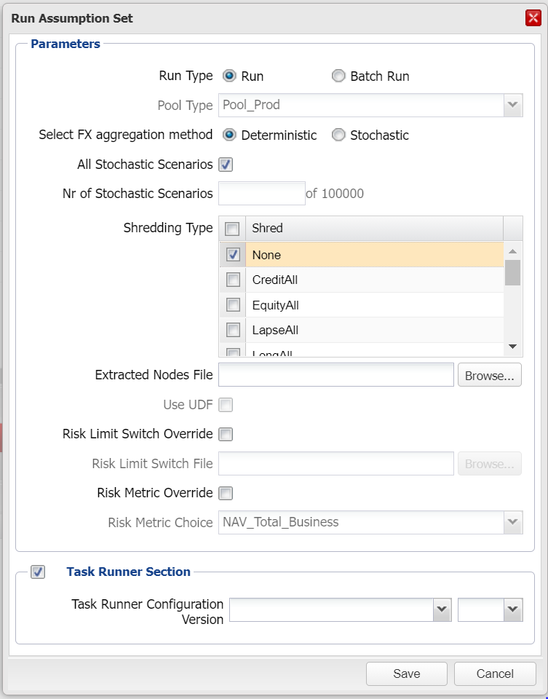

The system displays a window with various runtime parameters to be input as follows:

**Run Type:** The ‘Run’ radio button option must be selected (default)

**Pool Type:** This parameter is determined by the interface. Please see the above business context for more details. Options available to an assumption set run are ‘Pool_Prod’, ‘Pool_SB’, ‘Pool_BigBang’ and cannot be modified.

**Select FX aggregation method:** This allows the user to select which FX aggregation method to implement for the run.

**All stochastic scenarios:** If only a portion of the available scenarios are required to be run, then the user can un-tick this option and enter the number of scenarios that are required to be run, up to the maximum available, in the ‘Nr of stochastic scenarios’ field. If your scenario set contains more than a defined number of scenarios (currently 100,000), then untick the field and insert a number which is less than or equal to 10,000 in order to activate shredding, otherwise shredding would be disabled by default. If the entity set has not been validated, then the number of scenarios that can be run from the assumption set can be limited to a number lower than the maximum number of scenarios available in the scenario set. This limitation can be removed by validating the entity set (see section 10.3.9).

**Nr of Stochastic Scenario**s**:** See above.

**Shredding type:** It is mandatory that the user must select at least one option. Depending on version of the underlying RAFM project, the user has two options on the number of shreds included in the run. If the RAFM projects include the shred optimisation update, the user can either select to trigger a single base stochastic (none option) and/or any of stochastic shreds listed in the dialog box by ticking in the respective tick boxes next to the names of the shreds. If the RAFM project does not support running multiple shreds, the user can select only one shred or base run at the time. The RAFM projects that support running multiple shreds, are backward compatible with the single run functionality. If the underlying RAFM project does not support runs with multiple shredding types a warning message will inform the user that multiple selection is not available. Note that if more than a defined number of scenarios are required to be run (currently 10,000), the system will disable the option to shred and set it to ‘None’.

**Extracted Node Files (optional):** Use the browse function to select a file. The file consists of a list of nodes that is used to create stochastic extraction reports for each of the nodes listed, the maximum is controlled via system administrator configured value.

**Step 4: Use UDF:** currently disabled.

**Step 5**: **Risk Limit Switch Override:** Select whether risk limits are to be overridden or not by checking/unchecking the **‘Risk Limit Switch Override’** field

If the user elects to override the risk limits, they should supply an Excel file that provides the switches for the limits or any additional limits they wish to apply.

**Step 6**: **Risk Limit Switch File:** Use the browse functionality to select a file.

The responsibility for using risk limits with the lite model code rests solely with the end user (lite model developer). Further guidance on risk limits is available in the Appendix (section 14.3).

**Step 7**: **Risk Metric Override:** Select whether the risk metric is be overridden by checking/unchecking the box.

**Step 8**: **Risk Metric Choice:** When the risk metric override button is checked, then you can select the risk metric option from the dropdown box. The Risk metric options are set in the Configuration section in the System Administration menu.

**Step 9:** The user may choose the Task Runner configuration they want to associate with the Assumption Set run by checking the Task Runner Section box. This will provide the user with a list of Task Runner configurations (and available versions of each configuration) that are associated with the RAFM project version underlying the Assumption Set. Alternatively, if he or she does not check the Task Runner Section box, then the run will be triggered with the Task Runner configuration version assigned to the latest RAFM configuration associated with the underlying RAFM project version for the Assumption Set.

**Step 10**: Select ‘Save’ to start the run.

You may select the ‘Cancel’ button to abort the task.

* **You have now run an assumption set in the ICM interface.**
* **An email will be sent by the ICM interface to the user who triggered the run specifying the outcome of their run.**

Please note, when you trigger an Assumption Set run, the ICM will check if the version of the underlying standard or merged ICM RAFM project has an associated RAFM configuration.If a RAFM configuration does not exist for this version, the run will be rejected and user will receive an error message.

**States of a run**

A run can be in any of these particular states which are detailed below:

* **Queued:** This is the state a run is in when there are no environments available for it to be processed on.
* **Processing:** This is the normal processing stage of a run and is displayed as the data flows from the ICM to vGrid and back to the ICM.
* **Completed:** A successful run that generates no errors in RAFM will display a completed status.
* **Failed:** This is a run that fails as it is processing.
* **Invalidated:** Completed runs become invalidated when a run parameter or an ‘in review’ assumption set property or component is changed.
* **Cancelled:** Cancelled runs are those that have been stopped before the processing stage begins. A run can be cancelled at any stage before processing.

**Monitoring your ICM run:**

* The ‘Process overview’ table gives a more detailed report of what stage the run has reached. This is achieved by selecting the relevant run ID and checking the details table at the bottom of the tab.

**Reporting**

* ICM runs produce reports that can be used to verify the numbers produced from the ICM. Please refer to section **12.3.16** for details on how to download these reports.

**Manifest file**

* A separate (post) manifest file is also produced and assigned to the run.

### 12.3.12 How to run an assumption set as a batch

* ***Business context:***
* *The system will manage the following runs when a user triggers a batch run on the ICM. A batch run consists of one of the following sequences of individual runs:*

*1. A stochastic run (Det), a critical scenario set RSG run, a critical scenario run (Det)*

*2. A stochastic run (Sto), a critical scenario set RSG run, a critical scenario run (Sto)*

* Brackets above refer to the setting for the FX aggregation method

* *By performing a batch run, users can create critical scenario run results using a critical scenario RSG which is create from the CSID output of the stochastic run.*
* *The minimum requirement for a run is that the RAFM project can be compiled, an assumption set created with ‘In Review’ components assigned.*
* *All the code based components must have been successfully tested in the RAFM development environment before importing into the ICM interface.*
* ***To be able to run an assumption set as a batch, the following conditions must be met:***
* *The selected version of the assumption set is not locked.*
* *The assumption set has a stochastic scenario set associated with it and is complete with a lite model or aggregation rule attached to every node, except for any nodes marked as nesting nodes, which may remain incomplete.*
* *The tag of the scenario set associated is not "Historical".*
* *For assumption sets without nesting nodes, all ICM components have a status of validated.*
* *For assumption sets with nesting nodes, there exists at least one vanilla (non-batch) type run with ‘Completed’ status in the Runs Table of the assumption set.*
* *The selected version of the assumption set has run parameters assigned.*
* *The purpose of the assumption set is either base-stoch, what-if-stoch or proj-stoch*
* *The LM/AR Compliance flag (in validation panel) for the selected version of assumption set has value “Yes”*
* *The RSG Compliance flag (in validation panel) for the selected version of assumption set has value “Yes”*

**C:\Program Files\Microsoft Office\MEDIA\CAGCAT10\j0293236.wmf**

**Step 1**: Select the ‘Assumption Sets’ tab

**Step 2**: Select the assumption set that you want to run

**Step 3**: Select the node in the entity structure tree which will be the root node for the run. Right click on the node and select ‘Run’

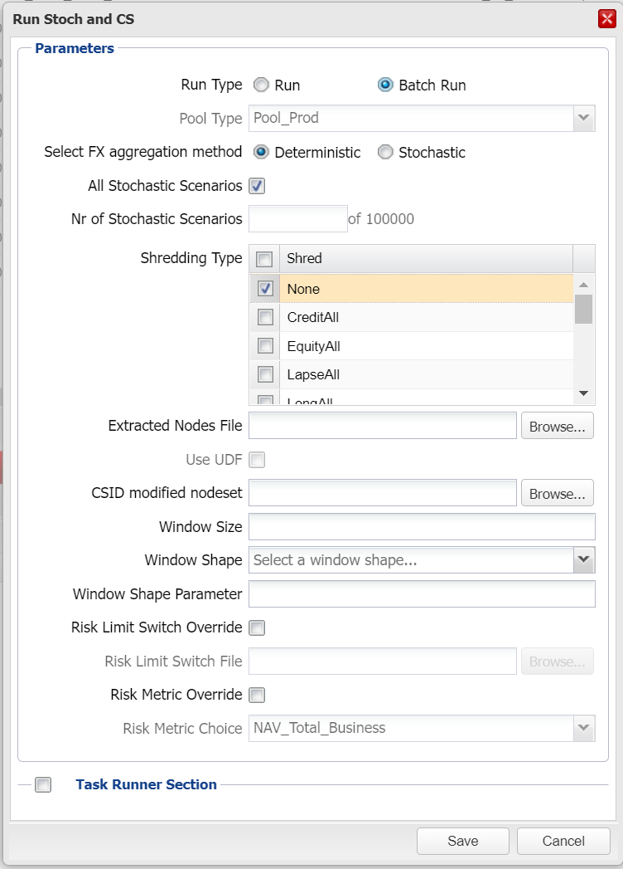

The system displays a window with various runtime parameters to be input as follows:

**Run Type:** The ‘Batch Run’ radio button option must be selected

**Pool Type:** This parameter is determined by the interface. Please see the above business context for more details. Options available to an assumption set run are ‘Pool_Prod’, ‘Pool_SB’, ‘Pool_BigBang’ and cannot be modified.

**Select FX aggregation method:** This allows the user to select which FX aggregation method to implement for the run.

**All stochastic scenarios:** If only a portion of the available scenarios need to be run, then this needs to be unticked and the user must enter the number of scenarios that are required to be run, up to the maximum available, in the ‘Nr of stochastic scenarios’ field. If your scenario set contains more than a defined number of scenarios (currently 10,000), then untick the field and insert a number which is less than or equal to 10,000 in order to activate shredding, otherwise shredding would be disabled by default.

**Nr of Stochastic Scenario**s**:** See above.

**Shredding type:** To run a standard batch run, no selection is needed here and the default of “none” will be fun. If the RAFM projects include the batch on shred update, the user can either select to trigger a single base stochastic (none option) as previously or one of stochastic shreds listed in the dialog box by ticking in the respective tick box next to the names of the shreds. If the RAFM project does not support a batch on shred run, the user cannot select a shred. Note users can select a maximum of one shred, for a batch on shred run.

**Extracted Nodes File (optional):** Use the browse function to select a file. The file consists of a list of nodes that is used to create stochastic extraction reports for each of the nodes listed, limited in number by a system setting.

**CSID modified nodeset:** This needs to be a csv file with the format defined in the section below (CSID_Mod_Nodeset<anytext>..csv file format section).

**Window size, shape and parameter:** These 3 fields are the usual parameters that the user would input for the generation of a critical scenario and should be relevant to the 2nd stage of the batch process.

Please note: ‘Uniform’ is the only permitted window shape.

**Step 4**: Select the various options as required from the runtime parameters window.

**Step 5**: **Risk Limit Switch Override:** Select whether risk limits are to be overridden or not by checking/unchecking the **‘Risk Limit Switch Override’** field

If the user elects to override the risk limits, they should supply an Excel file that provides the switches for the limits or any additional limits they wish to apply.

**Step 6**: **Risk Limit Switch File:** Use the browse functionality to select a file.

The responsibility for using risk limits with the lite model code rests solely with the end user (lite model developer). Further guidance on risk limits is available in the Appendix (section 14.3).

**Step 7**: **Risk Metric Override:** Select whether the risk metric is be overridden by checking/unchecking the box.

**Step 8**: **Risk Metric Choice:** When the risk metric override button is checked, then users can select the risk metric option from the dropdown box. The Risk metric options are set in the Configuration section in the System Administration menu.

**Step 9**: The user may choose the Task Runner configuration they want to associate with the Assumption Set batch run by checking the Task Runner Section box. This will provide the user with a list of Task Runner configurations (and available versions of each configuration) that are associated with the RAFM project version underlying the Assumption Set. Alternatively, if he or she does not check the Task Runner Section box, then the batch run will be triggered with the Task Runner configuration version assigned to the latest RAFM configuration associated with the underlying RAFM project version for the Assumption Set.

**Step 10:** Select ‘Save’ to start the batch run.

You may select the ‘Cancel’ button to abort the task.

* **You have now run a batch run in the ICM interface which can include up to 3 different runs being completed (2 x ICM runs, 1 x RSG standalone run)**
* **A single email will be sent at the end of the batch process to the user who triggered the batch providing details on the run outcomes of each individual run in the batch.**

Please note, when you trigger an Assumption Set batch run, the ICM will check if the version of the underlying standard or merged ICM RAFM project has an associated RAFM configuration. If a RAFM configuration does not exist for this version, the batch run will be rejected and user will receive an error message.

**Monitoring the progress of a batch**

* Each run in the batch will have a unique Batch ID assigned which is displayed against the run in the ‘Process overview’ table screen.
* The ‘Process overview’ table gives a more detailed report of what stage each specific has reached. This is achieved by selecting the relevant run ID and checking the details table at the bottom of the tab. The runs will each have their unique run IDs and will be run sequentially one after the other.

**Run manifest**

* A separate (post) run manifest file is assigned to each of the ICM runs upon completion.

**Batch run records**

* Batch runs produce an individual batch run record that is stored in a separate tab titled ‘Batch Runs’ in the details table of the assumption set. This batch run record is in additional to the three additional run records produced for each individual run within the batch.

**Batch run states**

* Individual run records have the same run states as normal runs. However, the batch run record additionally displays the following states:
* **Queued:** Assigned when the first run of the batch is queued
* **Processing:** When the first run of the batch is processing and until all the runs of the batch have completed or all remaining runs have been cancelled or until the processing run is failed
* **Cancelling:** When a non-completed run of the batch run has been requested to be cancelled
* **Completed:** When all the runs included in the batch run have ‘Completed’ status
* **Cancelled:** When all the runs of the batch run have been cancelled
* **Failed:** When all the runs of the batch run have status failed
* **Invalidated:** When the first run becomes invalidated and the batch process is stopped before triggering the RSG run

**Invalidation of runs**

* You should note that any modification to the stochastic assumption set that results in its runs becoming invalidated will also cause the critical scenario run to be invalidated (only applicable if a critical scenario assumption set run is involved).

**CSID_Mod_Nodeset<anytext>..csv file format**

CSID_mod_nodeset<anytext>.csv and contain at least one line of information. The first line must contain the root node of the run as below:

- Acct/Book root="~<ROOT NODE>"

The second line onwards must contain the names of the nodes that are required for the critical scenario generation and must be in format as below, depending on the hierarchical relationship of the nodes:

- <ROOT NODE>>><PARENT NODE>>><CHILD NODE>

This file will allows the system to retrieve from the completed CSID_ST.csv (following the completion of the 1st part of the batch) those nodes that are relevant to the user, together with the associated ranked scenarios and create trimmed down CSID_ST.csv file that will then be used to create the critical scenario in the 2nd part of the batch.

### 12.3.13 How to run an assumption set under a Bulk Run Profile

* ***Business context:***
* *Bulk run profiles can be used as templates for setting up combinations of runs which are triggered from the same node within an assumption set.*
* ***To be able to trigger a bulk run profile against a particular node within an assumption set, the following conditions must be met:***
* *The selected version of the assumption set is not locked.*
* *The tag of the scenario set associated is not "Historical".*
* *The assumption set has a valid scenario set associated with it and is complete with a lite model or aggregation rule attached to every child node under the node of interest for the runs.*
* *The selected version of the assumption set has run parameters assigned.*
* *The bulk run profile has status ‘Enabled’*
* *The bulk run profile has been shared with the geography in which the assumption set resides*
* *The purpose of the assumption set is either Stochastic (base-stoch, what-if-stoch or proj-stoch) or BigBang (base-bb, what-if-bb, or proj-bb)*
* *The bulk run profile shares a common purpose with the assumption set*
* *The LM/AR Compliance flag (in validation panel) for the selected version of assumption set has value “Yes”*
* *The RSG Compliance flag (in validation panel) for the selected version of assumption set has value “Yes”*

**C:\Program Files\Microsoft Office\MEDIA\CAGCAT10\j0293236.wmf**

**Step 1**: Select the ‘Assumption Sets’ tab

**Step 2**: Select the assumption set that you want to run from the summary table

**Step 3**: Select the node in the entity structure tree which will be the root node for the run. Right click on the node and select the name of the required bulk run profile under the ‘Run Profile’ submenu

The system displays a window with all the available runs (and details of their component runtime parameters) under the profile and checkboxes next to them.**Step 4**: Select the checkbox next to a single run. (Optional)

The ‘Modify’ button above the table is now active. This button will cease to be active if multiple runs are selected.

**Step 5**: Select the ‘Modify’ button. (Optional)

A ‘Modify Bulk Run Profile Run’ dialog box is displayed. The user is presented with the following runtime parameter options which can be edited:

**Description:** This is a free text field.

**Select FX aggregation method:** This allows the user to select which FX aggregation method to implement for the run

**Risk Limit Switch Override**: If this option is selected, the user must browse for and upload an Excel file that provides the switches for the limits or any additional limits they wish to apply to this run. The user now has up to 3 possible options:

1. Use the Default risk limits file
2. Use the Profile override risk limits file (if one has been uploaded by an administrator or business champion for this particular run within the bulk run profile)
3. Use a Runtime override (here the user can browse for an upload his/her own risk limits file which will replace the Default or Profile risk limits files where applicable)

Option 2 will be greyed out if no custom risk limits file had been set at the profile level.

If the purpose of the bulk run profile is Stochastic, then the following parameters will also be available for the user to set:

**All stochastic scenarios:** If only some of the available scenarios need to be run, then this box should be unticked and the user must enter the number of scenarios that are required, up to the maximum available, in the ‘Nr of Stochastic Scenarios’ field. If the scenario set underlying the assumption set from which the bulk run profile is triggered contains fewer scenarios than the number specified here, then the maximum number of scenarios actually available will be used instead at runtime.

**Shredding type:** This menu allows the user to add one or multiple stochastic shreds per run. The list of shreds available here is predefined by an administrator through the Configuration menu item under System Administration tab.

**Extracted Nodes File (optional):** Use the browse function to select a file. The file consists of a list of nodes that is used to create stochastic extraction reports for each of the nodes listed.

**Risk Metric Override:** If this option is selected, the user must then choose the risk metric in the box below.

**Risk Metric Choice**: This option allows the user to choose the risk metric. The list of risk metrics available here is predefined by an administrator through the Configuration menu item under System Administration tab.

If the ‘Batch Run Section’ checkbox is selected for a Stochastic purpose bulk run profile, the following additional options are available:

**CSID modified nodeset:** This needs to be a csv file with the format defined in the section below (CSID_Mod_Nodeset<anytext>..csv file format section).

**Window size, shape and shape parameter:** These 3 fields are the usual parameters that the user would input for the generation of a critical scenario and should be relevant only to the critical scenario stage of the batch process.

**Step 6**: Select ‘Save’ to save the runtime settings for that particular run.

You may select the ‘Cancel’ button to abort the modification task.

Steps 4 to 6 can be repeated as necessary for each run that the user wishes to change the runtime parameters for which had been preset within the bulk run profile template. Changing the parameters at this stage does not affect the settings in the original template.

**Step 7:** Select each run which the user wants to trigger. By default, no runs are selected. If the user wishes to select all runs in the profile (potentially after modifying them), the user can select the checkbox next to the column headers.

**Step 8**: The user may choose the Task Runner configuration they want to associate with the bulk run by checking the Task Runner Section box. This will provide the user with a list of Task Runner configurations (and available versions of each configuration) that are associated with the RAFM project version underlying the Assumption Set. Alternatively, if he or she does not check the Task Runner Section box, then the bulk run will be triggered with the Task Runner configuration version assigned to the latest RAFM configuration associated with the underlying RAFM project version for the Assumption Set. For the avoidance of doubt, the Task Runner configuration chosen in this step will be applied to all the individual runs selected in Step 7.

**Step 9**: Select ‘Run’ to trigger all the runs selected. These runs will be placed in a queue and sent to the RAFM execution servers for processing. This process is equivalent to the user triggering the all the runs individually from the assumption set and node of interest.

You may select the ‘Cancel’ button to abort the run task.

At this stage, runs are processed identically to the steps outlined in sections 12.3.11 (for individual runs) and 12.3.12 (for batch runs). Monitoring of runs also behaves identically in the ICM interface. The run progress can be seen in the details window in the assumption set tab.

* **You have now run triggered a bulk run profile against an assumption set in the ICM interface.**
* **An email will be sent by the ICM interface to the user who triggered the run specifying the outcome of each run.**
* **A separate (post-run) manifest file will be produced for each run.**

Please note, when you trigger a bulk run, the ICM will check if the version of the underlying standard or merged ICM RAFM project for the Assumption Set has an associated RAFM configuration. If a RAFM configuration does not exist for this version, the bulk run will be rejected and user will receive an error message. None of the individual runs selected for the bulk run will be triggered.

Furthermore, in the case you trigger a stochastic assumption set run using a bulk run profile, the ICM will check if the underlying RAFM project and the shreds’ setting of the bulk run profiles are compatible. In detail:

* An assumption set with an underlying RAFM project that has shred optimisation enabled, can trigger a run using bulk run profiles with both shredding run types, but the user is advised to use a bulk run profile that has multiple shreds run under a single vGrid run.
* An assumption set without an underlying RAFM project that has shred optimisation, can trigger a run using bulk run profile which run the shreds as individual runs.

For more details, please see the ICM Stochastic multi-shred on a single stochastic run process note.

### 12.3.14 How to download (post) run manifest

**C:\Program Files\Microsoft Office\MEDIA\CAGCAT10\j0293236.wmf**

* ***Business context:***
* *The run manifest provides users with a convenient downloadable file that, similar to the pre-run manifest file, lists all the components associated to an assumption set, including scenario set information and their respective versions as well as run parameters. Additionally, it also produces run data, with versioning of all components on which the assumption has been run. It also provides a full list of the environment variables from the box on which it has been run and includes the run data. The (post) run manifest also provides information for the RAFM configuration and Task Runner configuration used by the run.*
* *Users should note that a run manifest is particular to a single run, whereas a pre-run manifest file is valid for the whole assumption set version.*
* *The run manifest acts as a permanent record of the run and its constituent components and environment details and is therefore a reliable audit trail for future investigations or replication of the run results.*
* ***To be able to download a run manifest, the following conditions must be met:***
* *The selected version of the assumption set has been run at least once*
* A run is available and in ‘Completed’, ‘Failed’, ‘Cancelled’ or ‘Invalidated’ status
* *The user belongs to the owner user group of the assumption set*

**Step 1**: Select the ‘Assumption Sets’ tab.

**Step 2**: Select a version of an assumption set in the assumption set summary table.

**Step 3**: Select a run in the ‘runs table’ tab of the details table of the assumption set.

**Step 4**: Select the option ‘Run manifest’ from the ‘Download’ drop-down list. Please refer to note below.

The system will present the user with a file to download.

**Step 5**: Save the file produced to your local drive for inspection or open it to view.

You may select the ‘Cancel’ button to abort the task.

* **Upon completion of the above steps, the run manifest is available to the user.**

**Format and information availability of the run manifest**

* The run manifest is only available when the run is complete, failed, cancelled or invalidated. If unavailable the download option is greyed out. The run manifest is in csv format.
* A post-run manifest file will only contain information of the assumption’s set owning geography i.e. PCA will not be able to see GHO results.

### 12.3.15 How to download the Risk Limits file

**C:\Program Files\Microsoft Office\MEDIA\CAGCAT10\j0293236.wmf**

* ***Business context:***
* *The risk limits provide users with extra flags which are used to target certain sections of their lite model code, under certain business conditions. Currently they are used to generate alternate results for Matching Adjustment and Volatility Adjustment portfolio conditions.*
* ***To be able to download a run manifest, the following conditions must be met:***
* A run is available and in ‘Queued’, ‘Processing’, ‘Completed’, ‘Failed’, ‘Cancelled’ or ‘Invalidated’ status
* *The user belongs to the owner user group of the assumption set*

**Step 1**: Select the ‘Assumption Sets’ tab.

**Step 2**: Select a version of an assumption set in the assumption set summary table.

**Step 3**: Select a run in the ‘Runs Table’ tab of the details table of the assumption set.

**Step 4**: Select the option ‘Risk Limits’ from the ‘Download’ drop-down list. Please refer to note below.

The system will present the user with a file to download.

**Step 5**: Save the file produced to your local drive for inspection or open it to view.

You may select the ‘Cancel’ button to abort the task.

* **Upon completion of the above steps, the risk limits file is available to the user.**

**Format and availability of the risk limits file**

* The format of the risk limits file is in .csv and it will become available as soon as the run has been successfully submitted. It will remain available regardless of the run outcome.

### 12.3.16 How to download run logs/reports from an assumption set

**C:\Program Files\Microsoft Office\MEDIA\CAGCAT10\j0293236.wmf**

* ***Business context:***
* *The reports and logs from a completed assumption set run are the outputs that are stored on the ICM database for the user to retrieve.*
* *The run logs may be useful to either record what data was loaded or to investigate any failures. These are best suited for an initial inspection as the number of logs available can be limited and would help anyone without access to ICM support log files to make an early diagnosis of their run failures.*
* *The reports are produced and are a copy of those produced in the output folder. They are always available to download as they are stored on the ICM database and are therefore not linked to the original reports produced, which are subject the archiving.*
* ***To be able to download run reports and/or logs, the following conditions must be met:***
* *The selected version of the assumption set has been run at least once*
* *The user belongs to the run owner user group of the assumption set*

**Step 1**: Select the ‘Assumption Sets’ tab.

**Step 2**: Select a version of an assumption set in the assumption set summary table.

**Step 3**: Select a run in the ‘Runs Table’ tab of the details table of the assumption set.

**Step 4**: Select the option ‘Run log’ or any other report from the ‘Download’ drop-down list.

The system will present the user with a list of run results files to download.

**Step 5:** Select the required logs or reports or tick the topmost selection box to download all available reports.

**Step 6**: Save the file produced to your local drive for inspection.

You may select the ‘Cancel’ button to abort the task.

* **Upon completion of the above steps, the run logs and/or reports are available to the user.**

### 

### 12.3.17 How to upload reports to a run

**C:\Program Files\Microsoft Office\MEDIA\CAGCAT10\j0293236.wmf**

* ***Business context:***
* *The CSID_ST report produced by a stochastic run will include the ranked scenarios around the biting scenario for all the nodes present in the entity structure from which the run has been triggered.*
* *Not all of these nodes are relevant to the production of the critical scenario. Therefore, the ICM allows the user to download the CSID_ST report from the interface, using the method employed in section 3.3.8 4d, modify it to only include the relevant nodes and re-upload it to the interface for use during the critical scenario generation process. This results in the production of a critical scenario that only contains data for the nodes of relevance to the user.*
* *Users should note that the format and content of this uploaded file is different from the nodeset file that is selected during a batch run.*
* ***To be able to upload reports to a run, the following conditions must be met:***
* *The selected version of the assumption set has been run at least once, with a run record available with a status of completed or invalidated.*

**Step 1**: Select the ‘Assumption Sets’ tab.

**Step 2**: Select a version of an assumption set in the assumption set summary table.

**Step 3**: Select a run in the ‘Runs Table’ tab of the details table of the assumption set

**Step 4**: Select the option ‘Upload Reports’ from the details table menu. See note below for exceptions.

The system will present the user with a pop-up window allowing for a file to be browsed for and uploaded.

**Step 4**: Select the file required from your local/network drive and click ‘Upload’.

Please note, the filename should end with the run ID.

You may select the ‘Cancel’ button to abort the task.

* **Upon completion of the above steps, the uploaded report is available for use and for download from the interface.**

**Uploading to invalidated runs**

* Completed runs that are subsequently invalidated can have a modified CSID_ST.csv file uploaded just like it is possible to create a critical scenario set using the assumption set and its default CSID_ST.csv or any modified CSID_ST.csv that was uploaded.

### 12.3.18 How to generate BU Reports

**C:\Program Files\Microsoft Office\MEDIA\CAGCAT10\j0293236.wmf**

* ***Business context:***
* *The BU reports allow a user to reduce the original set of assumption set run results (ICM reports, which are available through the ‘Reports’ button on the Download dropdown menu) to a specific node level. The BU reports output would only contain the results of the requested Node and the levels below.*
* ***To generate BU Reports, the following conditions must be met:***
* *Users must have BU reports user permission*
* *Users must be provisioned with access to view specific node level results*

**Step 1**: Select the ‘Assumption Sets’ tab.

**Step 2**: Select a version of an assumption set in the assumption set summary table.

**Step 3**: Select a run in the ‘Runs Table’ tab of the details table of the assumption set

**Step 4**: Select the option ‘Request BU Reports’ from the details table menu.

The system will present the user with a ‘Post-processing Jobs Settings’ pop-up window allowing the user to select a node.

**Step 5**: Select the required ‘Node’ using the dropdown feature.

**Step** 6: Click ‘Submit’.

Please note below for pre-run validations.

You may select the ‘Cancel’ button to abort the task.

* **Upon completion of the above steps, the ‘Post-processing’ job will be submitted for execution.**

**Post-Processing Job Validations**

* A Post-processing Job for the same assumption set run and node is not already in progress (Queued or Processing)
* BU Reports for the same assumption set and node already exist

### 12.3.19 How to download generated BU Reports

**C:\Program Files\Microsoft Office\MEDIA\CAGCAT10\j0293236.wmf**

* ***Business context:***
* *The successfully generated BU Reports can be downloaded. These will contain the ICM Reports trimmed down to a specific Node and levels below it.*
* ***To download BU Reports, the following conditions must be met:***
* *Users must have BU reports user permission*
* *BU Reports request must have successfully completed previously*
* *The generated BU Report request output has not been archived*

**Step 1**: Select the ‘Assumption Sets’ tab.

**Step 2**: Select a version of an assumption set in the assumption set summary table.

**Step 3**: Select a run in the ‘Runs Table’ tab of the details table of the assumption set.

**Step 4**: Select the option ‘BU Reports’ from the download dropdown menu.

**Step 5:** The system will present the user with a ‘BU Reports’ pop-up window allowing the user to select BU report filenames to be downloaded by selecting individual check boxes.

**Step 6:** Select the ‘Download’ button.

The system will present the user with a file to download.

You may select the ‘Cancel’ button to abort the task.

* **Upon completion of the above steps, the BU Reports are available to the user.**

### 12.3.20 How to lock down assumption set

**C:\Program Files\Microsoft Office\MEDIA\CAGCAT10\j0293236.wmf**

* ***Business context:***
* *Locking down an assumption set allows for it to be versioned such that the results which produced a required balance sheet can be reproduced in the future.*
* *Locking down should also be used for BU-level assumption sets which have been nested onto by LBU entity sets, prior to nesting the BU-level assumption set onto a GWAS.*
* *Only one user is required to lock down the assumption set and any future changes to such an assumption set would result in a new version being produced, much like validated versions of components e.g. lite models.*
* *Locking down an assumption set has no effect on the validated status of its constituent components.*
* ***To be able to lock down an assumption set, the following conditions must be met:***
* *The selected version of the assumption set is unlocked and has a status of ‘in review’.*
* *All the associated entity sets,scenario set and the RAFM merged project are validated.*
* *The user locking down the assumption set is different from the user who last modified the assumption set.*
* *The user locking down the assumption set belongs to the user group that owns the assumption set*.
* *There is at least one valid run (i.e. with a status of ‘Completed’) that includes the entity set(s) assigned to the assumption set.*
* *If the assumption set being locked down is marked as ‘same as’, the original assumption sets need to also be locked down.*

**Step 1**: Select the ‘Assumption Sets’ tab.

**Step 2**: Select an assumption set in the assumption set summary table.

**Step 3**: Select the option ‘Lock down’ from the ‘Validation’ menu.

The system will present the user with a pop-up window with the following fields to be completed:

**RunID:** This is a complete list of all the runs that have a status of ‘Completed’ against the assumption set selected.

**Critical runID:** This is a complete list of all runs that have a status of ‘Completed’ against the assumption set selected but which were triggered using a critical scenario set.

**File:** Browse feature to upload a file (optional)

**Comments:** Optional free text field

**Step 4**: Select the required runIDs from above (i.e. those that contributed to the appropriate balance sheet) and fill in any relevant boxes

**Step 5:** Select ‘Lock down’.

The system updates the colour of the nodes in the tree table to blue and changes the status of the assumption set to ‘Locked down’ in the summary table. RunIDs selected in Step 4 are also marked with a red lock in the run details table.

You may select the ‘Cancel’ button to abort the task.

* **Upon completion of the above steps, the assumption set version is locked down and all its underlying components are shared with parents and grandparents. Completed runs attached to an assumption set are marked with a red padlock.**

**Special root node condition**

* When selecting runIDs for the locking down of the assumption set, at least one of those must have been triggered from the top node of the assumption set.

### 12.3.21 How to mark runs on locked down assumption set

**C:\Program Files\Microsoft Office\MEDIA\CAGCAT10\j0293236.wmf**

* ***Business context:***
* *Marking runs on a locked down assumption set allows users to mark one or more ICM runs with a status of ‘Completed’ after that assumption set has been locked down.*
* *This functionality allows users to add relevant runs to their locked assumption sets and provides some flexibility on the timing of certain runs versus the requirement to lock and version an assumption set as soon as it is practical to do so.*
* ***To be able to mark a run on a locked down assumption set, the following conditions must be met:***
* *The selected version of the assumption set is ‘Locked Down’*
* *The user marking the run belongs to the user group that owns the assumption set*
* *There is at least one valid run (i.e. with a status of ‘Completed’) that has not been marked on the assumption set*

**Step 1**: Select the ‘Assumption Sets’ tab.

**Step 2**: Select a locked down assumption set in the assumption set summary table.

**Step 3**: Select the option ‘Mark runs’ from the ‘Validation’ menu.

The system will present the user with a pop-up window with the following fields to be completed:

**RunID:** This is a complete list of all the runs that have a status of ‘Completed’ against the assumption set selected and that have not been marked on the locked down assumption set.

**Critical runID:** This is a complete list of all runs that have a status of ‘Completed’ against the assumption set selected but which were triggered using a critical scenario set and were not marked on the locked down assumption set.

**File:** Browse feature to upload a file (optional)

**Comments:** Optional free text field

**Step 4**: Select the required runIDs and fill in any relevant boxes

**Step 5:** Select ‘Mark runs’.

The system marks the runIDs selected with a red lock in the run details table.

You may select the ‘Cancel’ button to abort the task at any time.

* **Upon completion of the above steps, the selected runs are marked with a red lock in the run table in the Details for pane.**

### 12.3.22 How to download the lock down/sign off report of an assumption set

**C:\Program Files\Microsoft Office\MEDIA\CAGCAT10\j0293236.wmf**

* ***Business context:***
* *This feature allows users to download a sign off or lock down report where one has been uploaded*
* ***To be able to download the report, the following conditions must be met:***
* *The selected version of the assumption set is locked down or signed off and a report is available*

**Step 1**: Select the ‘Assumption Sets’ tab.

**Step 2**: Select a version of an assumption set in the assumption set summary table.

**Step 3**: Select the option ‘Download Lock Down / Sign Off Report’ from the ‘Download’ menu.

The system displays the list of available reports.

**Step 4**: Select one or more reports as required.

**Step 5:** Select ‘Download’.

The system makes the files available for download to the user.

You may select the ‘Cancel’ button to abort the task.

* **Upon completion of the above steps, the selected reports are available to download.**

**Report notes**

* If no reports were uploaded to the ICM during the sign off or lock down process, then the option to download reports is greyed out.
* The report is provided in the same format as it was uploaded.

### 12.3.23 How to assign a merged ICM RAFM project to an assumption set

**C:\Program Files\Microsoft Office\MEDIA\CAGCAT10\j0293236.wmf**

* ***Business context:***
* *A nested assumption set will not run until a merged ICM RAFM project is assigned*
* *A updated merged ICM RAFM project may need to be assigned where a previously assigned merged ICM RAFM project did not or will not produce the correct result*
* *The assigned merged ICM RAFM project is used for all runs of the assumption set*
* *If the assignment is unsuccessful, the user can download a report which shows which ICM component failed validation*
* ***To be able to assign a merged ICM RAFM project to an assumption set, the following conditions must be met:***
* *The selected version* of the merged project has a status of ‘Validated’
* The selected original assumption set has a published flag set to ‘Yes’.
* The copied assumption sets, Published flag can be ‘Yes’ or ‘No’.
* The selected assumption set is associated with a entity set with nesting via assigned geographies only.
* The selected assumption set is owned by or shared with the current geography.
* The selected version of the assumption set is not marked as ‘Same as’ assumption set.
* The assumption set is complete (all code bases are assigned)

**Step 1**: Select the ‘Assumption Sets’ tab.

**Step 2**:Select an assumption set in the assumption set summary table.

**Step 3**:Select the option ‘Assign Merged Project’ from the ‘RAFM Project’ menu.

**Step 4**: The system will present the user with a pop-up window with a list of assumption sets that will be invalidated after the modification of the assumption set takes effect.

If a modification occurs then queued and requested runs will be cancelled. Completed runs will be invalidated and processing runs will be invalidated after completion.

**Step 4**: Select ‘Ok’ to continue with the assignment.

You can select the ‘Cancel’ button to abort the task at this stage.

**Step 5**: The system will present the user with a pop-up window with a drop-down list listing all the Merged ICM RAFM projects.

**Step 6**: Select a merged ICM RAFM project from the dropdown list.

**Step 7**: Select the ‘Assign’ button.

You can select the ‘Cancel’ button to abort the task.

* **Upon completion of the above steps, the merged ICM RAFM project will be assigned to an assumption set. The group wide assumption set can now be run.**

### 12.3.24 How to unassign a merged ICM RAFM project from an assumption set

**C:\Program Files\Microsoft Office\MEDIA\CAGCAT10\j0293236.wmf**

* ***Business context:***
* *A user may need to replace or unassign a merged ICM RAFM project from an assumption set*
* *A nested assumption set will not run until a merged ICM RAFM project is assigned*
* ***To be able to download the report, the following conditions must be met:***
* *The selected version of assumption set is not locked*
* *The merged ICM RAFM project is assigned to the selected assumption set version*
* *The selected version of the assumption set is not marked as a "Same as" assumption set*
* *The selected assumption set version is owned by/shared with the current geography*

**Step 1**: Select the ‘Assumption Sets’ tab.

**Step 2**:Select an assumption set in the assumption set summary table.

**Step 3**:Select the option ‘Unassign Merged Project’ from the ‘RAFM Project’ menu.

**Step 4**: The system will present the user with a pop-up window asking the user to confirm that they want to unassign the assigned merged ICM RAFM project.

**Step 5**: Select the ‘Yes’ button.

You can select the ‘No’ button to abort the task.

* **Upon completion of the above steps, a merged ICM RAFM project will be unassigned from an assumption set.**

### 12.3.25 How to download an ICM RAFM project

**C:\Program Files\Microsoft Office\MEDIA\CAGCAT10\j0293236.wmf**

* ***Business context:***
* *A user may wish to take standard projects from multiple geographies and create a single merged project that can be used for runs consolidating numbers from multiple geographies. The download consists of a single zip file that contains standard RAFM projects (including library, object and script files) for the parent geography and each nested geography and a single set of input files created consistently with the inputs for the merged project assumption set. Having these files, although not required for the merging exercise, enables the user to validate the integrity of the merged project once the merging process has been completed outside of the ICM environment prior to reupload to reduce the risk of errors being reduced in the merging process.*
* ***To be able to download the report, the following conditions must be met:***
* *The selected assumption set is published*
* *The selected assumption set has at least one nested entity set*
* *The user must have access to the geography which owns the selected assumption set*

**Step 1**: Select the ‘Assumption Sets’ tab.

**Step 2**:Select an assumption set in the assumption set summary table.

**Step 3**:Select the option ‘Download RAFM Projects’ from the ‘Download’ menu.

**Step 4:** A window will pop up, similar to that which is seen when running an assumption set (see section 12.3.11).

The system makes the files available for download.

You can select the ‘Cancel’ button to abort the task.

The download contains all RAFM projects used in the assumption set. The download contains the Merged ICM RAFM Project in the main entity set of the selected assumption set and Standard RAFM Project(s) from nested entity set(s).

The download is a single zipped archive.

**Upon completion of the above steps, one or more Standard ICM RAFM project(s) will be downloaded in a single zipped file.**

### 12.3.26 How to export an ICM RAFM project

**C:\Program Files\Microsoft Office\MEDIA\CAGCAT10\j0293236.wmf**

* ***Business context:***
* *Whenever a user needs to update a RAFM project, the development work is undertaken in a standalone version of RAFM. Development is undertaken by the lite model developers and is independent of the ICM interface.*
* *Before a RAFM project can be tested in a standalone version of RAFM, RAFM also requires that an associated assumption set archive zip file is also available.*
* *An associated assumption set archive is maintained in the ICM interface and must be exported so that its data can be accessed by the standalone version of RAFM.*
* ***To be able to export an ICM RAFM project, the following conditions must be met:***
* *The user has permission to export RAFM projects*
* *The user belongs to the assumption set owner user group*
* *The selected version of the assumption set is not locked*
* *The assumption set has an associated scenario set*
* *The assumption set is complete*
* *The entity structure has an aggregation rule or lite model assigned to each node*
* *The LM/AR Compliance flag (in the validation panel) for the selected version of the assumption set has a value of “Yes” .*
* *The RSG Compliance flag (in the validation panel) for the selected version of the assumption set has a value of “Yes” .*
* *The tag of the scenario set associated is not 'Historical'*

**Step 1**: Select the ‘Assumption Sets’ tab.

**Step 2**:Select an assumption set in the assumption set summary table.

**Step 3:** Right click on the root node

**Step 4a**:Select the option ‘Export RAFM Project’.

The system will present the user with a pop-up window with the following parameter fields to be completed:

**Select FX aggregation method:** This allows the user to select which FX aggregation method to be associated with the project.

**Use UDF:** currently disabled.

**Risk Limit Switch Override:** Select whether risk limits are to be overridden or not by checking/unchecking the ‘Risk Limit Switch Override’ field. If the user elects to override the risk limits, they should supply an Excel file that provides the switches for the limits or any additional limits they wish to apply.

**Risk Limit Switch File:** Use the browse functionality to select a file.

For stochastic assumption sets, the following additional parameters are required:

**All stochastic Scenarios:** If only a portion of the available scenarios are required to be run, then the user can un-tick this option and enter the number of scenarios that are required to be run, up to the maximum available, in the ‘Nr of stochastic scenarios’ field. If your scenario set contains more than a defined number of scenarios (currently 10,000), then untick the field and insert a number which is less than or equal to 10,000 in order to activate shredding, otherwise shredding would be disabled by default.

**Nr of Stochastic Scenarios:** See above.

**Shredding Type:** This field is mandatory. The user must select one shredding type. The user may select shredding type ‘None’ which leaves the shredding type entry in the worker distribution file blank. The user may select one of a number of other shredding types available which will be used to populate that shredding type name in the worker distribution file.

**Extracted Nodes File (optional):** Use the browse function to select a file. The file contains a list of nodes that is used to create stochastic extraction reports for each of the nodes listed.

**Step 4b**:Select the option ‘Export Stoch & CS’ (performed after completing Steps 1-3).

The system will present the user with a pop-up window with the following parameter fields to be completed:

**Select FX aggregation method:** See above.

**All stochastic Scenarios:** See above.

**Nr of Stochastic Scenarios:** See above.

**Extracted Nodes File:** See above.

**CSID modified nodeset:** Use the browse functionality to select a file.

**Window Size:** Manually enter a window size.

**Window Shape:** Use the drop down functionality to select ‘Uniform’ as window shape.

**Window Shape Parameter:** Manually enter a window shape parameter.

**Risk Limit Switch Override:** See above.

**Risk Limit Switch File:** See above.

All non-greyed out fields are mandatory.

**Step 5**: Select the ‘Export’ button.

The system makes the files available for download.

You can select the ‘Cancel’ button to abort the task.

The download is a single zipped archive.

* **Upon completion of the above steps, an assumption set archive will be exported in a single zipped file.**

### 12.3.27 How to cancel a queued RAFM run

**C:\Program Files\Microsoft Office\MEDIA\CAGCAT10\j0293236.wmf**

* ***Business context:***
* *If an assumption set is queued to run in the RAFM environment and the run has not yet started processing, the user may cancel the run. Once the run has started to process, the run cannot be cancelled.*

* ***To be able to download the report, the following conditions must be met:***
* *User has the required permission to access the queue balancer*
* *At least one queued run is present in the queue balancer table*

**Step 1**: Select the ‘Queue Balancer’ option from the ‘System Administration’ tab.

**Step 2**:Select a queued run from the ‘Runs For RAFM’ summary screen

**Step 3**:Select the option ‘Cancel Run’ from the ‘Maintenance’ menu

**Step 4:** The system displays a pop-up asking the user to confirm cancellation.

**Step 5**: Select the ‘Cancel’ button.

You can select the ‘Cancel’ button to abort the task.

* **Upon completion of the above steps, a queued RAFM assumption set run will be cancelled and the run entry no longer be visible in the queue balancer table. The run will still be maintained in the process overview table with a status of ‘Cancelled’.**

### 12.3.28 How to download Scenario Set RSG Results Report from an assumption set

**C:\Program Files\Microsoft Office\MEDIA\CAGCAT10\j0293236.wmf**

* ***Business context:***
* *Each Assumption Set run is linked to an underlying Scenario Set run. The RSG Results Report that was produced by this Scenario Set run contains the risk model calculation for each given risk driver and scenario.*
* *The Scenario Set run RSG Results Report can be downloaded via the Assumption Set tab for investigative purposes.*
* *The report available for download from the Assumption Set tab is the same report that is also available from the Scenario Set tab.*
* *The RSG Results Report that is described here is different from the report of the same name that is available from Download->Reports (described in 12.3.18).*
* *This RSG report will be much larger and contains all scenario values, it is available for all run types. The RSG report as described in 12.3.18 is only available for a Base Stochastic run type and contains node level RSG values.*
* *The RSG report will only be available for a limited period time defined by the housekeeping rules. After this period, the file will not be available for download through ICM.*

**Step 1**: Select the ‘Assumption Sets’ tab.

**Step 2**: Select a version of an assumption set in the assumption set summary table.

**Option 1 -** To access the RSG report currently attached to a selected Assumption Set.

**Step 3**: Select the option ‘Download RSG Results Report’ from the ‘Download’ drop-down list.

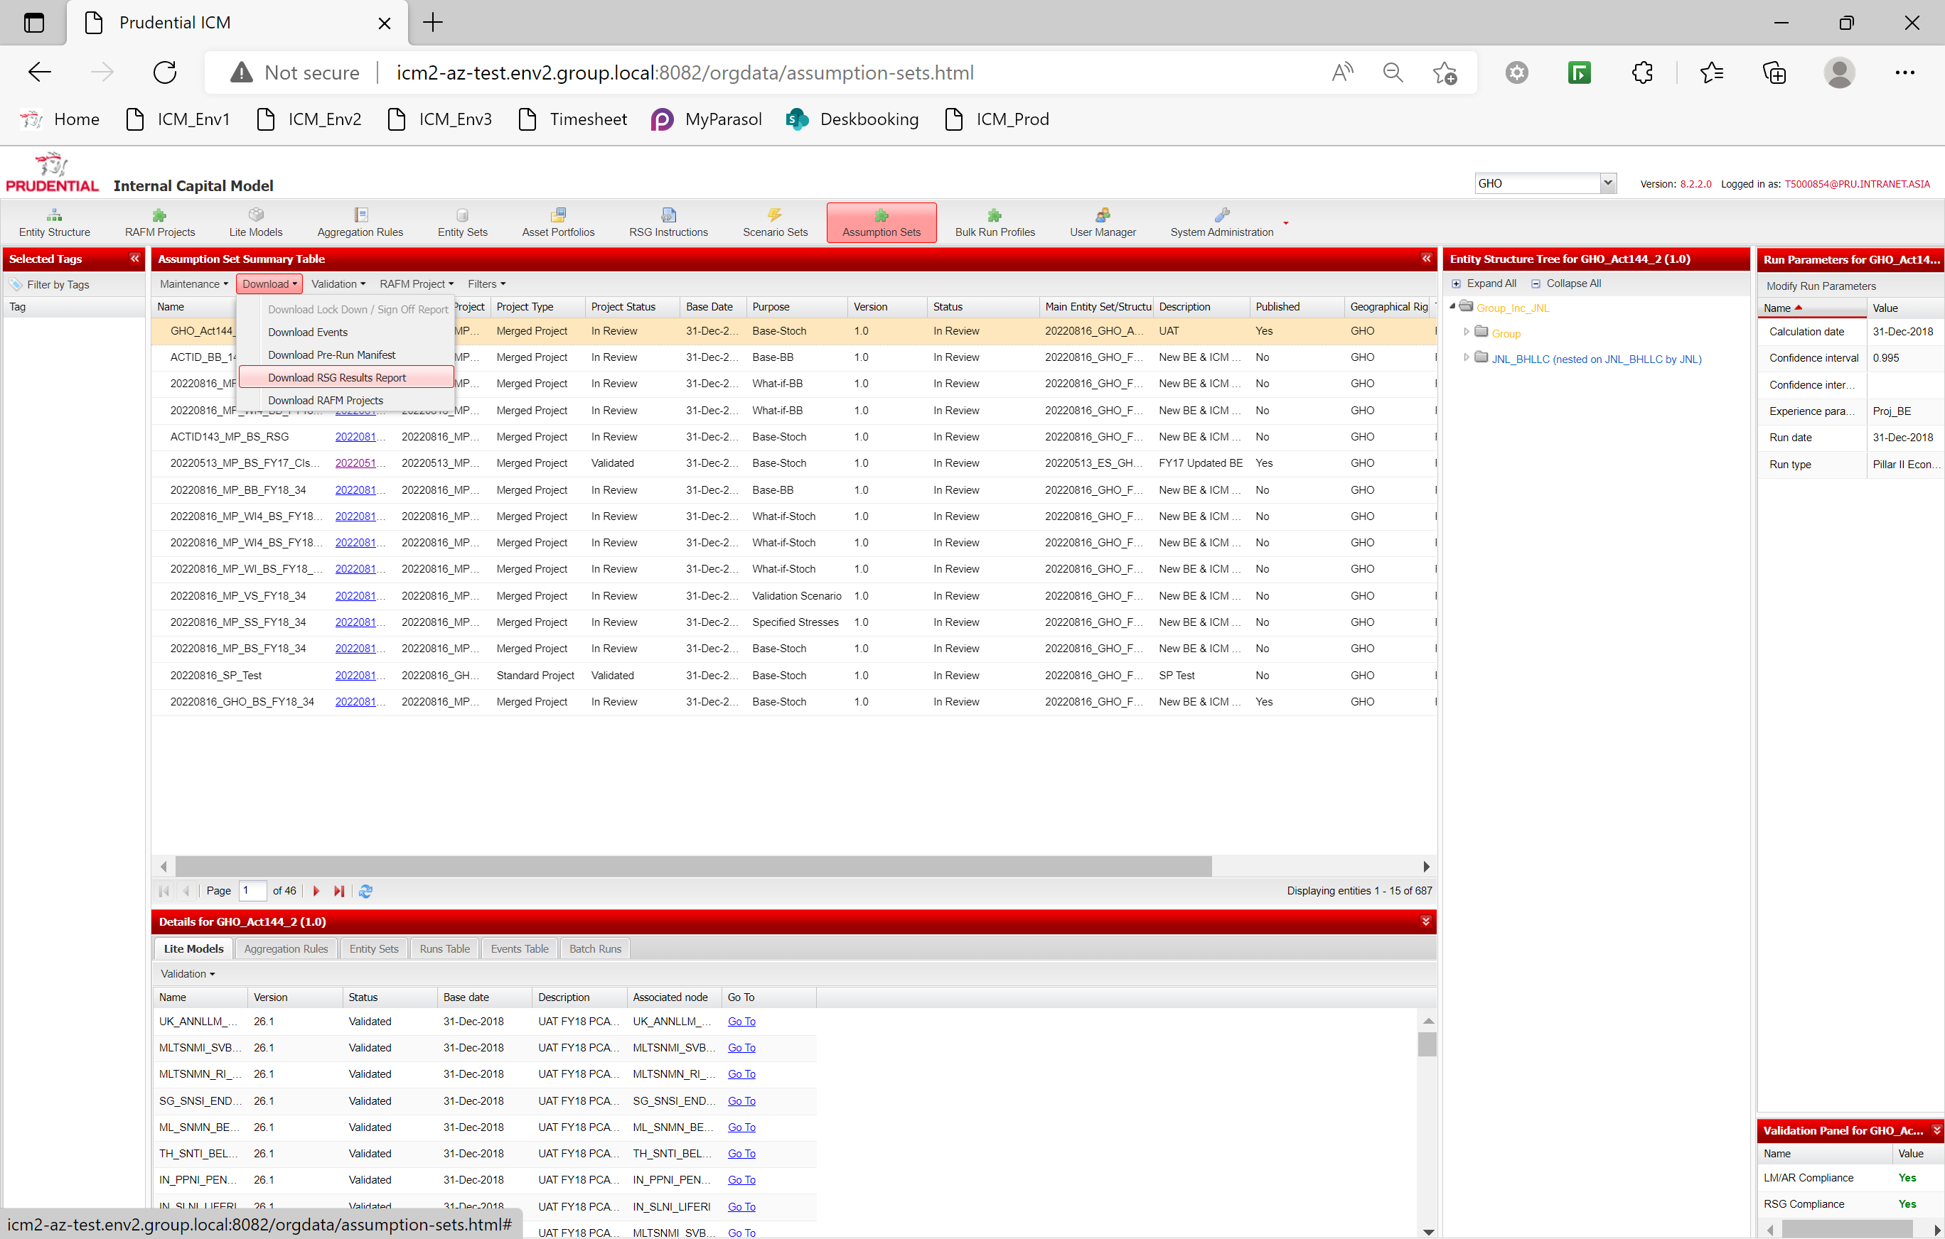

**Option 2 -** To access to RSG report that was used for a specific RunID.

**Step 3** Select a run in the ‘Runs Table’ tab of the details table of the assumption set. Select the option ‘RSG Results Report’ from the ‘Download’ drop-down list.

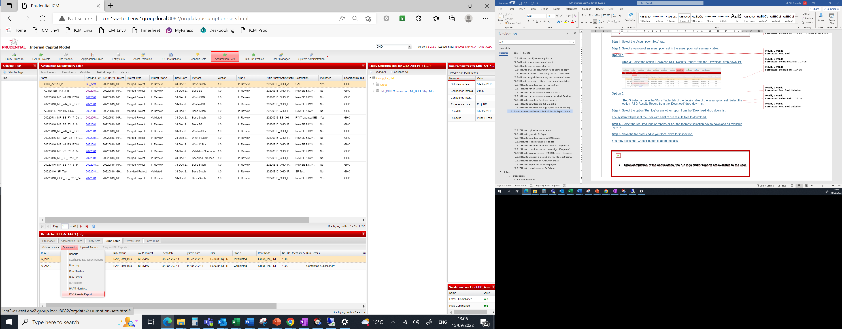

Please note, these two options will only download different reports if the Scenario Set attached to the Assumption Set has been modified after the chosen RunID has been created.

**Step 5:** If the report selected has been run with a large number of scenarios a warning message may appear to alert the user of the size of the download. Press yes to proceed.



You may select the ‘Cancel’ button from the local browser download menu options to abort the task.

* **Upon completion of the above steps, the RSG Results Report is available to the user.**

Chapter 13

Tags

# 13. Tags

 Learning objectives**

*By the end of this lesson you will have:*

* ***Learned what tags are, in the context of the ICM interface, and, how they are created and maintained***
* ***Developed an understanding of how to use tags to help segregate your various workflows***
* ***Worked through the following use cases:***

**13.3.1** Create a tag

**13.3.2** Modify a tag

**13.3.3** Delete a tag

**13.3.4** View or download tag usage

**13.3.5** Apply filter on ICM using a tag

**13.3.6** Assign a tag

**13.3.7** Archiving

## 13.1 Introduction

* **What is a tag?**

A tag or a set of tags is a property of a component as a label to aid in filtering, data management and archiving within the ICM.

Users can request to have tags created that are specific to their purpose. This could be a prescriptive reporting tag, such as monthly or quarterly reporting tags, or a descriptive tag, such as What-if analysis tags. These tags are then assigned to components through specific business rules.

* **Business context**

Users typically work over several reporting periods and therefore have access to several versions of lite models, aggregation rules and entity structures. Tagging facilitates the segregation of those components so that the ICM interface only displays those components that the user requires for their purposes.

* **Working with tags via the ICM interface**

The ICM interface will allow users to undertake the following tasks:

* Create a tag
* Modify a tag
* Delete a tag
* Maintain a tag (including archiving)

Create, maintain and view tags (applicable to PruGroup users)

* Apply a filter on the ICM using a tag
* Assign a tag to an assumption set
* Assign a tag to an entity set
* Assign a tag to a scenario set

Use a tag (applicable to all users)

* **Some of the key properties displayed in the ICM interface for each tag are highlighted below** (boxes outlined in grey are only applicable for reporting tags, boxes in red are applicable for both reporting and descriptive tags – note that the name is set by the system for reporting tags).

Type

Reporting period type

Name

Reporting period start date

Description

Reporting period end date

Available for filter

Archive status

Year

## 13.2 Key inputs and outputs

**Available** **Not available**

|  |  |  |  |
| --- | --- | --- | --- |
| **Key inputs** | **Input requirements** | **Descriptive tag** | **Prescriptive tag** |
| * **Type** | * Must be set at creation, not modifiable later * Defines the selection of input required at creation stage |  |  |
| * **Name** | * Free text * Prescriptive tag name is automatically set by the system based on reporting period user inputs (see below) * Must be unique |  |  |
| * **Description** | * Free text |  |  |
| * **Available for filter** | * Tick box |  |  |
| * **Archive** | - Tick box  - Not available at creation, only at modify stage | / | / |
| * **Reporting period type** | * Drop down feature * Selection deploys a secondary drop-down to select individual time periods (e.g. M1, Q1 etc.) |  |  |
| * **Start date** | * Date feature |  |  |
| * **End date** | * Date feature |  |  |
| * **Year** | * Incremental counter with 2 digit year denominations from ‘10’ (2010) to ’99’ (2099) |  |  |
| **Key outputs** | | **Tag** (available for use & archiving) | **Tag** (available for use & archiving) |

## 13.3 Step by step approach: use cases

This section outlines a step by step approach for the following seven use cases:

**13.3.1** Create a tag

**13.3.2** Modify a tag

**13.3.3** Delete a tag

**13.3.4** View or download tag usage

**13.3.5** Apply filter on ICM using a tag

**13.3.6** Assign a tag

**13.3.7** Archiving

### 13.3.1 Create a tag



* ***Business context:***
* *Creation of a tag allows its use by all BUs across the ICM for filtering items specific to a task/project/reporting period. Only select users from PruGroup are allowed to create new tags on the system. These will normally be the customary reporting tags created in advance of the requirement for the specific reporting period and descriptive tags that will be on request from BUs.*
* ***Prior steps:***
* *An existing tag with the same name must not already exist in the system and the user must have the right permissions (i.e. have System Administrator privileges in the PruGroup geography)*

**Step 1:** Select the ‘PruGroup’ geography

**Step 2**: Select the ‘Tags Management’ option from the ‘System Administration’ tab drop-down menu

**Step 3:** Select ‘Create’ from the ‘Maintenance’ drop-down list. In the pop-up window enter details for:

* **Type:** Drop down for selecting ‘Descriptive’ or ‘Prescriptive’ (this is a one-time election and cannot be changed once the tag is created)

If ‘Descriptive’ is selected:

* **Name:** Free text format, but must be unique and relevant
* **Description:** Free text format (optional)
* **Available for filter:** Tick-box feature
* **Archive:** Greyed out – not modifiable (default setting is not ticked)

If ‘Prescriptive’ is selected:

* **Name:** Greyed out – not modifiable (system generated)
* **Description:** Free text format (optional)
* **Available for filter:** Tick-box feature
* **Archive:** Greyed out – not modifiable (default setting is not ticked)
* **Reporting period:** Drop-down feature with 4 selections: ‘Daily’, ‘Monthly’, ‘Quarterly’ and ‘Final/Half year’
  + **Additional drop-down menu options available for 3 of the 4 selections:** Monthly – M1 to M12, Quarterly – Q1 to Q4, Final/Half year – HY and FY
* **Start date:** Date-picker feature
* **End date:** Date-picker feature
* **Year:** Incremental counter with 2-digit yearly feature starting from ‘10’ for 2010 to a maximum of ‘99’ for 2099

**Step 4:** Select the ‘Save’ button

You may select the ‘Cancel’ button to abort the task.

This completes the steps required for the creation of a tag.



* **You will now have a newly created tag on which users can filter in the ICM.**

**Special tag properties**

a. Tags are agnostic to a user’s geography, i.e. they are visible across all geographies and can be selected by any user irrespective of which BU they sit in.

b. Reporting tag names are set by the system in the following convention:

[Reporting Period Type Element] – [Year Element] e.g. FY-13, M4-12, Q3-14 or Daily-15.

c. There are three system tags: “New”, “Historical”, “Rejected” – these are only assigned to components that have no other tags (i.e. which are not attached to any entity set, lite model or aggregation rule)

d. Note that the ‘End date’ field of the reporting period for a prescriptive tag must be in the same calendar year as the ‘Year’ field, otherwise, the system will not allow for the tag to be saved.

### 13.3.2 Modify a tag



* ***Business context****:*
* *Tags be required to be modified to reflect a more accurate description or to change their names if the business rules allow it. This is an administrative process that is usually carried out on request or following an error. Modification also allows for a tag to be made unavailable for filtering. If reporting dates change, these can also be modified.*
* ***Prior steps:***
* *The tag to be modified is displayed in the tag summary table and the user must have the right permissions (i.e. have System Administrator privileges in the PruGroup geography)*

**Step 1:** Select the ‘PruGroup’ geography

**Step 2**: Select the ‘Tags Management’ option from the ‘System Administration’ tab drop-down menu

**Step 3**: Select the required tag from the tag summary table

**Step 4:** Select ‘Modify’ from the ‘Maintenance’ drop-down list. In the pop-up window modify details as required:

* **Type:** Greyed out and not modifiable

If ‘Descriptive’ is selected:

* **Name**: Free text format, but must be unique and relevant – can only be modified if the tag has not been assigned to any entity in the system
* **Description:** Free text format (optional)
* **Comments:** Free text format (optional)
* **Available for filter:** Tick-box feature
* **Archive:** Tick-box feature (note that ticking the archive box will automatically toggle the tick box for ‘Available for filter’ to unticked – this can be toggled back if required while maintaining the archiving requirement)

If ‘Prescriptive’ is selected:

* **Description:** Free text format (optional)
* **Comments:** Free text format (optional)
* **Available for filter:** Tick-box feature
* **Archive:** Tick-box feature (note that ticking the archive box will automatically toggle the tick box for ‘Available for filter’ to unticked – this can be toggled back if required while maintaining the archiving requirement)
* **Reporting Period Type:** Greyed out and not modifiable
* **Start date:** Date-picker feature (modifying this field will show a warning if the tag is assigned to components, but will not prevent the user from proceeding)
* **End date:** Date-picker feature (modifying this field will show a warning if the tag is assigned to components, but will not prevent the user from proceeding – the new date will still require to be in the same year as the non-modifiable ‘Year’ field)
* **Year:** Greyed out and not modifiable

**Step 5:** Select the ‘Save’ button

You may select the ‘Cancel’ button to abort the task.

This completes the steps required for the modification of a tag



* **You will now have a tag modified as per your requirements.**

### 13.3.3 Delete a tag



* ***Business context****:*
* *A tag created in error or that is not being used by any component can be deleted from the interface.*
* ***Prior steps:***
* *The user must have System Administrator privileges in the PruGroup geography and the tag to be deleted must be displayed in the tag summary table and not assigned to any ICM components or structures.*

**Step 1:** Select the ‘PruGroup’ geography

**Step 2**: Select the ‘Tags Management’ option from the ‘System Administration’ tab drop-down menu

**Step 3:** Select the tag to be deleted from the tag summary table

**Step 4:** Select ‘Delete’ from the ‘Maintenance’ drop-down list.

The system displays a confirmation message for the user to accept.

**Step 5:** Select the ‘Yes’ button

You may select the ‘Cancel’ button to abort the task.

This completes the steps required for the deletion of a tag.



* **The tag you selected is now deleted from the tag summary table and the ICM database.**

**Tag deletion rule**

* Any tag that is assigned to a component cannot be deleted from the interface.

### 13.3.4 View or download tag usage



* ***Business context****:*
* *As users increasingly use tags to manage and filter their data, it may be necessary for tag administrator to determine how a tag is being utilised, whether it be for resourcing or audit purposes. The ICM allows for this by providing the facility to view or download tag usage.*
* ***Prior steps:***
* *The user must have System Administrator privileges in the PruGroup geography and there must be at least one tag in the tag summary table that is attached to a component.*

**Step 1:** Select the PruGroup geography

**Step 2**: Select the ‘Tags Management’ option from the ‘System Administration’ tab drop-down menu

**Step 3:** Select the required tag in the tag summary table

**Step 4a:** To download the usage information, select the option ‘Download usage’ from the ‘Download’ drop-down menu

The system presents the user with the option to open, download or cancel the download of the csv file (the file name will include the exact time stamp at which it was requested from the interface).

**Step 5a:** Select the ‘Save’ button to store a copy of the file to your local or network drive

**Step 4b:** To view the tag usage, select the ‘Usage Table’ tab in the details table below the tag summary table

**Step 5b:** Click through the relevant tabs to view all components using the tag as required. This is available on a ‘per component’ basis. No links are provided in this table to ‘go to’ individual components

This completes the steps required for verifying the usage of a tag.



* **You can now view detailed information about where the tag is being used, on a component by component basis.**

**Granularity of available tag information**

* The user will be presented with the following information for each tag they select: the type of component using the tag, its name, version, status, geography and all other tags that are also assigned to that component.
* For tags with high usage, it may be preferable to use the csv file for analysis.

### 13.3.5 Apply filter on ICM using a tag



* ***Business context****:*
* *The main use of the tags for business users is to compartmentalise and manage their data according to the reporting period or specific project/assignment they may be working on. Data in the ICM is already segregated via different geographies, with sharing allowed for cross-geography availability. Filtering on a tag allows a user to manage the data available within their own geography. In order to do this, components must already have tags assigned on which they can be filtered. (for assignment rules, see the latter sections in this chapter)*
* ***Prior steps:***
* *The components the users wish to use after filtering all have the required tag assigned to them.*
* *The tag to be used for filtering has been available for filtering by administrative users.*

**Step 1:** Navigate to any of the tabs from ’Entity Structure’ to ‘Assumption Sets’

**Step 2**: If required, expand the tag filtering menu using the double arrows located under the ’Entity Structure’ tab

**Step 3:** Click the ‘Filter by Tags’ button.

**Step 4:** The system displays a pop-up window with three collapsible sections:

* **Default Tags:** These are system generated and only refer to those components with no assigned tags. Default tags are ‘new’, ‘rejected’ and ‘historical’
* **Descriptive Tags**: Specifically requested tags
* **Prescriptive Tags:** Standard reporting period tags

**Step 5:** Select all required tags in any combination. Note that you can select all or deselect all tags for selection convenience using the button at the top of the pop-up window immediately below the title. You also have the option to select all tags within a given section by ticking the ‘Tag’ box at the top of the tag list within each section.

**Step 6:** Select ‘Ok’ to commit your changes

You may select the ‘Cancel’ button to abort the task.

This completes the steps required filtering on a tag.



* **You can now view only components that are tagged with the tag you have selected.**

**Additional screen information**

* Once the required tags have been selected, they are the only tags visible in the ‘Selected Tags’ table on the left hand side of the ICM interface screen.
* Filtering is only available in the following screens:
  + Entity Structure
  + RAFM Projects
  + Lite Models
  + Aggregation Rules
  + Entity Sets
  + Asset Portfolios
  + RSG Instructions – Scenario Assumption Set sub-tab
  + RSG Instructions –Translators sub-tab
  + Scenario Set – Normal sub-tag
  + Scenario Set – Critical sub-tab
  + Assumption Set
* Bulk Run Profiles, User Manager and System Administration screens are always unfiltered.

**Boolean logic for filtering on the ICM (tags and property)**

* Selection of 1 or more tags results in the OR relationship being applied, i.e. objects tagged with one of the selected tags are displayed.
* Property filtering on the ICM (‘Filters’ menu) uses an AND relationship to display results. For example, if a user filters on ‘Validated’ with name ‘RDS*’ for a lite model, then only lite models with both, not either, properties are displayed.

The combination of tags and property filtering use the AND relationship as shown in the example below:

A user filters the ICM on the following tags:

* ‘FY-13’;’HY-13’

and applies the following properties filter on the lite model screen:

* Status : ‘Validated’
* Name : ‘RDS*’

The Boolean representation of this filter as applied on the lite model screen is to display all lite model versions with:

* **Tags** (‘FY-13’ OR ‘HY-13’) AND (**status** =’Validated’ AND with a **name** starting with ‘RDS’)

### 13.3.6 Assign a tag



* ***Business context****:*
* *Before filtering via a tag, all components are required to have tags assigned to them. The method for each type of component to receive a tag varies. Users can only actively assign tags to five types of components: assumption sets, entity sets, scenario sets, translators and scenario assumption sets. All other tags are assigned via inheritance rules that are governed by specific business rules.*
* ***Prior steps:***
* *Tag assignment requires the tag to be available to the user, i.e. it must have already been created by a PruGroup user with system administration privileges*

**Summary of tag assignment properties**

Tags are assigned by a user to assumption set, entity set, scenario sets, translators, scenario assumption sets and RSG static data as part of their properties during creation/modification. Entity sets, lite models, aggregation rules and entity structures receive tags via inheritance by the system. A summary of tag properties and assignment method can be found in the table below:



Note:

1. Only if the component is ‘in review’

2. Only if the component is ‘in review – validated’

3. New versions or copies of validated components or locked down assumption sets inherit the tags from the component from which they have been copied or versioned from.

**Specific additional business rules per component**

In addition to the summary of properties detailed above, the following are special rules applicable to the different components of the interface.

Assumption set

* The tag assigned to a locked down/signed off assumption sets cannot changed to another tag.
* Changing a tag will cascade it down to all the constituent components assigned to the assumption set, if they do not already hold it, excluding RSG Instructions components.
* Same as copies of an assumption set inherit the tag of the source assumption set.
* Different versions of assumption sets can have different tags.

Entity set

* The tag assigned to an entity set by a user cannot be modified on a validated version of an entity set.
* Changing a tag will cascade it down to all the constituent components assigned to the entity set.
* Tags inherited by an entity set from an assumption set are also inherited by the lite models, entity structure and aggregation rules attached to that entity set, if they do not already hold it.
* Different versions of entity sets can have different tags.
* Only the tag that is set by the user on an ‘in review’ entity set can be modified. As with other entities, tags inherited from the assumption set cannot.

Scenario set

* Validated scenario sets cannot have their tag changed.
* A scenario set can only have one tag at any one time and therefore also does not inherit the tag of any assumption set to which it is assigned to.

Tag lifecycle for lite models, asset portfolios, aggregation rules and entity structures

The diagram below illustrates the lifecycle of the assignment of tags on :

* Lite models;
* asset portfolios;
* aggregation rules; and,
* entity structures.

Asset portfolios are slightly different in that they follow the tag lifecycle of the lite model they are attached to but the principle remains the same.

ES-TAG

AS-TAG

NEW-TAG1

HISTORICAL-TAG2

ES-TAG

REJECTED3

Component removed from entity set

AS-TAG

Entity set assigned to assumption set

AS-TAG

Component assigned to entity set

AS-TAG

Entity set removed from assumption set

AS-TAG

Component assigned to entity set

AS-TAG

**THE TAG**

**LIFECYCLE**

Component removed from entity set

AS-TAG

Key: ES-TAG: entity set tag; AS-TAG: assumption tag

Colour code: Grey box: system tag; orange box: user assigned/inherited tag; red arrow: removal; blue arrow: assignment

Note:

1. The new tag is the default tag present when a component is created.

2. The historical tag is the tag present on components at day 1 of Release 1.2 that are orphans in the system (i.e. not assigned to any entity set)

3. Rejected is the system tag assigned to all components, post day 1, that get their tags removed by being dissociated from all entity sets to which they had been previously attached.

Please note that the diagram above illustrates the lifecycle across one component, entity set and assumption set. However given that each lite model, aggregation rule, or entity structure can be assigned to multiple entity sets and assumption sets then the picture becomes more complex, however the rules above can be applied for each assignment/un-assignment.

### 13.3.7 Archiving



* ***Business context****:*
* *Tagging provides a useful way for users to mark items for archiving that may not be required either in the short term future or at all. Users are therefore able to highlight any tag (and all associated components) for archiving or may request to restore any tag that had been previously marked for archiving.*
* ***Prior steps:***
* *The user must have System Administrator privileges in the PruGroup geography and there must be at least one tag in the tag summary table.*

**Step 1:** Select the ‘PruGroup’ geography

**Step 2**: Select the ‘Tags Management’ option from the ‘System Administration’ tab drop-down menu

**Step 3:** Select the required tag in the tag summary table

**Step 4:** Select ‘Modify’ from the ‘Maintenance’ drop-down menu

The system presents the user with a pop-up window displaying the properties of the tag.

**Step 5:** Check the ‘Archive’ box

**Step 6:** Deselect the ‘Available for filter’ box

The user has the choice of forcing the filter to operate even while the tag is archived.

**Step 7:** Click ‘Save’ to commit the changes

You may select the ‘Cancel’ button to abort the task.

This completes the steps required for archiving a tag.



* **You have now archived a tag and marked all components associated to it.**

**Impact of archiving and restoring**

* When a user selects the option to archive a tag, all components associated with it are marked as ‘archive requested’ in their properties. While the scope of this document is beyond future architectural implementations, the guiding principle behind marking a component as ‘archive requested’ is that they may then be taken off the system database after a set period of time.
* Note that for a component to be marked as ‘Archive requested’, the tag being archived must be the only tag associated with it, or, if it has more than one tag, then all tags associated with it must have been archived. Any component with a tag that is not archived will not be marked as ‘Archive requested’ irrespective of how many other archived tags it is associated with.
* If a user wishes to restore a tag that has been previously archived, the steps are as above are to be followed with the ‘Archive’ box kept unchecked. This will then mark all components associated with the tag as ‘Restore requested’. Once the component has been physically restored to the interface, it is marked as ‘Restored’.

# Appendix

## 14.1 Run types explained

A stochastic run is used to calculate the capital requirements and identifies the critical scenario which is the 1 in 200 year risk, based on the selection and value of risk drivers included in the scenario set.

A critical scenario run applies the smoothing effect to the critical scenario identified from the stochastic run.

A big bang run produces the capital requirements based on a predefined set of shocks.

A 10k run with shreds is a stochastic run using a 10k scenario set. It applies a set of shreds (where a risk group e.g. equity, is stressed and all other groups are kept constant) to the data on a base, projection or what-if run bases. A stochastic run is completed for each shred, providing its own report to show what would happen if a particular risk occurred.

**Run basis**

The run types can be set off on each of the run bases described below:

A base run calculates the value of the book of Prudential business, providing the capital requirements based on the risk driver position at the calculation date (which is equal to the actual run date).

A projection run calculates the value of the book of Prudential business using the base position as at the starting point i.e. assuming the same set of assets and liabilities, and applies a 1 (or 3) year projected view of the risk drivers.

A what-if run calculates the value of the book of Prudential business, and starting from the base position it applies a stressed view of one risk group.

Each run base produces results that are used for a different purpose.

## 14.2 Dates in the ICM

**Calibration date (lite model)**

* This is the date at which real world data is used to calibrate the lite models to their heavy model counterparts. Actual data is used to populate the risk driver values which are fed into the lite models, and certain parameters are adjusted so that the outputs of these lite models match the outputs of the heavy models
* There may be a range of calibration dates over a given period, but the important point is that we must have actual deterministic data available at these dates
* Normally these dates should correspond to one of the deterministic time steps in the t=0 scenario set
* This is not an ICM user input - it is embedded within the Calibration Parameters file for a lite model

**Session date**

* This is the earliest calibration date of all lite models in the entity structure
* It is pre-determined within the RSG and corresponds to the first time step in a scenario set
* This corresponds to time zero within RAFM and all future dates are represented by a day count against this session date
* This is based on the information in a scenario set but is user input when a scenario set is created in the ICM, except for Critical Scenario sets

**Run date**

* This represents the date at which the last bit of actual deterministic information is available
* It corresponds to the end of historical scenario information and it will be the same as the calculation date in a t=0 or What-If, and it will be less than the calculation date in a t>0 scenario set
* It is a user input in the run parameters for an assumption set in the ICM and scenario assumption set for RSG standalone runs
* It is not used by RAFM - it is only a parameter to be used within lite model code if necessary to distinguish between periods of actual deterministic information and expected deterministic information
* This is also an input in the Balance Sheet Tool to identify whether new business outputs should be captured by the SCR Metric for ranking scenarios

**Calculation date**

* This represents the date at which the last deterministic (actual or expected) information is available
* It corresponds to the beginning of stochastic simulations. For a t>0 scenario set, expected deterministic scenarios will lie at the time steps between the run date and the calculation date
* It is also user input in the run parameters for an assumption set in the ICM
* This is not a user input for the BST unlike the run date - it is captured explicitly from the reports produced

**Snapshot date**

* This is the date at which the portfolio as a whole is "calibrated"
* For a given subportfolio provided as IFF file, the snapshot date will be located in the first line of the file
* Normally the snapshot date of a subportfolio will correspond to the calibration date of all the instruments contained within
* The snapshot date of a parent asset portfolio is a user input which is specified when it is built in the ICM
* Normally this snapshot date should also correspond to the snapshot dates of the subportfolios contained within the parent portfolio

**Base date**

* This is an ICM specific feature used to provide an extra layer of validation in the use of separate components of the ICM
* Normally there is a check underlying the interface on whether components attached to an assumption set are "based" within some reasonable reporting time frame (within 1 year)
* The Base Date does not get used otherwise in the ICM reporting process

## 14.3 Risk limits

The risk limits feature was introduced as part of release 1.3.4 (2014) as a placeholder for future usage by GHO and BUs.

Its implementation does not affect any current dataset in the ICM and users are not required to switch risk limits on/off or input their own risk limits when they perform their run (a switch has been provided to allow for this on the run-time parameters pop-up window – see sections 12.3.10 to 12.3.12).

Going forward, users may modify their lite model code to include conditional statements that will allow for a given calculation to be performed provided a risk limit is active.

In a nutshell, the objectives of the risk limit functionality are to:

a. allow the system to provide a mechanism for all geographical users to activate and deactivate risk limits

b. allow the system to record information about the risk limits run to ensure auditability(such information is also available to the end user through the post-manifest file)

c. allow the output from a risk limit run to be provided to the geographical run owner and users with permissions.

#### 14.3.1 Risk limits switch

A new option is now available to the user on the runtime pop-up window to allow the user to

a. upload an Excel file that contains the settings for default risk limits (switching them on or off)

b. input their own risk limits and their associated states (i.e. either on or off) through the Excel file.

This option is in conjunction with functionality described in 12.3.10 and is not a mandatory input.

An example of a risk limit file and the constraints around updating/building one is provided below.

**Risk limits file example**

A risk limit file is an excel format file which contains at least two tabs names ‘Limits’ and ‘Risk Limit Flag Values’. There can be more tabs in the risk limit file, but the ICM will not process or validate their data. An example of a risk limit file that a user can upload is displayed below:

In the ‘Limits’ tab, there is a table as the following one:

|  |  |
| --- | --- |
| Limit | flag |
| Limit_UK_ann_credit | 0 |
| Limit_UK_EBR | 1 |
| Limit_JNL_rates | 1 |
| Limit_PCA_morbidity | 1 |
| Switch_UK_Ann_LQP | 1 |
| Switch_UK_Ann_ICA | 0 |
| VA_SWITCH | 1 |
| Switch_PCA_CB | 0 |
| Intrinsic_BT_Ind | 1 |
| VA_DYNAMIC | 1 |
| GOV_SP | 0 |
| VA_FULL | 1 |
| CF_Sup | 1 |
| No_NBA | 0 |
| No_Unwind | 0 |
| Additional_NYC_Smoothing | 0 |
| AddNYCSmth_Reference | 0 |

In the ‘Risk Limit Flag Values’ tab, there is a table as the following one:

|  |  |
| --- | --- |
| risk limit flag | value |
| AddNYCSmth_Threshold_1 | 0.25 |
| AddNYCSmth_Threshold_2 | 0.5 |
| AddNYCSmth_Threshold_3 | 0.75 |
| AddNYCSmth_CTE_Percentile | 0.95 |
| AddNYCSmth_SD_Percentile | 0.95 |
| AddNYCSmth_Min_Count | 0.2 |
| AddNYCSMth_Min_Window | 200 |

If the risk limit switch spreadsheet is provided by the user, the system displays an error message if the file:

- is not in Excel format;

- in the ‘Limits’ tab has a header that does not contain the attributes 'limit' and 'flag';

- in the ‘Limits’ tab has values of the attribute 'flag' that are not in the agreed format: 0 or 1;

- in the ‘‘Limits’ tab has a limit without a flag value , i.e. one cannot be provided without the other;

- in the ‘Risk Limit Flag Values’ tab has a header that does not contain the attributes ' risk limit flag’ and 'value';

- in the ‘Risk Limit Flag Values’ tab has a risk limit flag without a value , i.e. one cannot be provided without the other;- either the ‘Limits’ and/or ‘Risk Limit Flag Values’ tabs does not contain at least one line of data information;

Note that if the user uploads the risk limit switch file, the default risk limit parameters are overwritten with the values provided by the user.

The ICM will then translate the risk limits into the appropriate format for RAFM to use.

## 14.4 Lite Model/Aggregation Rule and RSG Compliance Validation

The following table describes the various validation combinations that are possible in the assumption sets validation panel and the inference drawn as a result of the possible combinations.

|  |  |  |
| --- | --- | --- |
| **Scenario:** | **LM/AR Status** | **RSG Status** |
| **Assumption set without nesting, or with nesting via nesting nodes**  BE on Scenario set does not match scenario set on the common Standard RAFM Project.  **Assumption set with nesting via assigned geographies**  BE on Scenario set does not match scenario set on the Assigned Merged RAFM Project. | Yes | No |
| **Assumption set without nesting, or with nesting via nesting nodes**  There are multiple Standard RAFM Projects assigned to a single entity set, or different Standard RAFM Projects assigned to nested LBU entity sets, and main BU entity set.  RSG status cannot be tested against multiple possible Base Engines and is set to No.  **Assumption set with nesting via assigned geographies**  The assigned Merged RAFM project does not meet the LM/AR indicator validation requirements.  BE assigned to scenario set does not match the BE assigned to the Merged RAFM Project. | No | No |
| **Assumption set without nesting, or with nesting via nesting nodes**  Combination not possible  **Assumption set with nesting via assigned geographies**  *The assigned Merged RAFM project does not meet the LM/AR indicator validation requirements.*  *BE assigned to scenario set does match the BE assigned to the assigned Merged RAFM Project.* | No | Yes |
| **Assumption set without nesting, or with nesting via nesting nodes**  Single Standard RAFM Project assigned to the single entity set without nesting nodes, or common Standard RAFM Project assigned to main BU entity set and to any nested LBU entity sets (in the case of assumption set with nesting nodes)  For assumption set without nesting nodes, LM/AR from the same Standard RAFM project must be attached to all nodes. For assumption set with nesting nodes, attachment of entity sets to nesting nodes is not mandatory.  BE on scenario set matches the BE on the Assigned Merged RAFM project OR single standard RAFM project.  **Assumption set with nesting via assigned geographies**  Merged RAFM Project assigned to the single entity set that meets all LM/AR requirements.  BE on scenario set matches the BE on the Assigned Merged RAFM project. | Yes | Yes |
| **Assumption set without nesting, or with nesting via nesting nodes**  Entity set(s) not complete with all LM/ARs assigned to test the LM/AR criteria.  The RSG status cannot be assessed whether there is scenario set assigned or not to the assumption set.  **Assumption set with nesting via assigned geographies**  Merged RAFM project is not assigned to allow the LM/AR or RSG indicator criteria to be applied and tested. | N/A | N/A |
| **Assumption set without nesting, or with nesting via nesting nodes**  Single Standard RAFM project assigned for assumption set without nesting nodes, or otherwise common Standard RAFM Project assigned to all BU/LBU entity sets for assumption set with nesting nodes. No scenario set assigned.  For assumption set without nesting nodes, LM/AR from the same Standard RAFM project must be attached to all nodes. For assumption set with nesting nodes, attachment of entity sets to nesting nodes is not mandatory.  **Assumption set with nesting via assigned geographies**  Merged RAFM project meets all the LM/AR criteria, no scenario set assigned. | Yes | N/A |